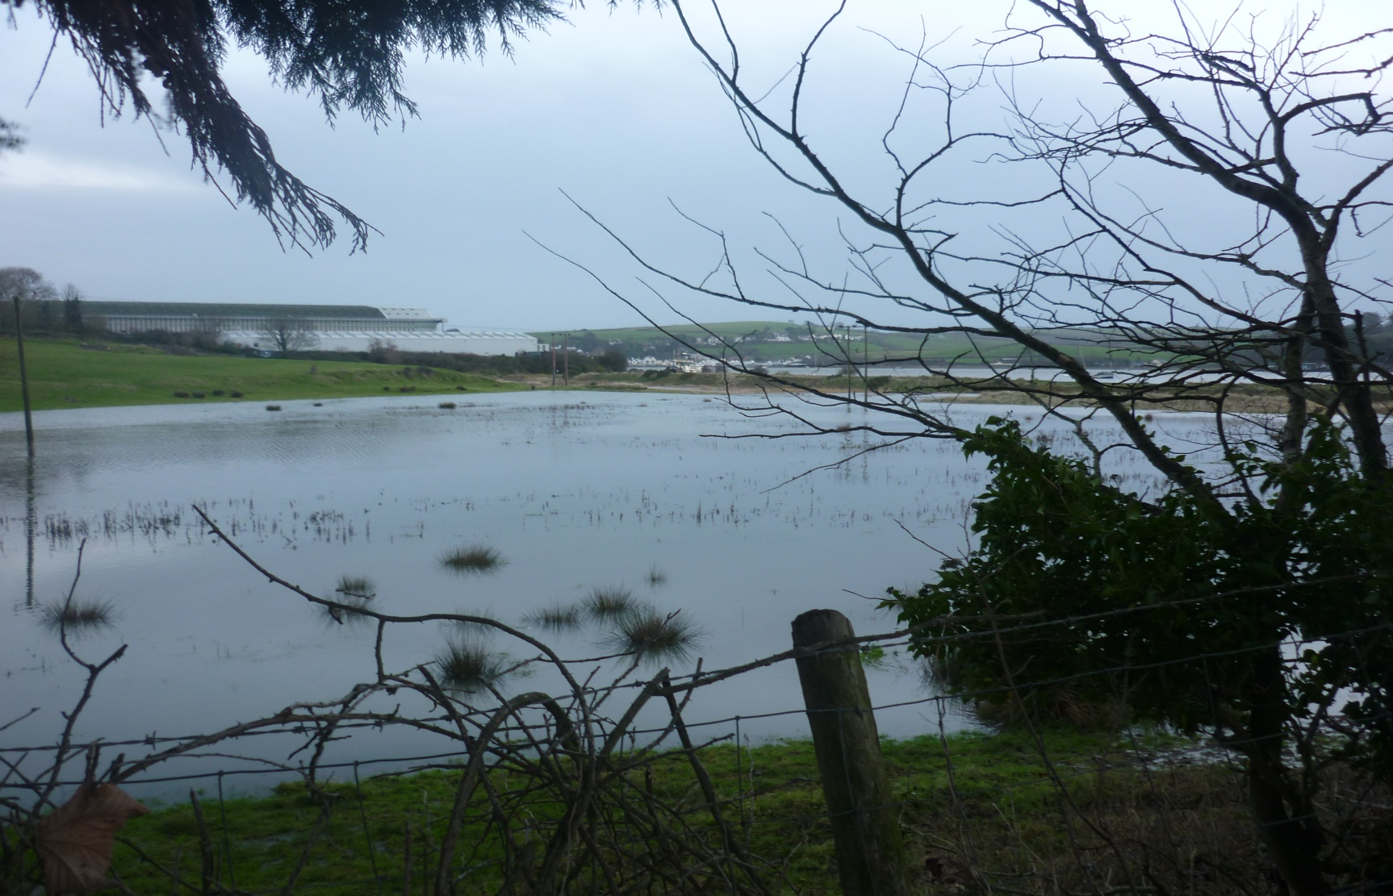

**Northam Town Council**

Climate Emergency Action Plan

DRAFT

**Contents**

**1. Introduction 2**

**2. Aims and Vision 4**

**3. Key Information About Northam Parish 7**

**4. Action to Reduce Emissions 12**

**5. Engaging with the Community 15**

**6. Our Actions So Far 16**

**Appendix 1 Carbon Audit 18**

**Appendix 2 Climate Survey 24**

**Appendix 3 Resources and Sources 26**

**1.Introduction**

Our planet’s climate is changing and warming is accelerating. The latest reports of the Intergovernmental Panel on Climate Change (IPCC) have warned that we have 10 years to limit climate change to avoid a catastrophe. The most recent report published in 2022 has warned that climate breakdown is accelerating rapidly and that some of the impacts will be more severe than predicted with only a narrow chance of avoiding its effects if average temperatures increase to 1.5 degrees above pre-industrial levels. These effects include increased risks to life and health, to livelihoods, food security, water supplies and economic growth.

Limiting global warming to 1.5ºC requires ‘rapid and far-reaching’ transitions in land, energy, industry, buildings, transport and cities. The IPCC reports emphasise that with ambitious action from national and sub-national authorities, civil society, business and local communities, it may still be possible to limit warming.

In addition, a recent Intergovernmental Panel for Biodiversity and Ecosystem Services (IPBES) 2 stated that around 25% of the world’s species are now at threat of extinction due to habitat loss and the effects of climate change. Climate change has severe direct and indirect impacts on biodiversity and is predicted to be a significant driver of future biodiversity loss. At the same time, the loss of biodiversity magnifies the adverse effects of climate change. Biodiversity impacts linked to climate change include habitat degradation/destruction and the introduction of invasive alien species to ecosystems. Managing and protecting biodiversity will mitigate the negative impacts of climate change and help humans adapt to it; policies and actions aiming at limiting the effects of climate change will contribute to the protection of biodiversity.

Humans have already caused irreversible climate change, the impacts of which are being felt all around the world - for example, melting glaciers causing sea level rise, drought conditions or severe flooding (both affecting food crops and driving emigration to the cities and beyond), reduction in water supplies and loss of habitats for wildlife leading to species extinction.

Global temperatures have already increased by 1ºC from pre-industrial levels. Atmospheric CO₂ levels are above 400 parts per million (ppm). This far exceeds the 350ppm deemed to be a safe level for humanity. The Met Office’s latest predictions by the for the UK are for an increased chance of warmer, wetter winters and of hotter, drier summers, along with an increase in the frequency and intensity of extremes’.

Source: <https://nas-sites.org/americasclimatechoices/more-resources-on-climate-change/climate-change-lines-of-evidence-booklet/evidence-impacts-and-choices-figure-gallery/figure-6/>

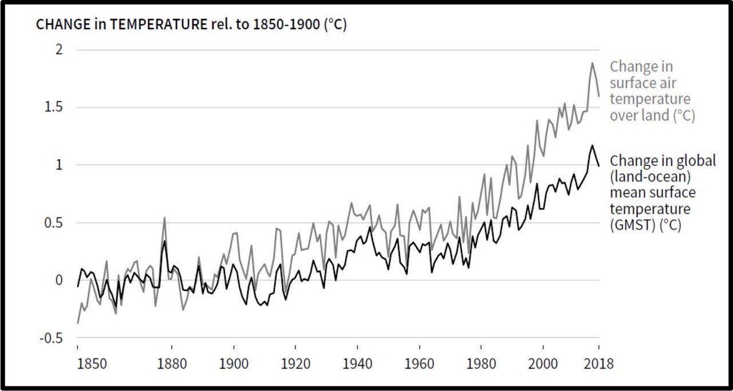

Source: IPCC Special report Climate change and land use (2019) (<https://www.ipcc.ch/srccl/>)

For those who say that climate change is not happening, we need to look at the evidence provided by the reports of the International Panel on Climate Change, the Meteorological Office, the Parliamentary Committee on Climate Change and other official bodies.(e.g. ref Report of IPCC, April 2022). Globally, 2010-2019 was the warmest decade since records began in 1850 and each decade since 1980 has been warmer than the preceding one. 2019 was the second warmest year on record.

All governments (national, regional and local) have a duty to implement policies which limit the impact of climate and environmental breakdown. Towns, cities and local authorities at all tiers are uniquely positioned to lead the world in reducing carbon emissions; Bold climate action can deliver economic benefits in terms of new jobs, economic savings and market opportunities as well as improved personal, social and environmental well-being for people, locally and worldwide.

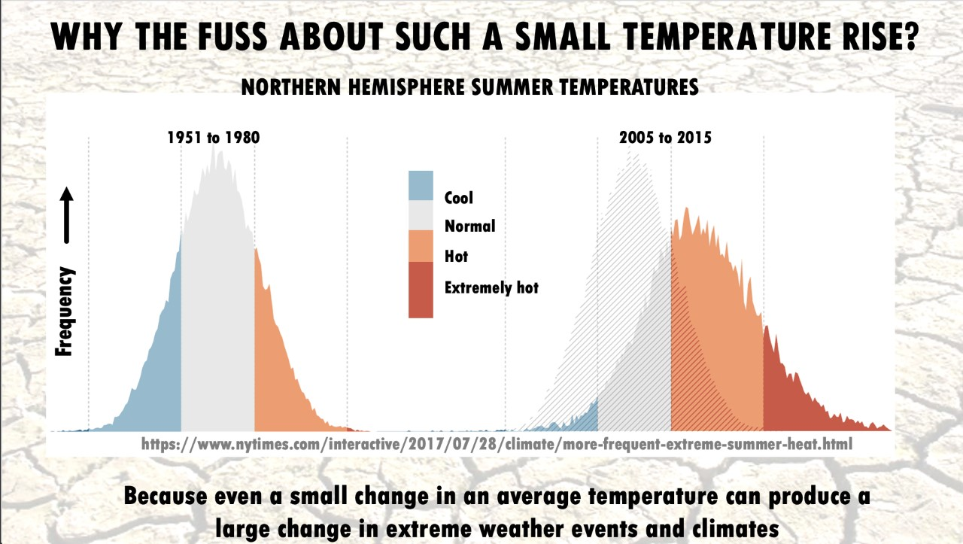

Source: <https://www.nytimes.com/interactive/2021/climate/extreme-summer-heat.html>

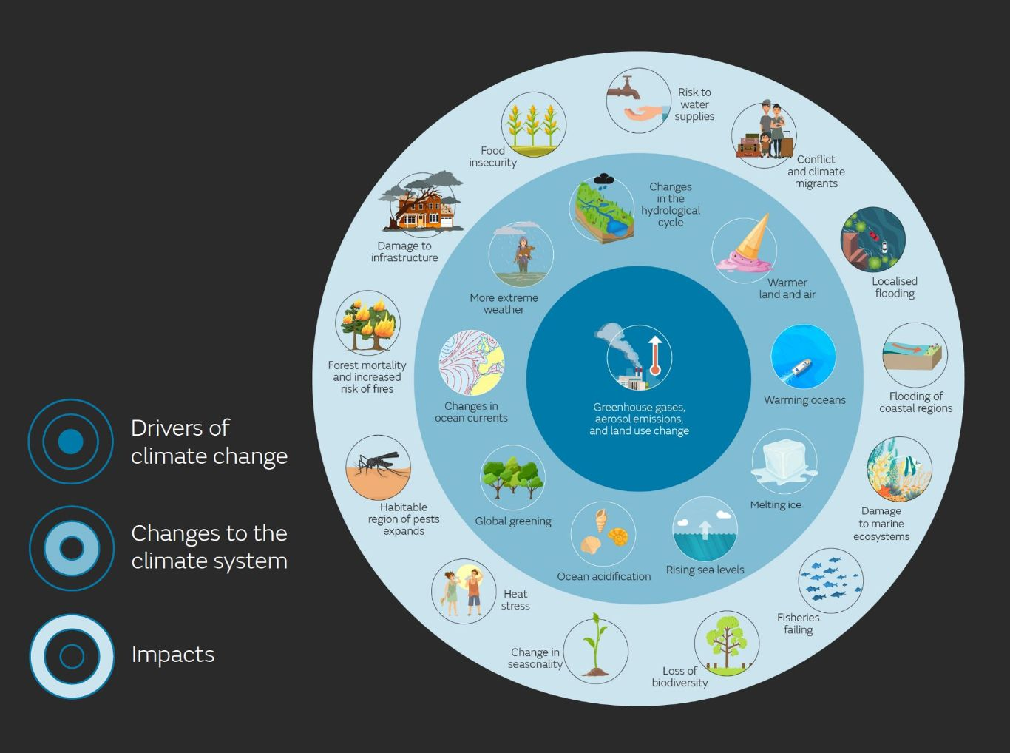

Source: Met Office UK

**2. Aims and Vision**

Northam Town Council declared a Climate Emergency in August 2019. To support this declaration the Council committed to adopting an action plan by the end of January 2020 detailing how the it plans to secure net zero carbon emissions by 2030 across its buildings, assets and operations. The Plan would also detail how the Council could support the wider community in significantly reducing its carbon footprint by the same date. A Climate Emergency Committee was set up consisting of five Councillors and four co-opted members of the public and tasked with preparing and implementing a Climate Emergency Action Plan.

The Council aims to reduce carbon emissions from its buildings and operations through reduction in its waste, transport and energy use, through influencing planning decisions and policies, through the Council’s procurement of goods and services and by looking at investing in environmentally sustainable funds. The Council also plans measures to increase biodiversity and to reduce water usage. However, If the Council succeeds but the rest of Northam parish fails to meet these targets then there will be failure overall. The Council’s own emissions are a tiny proportion of that area’s total emissions, so it is vitally important to work with the community to achieve our carbon net zero target.

Our initial proposals of action to reduce emissions are set out in Section 4 of this Action Plan and proposed actions to engage the community in achieving our target are set out in Chapter 5.

Our vision is that by coming together to reduce our carbon emissions the lives of local people can be greatly enriched. Imagine a future of clean air with fewer cars on the roads and more people cycling and walking along dedicated tracks, children playing safely outside, more birdsong, bees, butterflies and other wildlife, thriving local, self-sufficient economies and energy-efficient homes and businesses powered by renewable energy. It would be a society of connection, collaboration and community, with a sense of collective purpose, informed by the recognition that we should live in harmony with the natural environment.

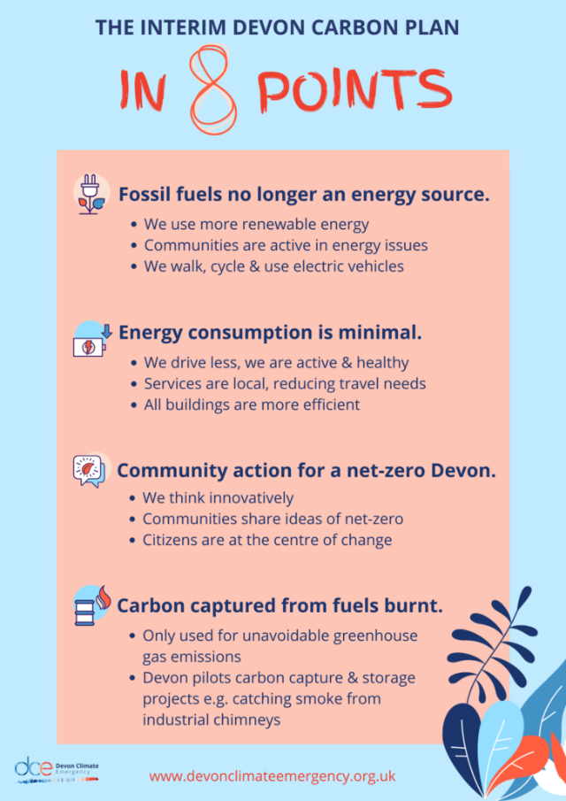 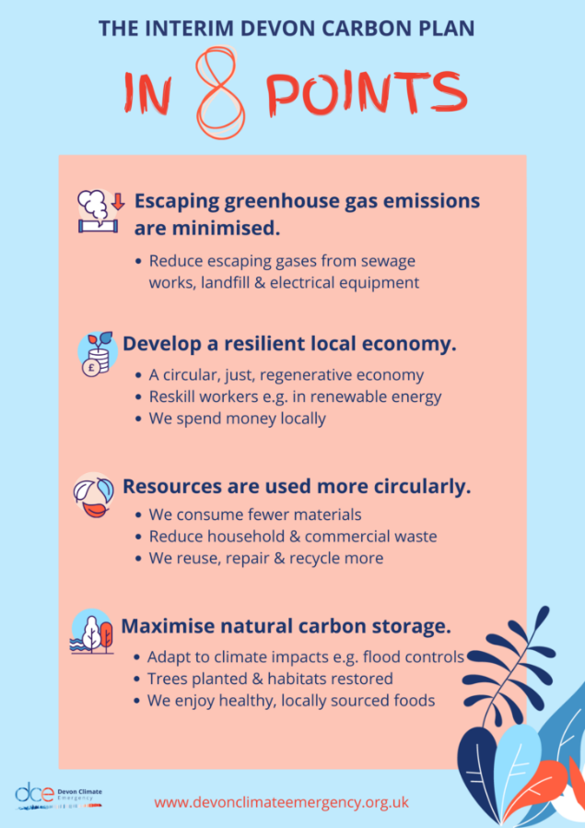

Reproduced from the Devon Climate Plan.

**3. Key Information About Northam Parish**

The parish of Northam includes Northam, Appledore, and Westward Ho!. Northam is mainly a residential area with an historic core of narrow streets, shops and church. Appledore is separated by green fields from Northam and lies at the tip of a peninsula at the mouth of the Torridge estuary. The village has a strong visual identity which is formed by old houses on narrow streets and passageways called ‘drangs’. It has a rich fishing and ship building tradition. Westward Ho! was developed by the Victorians as a holiday resort and as well as accommodating extensive residential development still includes the holiday function in modified form.

The total population of the parish in 2021 was 12,425 .According to the Torridge Ward Profiles compiled in 2020 the population consisted of the following age groups:

|  |  |  |  |  |  |  |  |  |
| --- | --- | --- | --- | --- | --- | --- | --- | --- |
| **Population Age** | **0-4** | **5-15** | **16-24** | **25-44** | **45-64** | **65-74** | **75-84** | **85+** |
| Appledore ward | 4.5% | 11.1% | 6.1% | 19.1% | 29.7% | 16.2% | 10.2% | 3.1% |
| Northam ward | 3.4% | 8.3% | 5.5% | 15.6% | 28.0% | 19.6% | 12.8% | 6.8% |
| Westward Ho! ward | 3.5% | 6.7% | 6.8% | 17.0% | 27.7% | 21.2% | 12.6% | 4.6% |
| Torridge District | 4.7% | 11.6% | 7.9% | 19.0% | 29.7% | 15.5% | 8.4% | 3.3% |

These figures show there is a significant element of retired people in the parish (more than the Torridge average). Most of those who are employed or self-employed mainly work outside the area, except those who work locally in the shops, cafes and tourist facilities. Tourism is an important element in the local economy and another important source of employment is the large indoor shipyard at Appledore, owned by Harland and Wolff.. (See the Torridge Ward Profile 2020 for detailed information about the populations of Northam, Westward Ho! and Appledore.)

Apart from residential areas the parish is notable for the long sandy beach at Westward Ho! which is backed by a long and high bank of pebbles known as the Pebble Ridge. Behind the Ridge lies Northam Burrows which is a grazing common and also a Site of Special Scientific Interest and part of the UNESCO North Devon Biosphere. The Burrows leads to the Torridge Estuary which is also an SSSI.

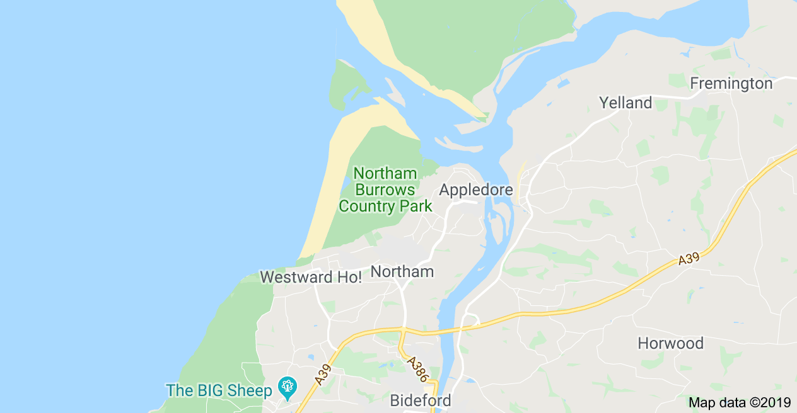

The main specific climate challenge to the area is future flooding from rising sea levels which will affect Northam Burrows and residential properties at Westward Ho!, exacerbated by the gradual angling in of the Pebble Ridge towards Westward Ho! (as explained in the Pethick Report on the Geomorphology and Management of the Taw and Torridge Estuaries, published in 2007). Smaller coastal strips at Appledore and on the estuary at Northam would also be affected by sea level rise. The Environment Agency’s maps reproduced below (published in 2021) show possible flooding in the area over the next fifty and 100 years.. It should be emphasised that the maps are intended to show a ‘worst case’ scenario and don’t necessarily indicate that the land is going to flood or that properties are at immediate risk. Rather it is prudent to plan for the potential of this outcome by investing in future flood defence improvements and by directing future developments to areas with lower risk of flooding.

Another process likely to impact on the parish is an increase in average temperatures due to global heating which will lead to more frequent drought conditions with serious effect on the quality of grazing on Northam Burrows and other areas in the parish and on food supplies.

**4. Action to Reduce Emissions**

The following is a list of actions which the Council will pursue in order to achieve its net zero target by 2030, highlighting specific projects designed to have the most impact.

**Waste**

**Northam Town Council**

Prioritise re-use of materials and repair of equipment used in the Council office and workshop and by the maintenance staff in carrying out their duties; provide re-usable water bottles to staff; minimise paper use; re-use paper by printing on blank sides; increase recycling (e.g. ink cartridges), provide composting facilities for maintenance staff; reduce food waste in office and at functions, adopt a policy of no single plastic use in the Council offices and at Council functions.

**Parish**

Encourage increased recycling rate in Northam. Emphasise on the Council’s website the priorities of re-use and repair and provide information about local repair services. Encourage the reduction of single use plastics and polystyrene surf boards. Carry out a food waste reduction campaign (e.g. in schools); investigate a community composting scheme; set up recycling for hard to recycle materials; place recycling bins in NTC open spaces.

**Transport**

**Northam Town Council**

Encourage staff and councillors to walk, cycle, use public transport and car share. Change to electric or other alternative fuel vehicles for maintenance staff. Encourage reduction in staff/councillor travel and aim to reduce guest travel distance to NTC functions e.g. Mayor’s dinner; install bike racks in Westward Ho!, Appledore, Northam at NTC parks

**Parish**

Encourage walking, biking, bus use in parish, circulate a local footpath guide book, actively push for Kenwith Valley and other local cycle routes and investigate funding; promote car sharing, alternative transport to work places, investigate possible sites for EV charging points, promote alternatives to cars at Northam May Fair.

**Energy**

**Northam Town Council**

Install a solar/battery storage system on Northam Hall roof to provide power for the building, for EV vehicles and for battery powered equipment and introduce energy saving measures in the building (e.g. thermostats, roof and wall insulation) Replace the gas heating with heat pump system; fit LED bulbs in the Town Hall and other NTC buildings; paint walls white for reflected light, introduce a no artificial light policy in NTC buildings when there is strong sunlight; turn off decorative lighting overnight e.g. Xmas lights, use sava plugs; work with Torridge to introduce more efficient, low carbon heating at the Town Hall and in the Council chamber repair or replace draughty windows, lower ceiling and insulate walls; provide instant hot water units for beverages; a low energy computer system, turn off computers at night; change to a renewable energy electricity tariff; install smart meters in NTC buildings.

**Parish**

Encourage community renewable energy schemes, working with S.W. Community Energy; work with local schools including contributing funding for carbon reduction schemes, publish information on NTC website about Government and local authority insulation schemes and heating subsidies, hold energy reduction exhibition at libraries, halls, schools; negotiate bulk discounts on insulation and sustainable energy systems for households.

**Planning**

**Northam Town Council**

New-builds by Town Council to be carbon neutral (Northam Hall extension, the Pavilion at Westward Ho! Park)

**Parish**

Engage with Torridge District Council to ensure that obligations under the National Planning Policy Framework (NPPF) to reduce carbon emissions are being met in the Local Plan (Para 2.7 of the NPPF states that the purpose of planning is ‘sustainable development’. Chapter 14, para 148 ‘contribute to radical reductions in greenhouse gas emissions’, para 149 ‘Plans should take a proactive approach to mitigating and adapting...in line with the objectives of the Climate Change Act.’). Call for renewable energy provisions and energy efficient buildings as part of planning; push for tree planting for development sites and other biodiversity measures, oppose destruction of wildlife habitats, identify habitats and corridors in NTC’s Neighbourhood Plan; water-saving to be incorporated in planning applications. Measures in new builds to cope with future intense rainfall and monsoon-like conditions, to include permeable paving and any play areas, rills around each house, green roofs to absorb excess water, large basin/sinks, sustainable drainage systems (SUDs) should be incorporated (and would provide wildlife habitats as well).

**Food**

**Northam Town Council**

Provide non-meat options at Council functions; any waste to go to food bank or recycled; provide alternatives to meat and fish at Council functions, promote healthy eating, create more allotment plots, source locally-produced food.

**Parish**

Promote local low carbon emission, organic food production and local food markets.

**Biodiversity**

**Northam Town Council**

On Council land plant more trees, sow more wildflowers, minimise grass cutting, and seek environmentally-friendly alternatives to chemical sprays including cordless power equipment. Engage with a community gardener to advise on creating and maintaining areas of biodiversity in the Parish.

**Parish**

Provide grants for tree planting; leave inner areas of wide verges uncut to encourage re-wilding and sow wildflower seeds at selected sites..

**Water**

**Northam Town Council**

Install water saving taps and cisterns, water butts; mulch flower beds, plant drought- tolerant shrubs in beds, hanging baskets and boats.

**Parish**

On website and in newsletters encourage reduction in water use, water saving.

**Procurement**

Prioritise re-use and repair of materials and equipment and adopt a policy of purchasing environmentally sustainable products and services, favouring local suppliers.

**Investments**

Move Council investments to green accounts and disengage from funds invested in fossil fuels.

**5. Engaging with the Community**

In the wider community, the Council aims to work with local people so that the parish as a whole can achieve significant reductions in carbon emissions and facilitate a shift to a more integrated and environmentally-aware way of living.

The Council could engage with the community through such participatory mechanisms as citizen’s assemblies and open space events and should encourage initiatives which build community co-operation and resilience e.g. social enterprises, development of the local economy, local energy schemes, working with local schools to develop projects.

Northam Town Council also recognises that in the light of damaging carbon levels which have already occurred and will occur there is a need to develop with the community a climate emergency plan to enable greater resilience in the face of more extreme weather conditions. For example, it is predicted that the UK will experience periods of much more intense rainfall and monsoon-like conditions leading to flooding. More severe storm conditions and also periods of drought will also be associated with climate change.

Given the above, the following strategy is proposed:

1. Publish a carbon audit of Northam.
2. Hold public meetings in the Parish as and when possible to set out the aims of the Climate Emergency Plan, the vision and the proposed means of achieving them within the Council and in the community, and to take on board the public's responses. Hand out/deliver survey forms in the meantime to gather feedback regarding possible actions
3. Engage with all areas of the community and as a result set up an advisory, participatory and all-embracing group to work with the Council to achieve the target of net zero carbon in the community by 2030.
4. Key elements of the work of such a group would be agreement on the sort of low carbon world which is being aimed for by 2030, generation of ideas for action and ways of achieving objectives, provision of information and communication systems, mapping of networks and organizations and assembly of data regarding resources available in the community.
5. Information on available resources (human and otherwise) will be vital to build up community resilience in the face of likely climate-related events such as flooding, storm damage and drought. Such resilience could be promoted and harnessed through the creation of a Northam Emergency Plan involving the establishment of a community network of volunteers.

**6. Council Actions So Far**

Since declaring a Climate Emergency Northam Town Council has fulfilled the following projects:

**Biodiversity**

Committed to a scheme to leave selected verges in the parish partly unmown to encourage re-wilding.

Committed to sow wild flower meadows on selected verges in the parish.

Planted trees and insect friendly shrubs at Anchor Park, Westward Ho! Park, Blackies and committed to an insect friendly planting scheme outside the Town Hall

Committed to a policy to minimise and eventually dispense with chemical weed control

**Data Collection**

Engaged 361 Energy to do a carbon audit of the Council’s property and activities.

**Energy**

Committed to a solar energy/battery installation at Northam Hall to provide energy for the Hall and for future heat pump system, EV vehicles and battery powered equipment.

**Engaging with the Community**

The Council participated in a Climate Day at Kingsley School and mounted a Climate Emergency display at Northam Library.

A Climate Survey was sent to all residents of Northam. See Appendix 2 Climate Survey and Responses

(NB Full community engagement was prevented by the Covid epidemic after March 2021.)

**Planning**

Incorporated policies in the draft Northam Neighbourhood Plan to combat and adapt to Climate Change and to conserve and increase biodiversity.

**Procurement**

Committed to a revised environment policy stating that the Council will purchase sustainable products and services whenever possible.

**Transport**

Installed bike racks at Lords Meadow, Anchor Park, Westward Ho! Park, Churchfields Car Park and Town Hall.

Contributed financially to and participated in the preparation of Local Cycle and Walking Infrastructure Plan covering Northam, Bideford and Barnstaple.

Identified and promoted local cycle and walking routes.

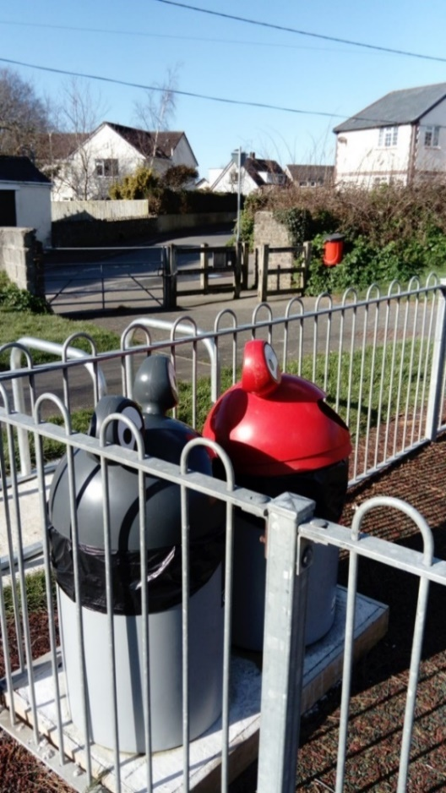**Waste**

Reduced paper waste in Council offices

Committed to a policy of no single plastic use in Council offices and at Council functions

Supported a local anti-polystyrene surf board campaign

Arranged to participate in an ink cartridge recycle scheme for charity.

Provided recycling containers at play areas in Lords Meadow (pictured above with bike racks), Anchor Park and Westward Ho! Park.

**Water**

Committed to installing a rain water capture system at Northam Hall

Installed water fountain at Churchfields Car Park, Appledore to encourage reduction of plastic bottled water use.

**Appendix 1: Carbon Audit**

**Northam Parish Council’s Carbon Emissions**

To achieve the Council’s zero carbon target by 2030 it was necessary to first measure the carbon emissions of the Council in its buildings. In 2020 the Council commissioned local energy advisory group 361 Energy to do a carbon audit. The following is its report and recommendations:

**Summary of Energy Audit.** 30th September 2020 **Audited by**: Matt Whitehead. CEnv.

**Scope of survey:** Northam hall (Fore Street), Northam town hall (Windmill Lane), vehicles.

**Objective:** Identify ways in which carbon emissions can be reduced at Northam Parish Council to support the Climate Emergency Action Plan.

**Context**

For the UK to achieve net zero carbon emissions by 2050, there will need to be a wholesale move away from fossil fuels (e.g. gas, petrol, diesel). The political and scientific consensus is that fossil fuels should be substituted with grid supplied electricity (assuming that targets to fully decarbonise grid supply are achieved), locally produced electricity through renewables, hydrogen, and biofuels where appropriately sourced.

Emissions of CO2 are currently greater per kWh of electricity consumed compared to a kWh of gas. However, this gap is narrowing each year and the convergence point where gas consumption emits more CO2 per unit than electricity is expected to be reached shortly after 2025.

This is recognised and supported by central Government policy which is in place to start making a shift from fossil fuels to electricity. For example, gas heating systems will be banned in new houses from 2025. To address vehicles, sales of new petrol and diesel cars and vans will be banned from 2035.

**Reducing Carbon emissions at Northam Parish Council**

Energy 361 were commissioned to carry out building and vehicle energy audits to recommend ways to reduce carbon emissions. In working towards a net zero carbon goal, Northam Parish Council should consider the degree of control that the Council has over its emissions to most effectively respond to this challenge. We identified the following categories during the survey:

**Directly controlled by Northam Parish Council**

* A picture containing device

  Description automatically generatedHeating and electricity at Northam hall. Systems are owned and maintained by Northam Parish Council (NPC). However, it is slightly more complicated as community groups use the building and have a significant impact on energy consumption.
* A parking meter on the side of a road

  Description automatically generated with medium confidencePetrol and diesel for maintenance vehicles. Vehicles are owned, operated, and maintained by NPC.
* Petrol for machinery (grass cutting, etc) also owned, operated, and maintained by NPC.

**Indirect control**

* Heating at Northam town hall. As this owned by Torridge DC but leased to NPC, there is a split responsibility. For example, procuring a boiler for the building is the responsibility of Torridge DC, but temperature and time controls are under the direct control of NPC.

**Influence**

* Petrol and diesel cars used for business (other than maintenance vehicles). These are claimed on expenses. Being private cars, NPC cannot control which cars are driven on business but can have an influencing role. We know of no company cars
* Commuting. NPC can only influence the travel choices of staff and contractors.

**Carbon footprint**

An estimate has been made of the carbon footprint based on the available data published by NPC within their Climate Emergency Action Plan Version 6. CO2e is defined as carbon dioxide equivalent and takes into account several greenhouse gases to produce a single unit. This is the standard for reporting of carbon emissions.



Emissions that are under the council’s direct control are broken down as follows.



Machinery in this context is defined as grass and hedge cutting vehicles and equipment.

An additional 10,000 kgCO2e is associated with energy used in the Northam town hall where the council can exert some but not full control. This level of influence should be borne in mind when prioritising actions for implementation.

It has not been possible to account for emissions arising from commuting to work as the data is not available. This carbon footprint does not also take account of water use and wastewater or ‘scope 3’ emissions such as procurement and waste.

**Summary of recommendations**

* Full details of each recommendation are contained in the accompanying sheets.
* CO2e savings are based on DEFRA 2020 carbon emission factors.
* tCO2e saved over lifetime of the measure is used forcomparing competing carbon reduction options. The higher the number, the more attractive the scheme. Differing scheme lifetimes apply to different projects. These are stated in the recommendation sheets.

**Northam Hall**: Recommendation: NPC- 01. Install an electric radiant heating system for space heating in combination with point of use electric water heaters once the existing boiler fails. There should be little difference in the cost of this intervention compared to installing a new boiler.

|  |  |  |  |
| --- | --- | --- | --- |
| **Capital Cost £** | **Carbon Saving CO2e p.a.** | **tCO2e saved over lifetime** | **Timeframe** |
| 0 | See detail in NPC-01 sheet | See NPC-01 sheet | Commence from 2025 |

**Maintenance vehicles**: Recommendation: NPC- 02. Replace pickup petrol vehicle WA61 KBF with a battery electric vehicle. Review case for replacing other maintenance vehicles once equivalent electric vehicles come to market.

|  |  |  |  |
| --- | --- | --- | --- |
| **Capital Cost £** | **Carbon Saving kgCO2e p.a.** | **tCO2e saved over lifetime** | **Timeframe** |
| 6,400 | 381 | 5 | From now. |

**Grass cutting and machinery**: Recommendation: NPC-03. Replace the petrol blowers and hedge trimmers with electric alternatives. Purchase an electric mower for smaller tasks. This results in a saving in capital cost and carbon emissions.

|  |  |  |  |
| --- | --- | --- | --- |
| **Capital Cost £** | **Carbon Saving kgCO2e p.a.** | **tCO2e saved over lifetime** | **Timeframe** |
| -3,763 | 311 | 2 | As soon as possible. |

**Northam Hall**: Recommendation: NPC- 04.

Option 1: Install solar photovoltaic panels on the SE facing roof of Northam hall delivering a 70% reduction in CO2 emissions for an 11 year payback. It is understood that this has been considered before but not taken forward due to concerns regarding asbestos. However, this could be a key measure if it can be implemented.

|  |  |  |  |
| --- | --- | --- | --- |
| **Capital Cost £** | **Carbon Saving kgCO2e p.a.** | **tCO2e saved over lifetime** | **Timeframe** |
| 5,500 | 793 | 18 | Investigate now |

Option 2: Install a battery storage system in combination with the solar panels delivering an 85% reduction in CO2 emissions for a 15 year payback. When combined with storage, this system could provide the required source of power for electric vehicle charging.

|  |  |  |  |
| --- | --- | --- | --- |
| **Capital Cost £** | **Carbon Saving kgCO2e p.a.** | **tCO2e saved over lifetime** | **Timeframe** |
| 10,500 | 973 | 22 | Investigate now |

**Northam Hall**: Recommendation: NPC-05. Complete the substitution of fluorescent lighting in Northam hall with LED tubes. Progress has been made in this area by substituting several tubes. We understand the strategy is to replace on failure. Installing the remaining 17 tubes in bulk would deliver a payback in under a year and provide uniformity of light levels.

|  |  |  |  |
| --- | --- | --- | --- |
| **Capital Cost £** | **Carbon Saving kgCO2e p.a.** | **tCO2e saved over lifetime** | **Timeframe** |
| 162 | 294 | 4 | From now |

**Additional unquantified recommendations**

**Northam hall insulation**. Based on our survey of the building we expect that the radiators are undersized for the space and in winter will struggle to meet the target temperature. There are opportunities to improve the insulation for comfort and efficiency which will better retain heat. It is understood that the middle section of the ceiling is insulated with mineral wool, however this is not the case in the pitched section closest to the walls. The walls are solid and insulation could be introduced by through internal or external cladding. There are several aesthetically pleasing options available. More information is available at: https://energysavingtrust.org.uk/home-insulation/solid-wall

Energy 361 offers a thermal imaging survey service to pinpoint specific areas to target.

**Northam town hall.** Corridor electric heating timer. During our survey we observed that the electric heater closest to the main door included a timer that was not enabled so that there is at least the potential for this to be on 24 hours a day. As the building is operated Monday – Thursday 09:00 to 15:00 and Friday 09:00 to 13:00, this is potentially a source of wasted energy. We suggest this be reviewed and adjusted appropriately.

**Staff cars**. NPC has direct control over vehicles that travel between sites. Currently, the maintenance team uses the petrol vehicles. However, where appropriate (e.g. from the Town Hall to Northam Hall) it may be appropriate to use electric bikes instead. Electric bikes are now cost competitive with a good range at £1,500, with some in the £1,000 bracket. NPC should consider procuring a ‘pool bike’ for these purposes.

**Commuting**. Staff claims for mileage amounts to at least 3,700 kgCO2e. The council may be able to influence this by promoting cycling for example. If not already available, the council can offer a cycle to work scheme: <https://www.cyclescheme.co.uk/>.

**Awareness**. According to the 2019 Committee on Climate Change report: Net Zero The UKs contribution to stopping global-warming, 9% of the near zero goal will need to be met by societal or behavioural changes, with a further 53% of measures being comprised of combined low-carbon technologies and societal / behavioural changes. In conversation with staff, the cost or amount of energy consumed at Northam town hall was not known, just that it was paid for in the rent to Torridge District Council. The first step to involving your staff in reducing emissions is to make these figures visible. We suggest that at the very least carbon emission data for the building is shared to all employees of NPC.

Following on from this, a behavioural change campaign should be rolled out. There are numerous resources available including:

<https://www.carbontrust.com/resources/low-carbon-behaviour-change-the-ps300-million-opportunity>

<https://www.carbontrust.com/news-and-events/insights/five-tips-for-better-behaviour-change-campaigns-and-a-new-collaborative>

Simple measures include only boiling enough water for tea’s, not opening windows when the heating is on, and switching computers and monitors off when leaving for the day.

Energy 361 operates a range of behavioural change advice initiatives for Councils.

**Northam Parish Carbon Emissions**

A report of Northam’s carbon footprint was produced by the University of Exeter Centre for Sustainable Energy in 2022. To read the results follow this link: <https://impact-tool.org.uk/report?regionId=E04012900&geography=parish>

To calculate your household carbon footprint follow this link: <https://calculator.carbonsavvy.uk/calculator/taster>

Using the online [IMPACT | Community carbon calculator](http://www.impact-tool.org.uk), the Council has derived the report reproduced on the following pages.

Impact is a digital visualisation tool that helps community’s understand their carbon footprint from the Centre for Sustainable Energy[1]. It draws on meta data and works for parishes, wards and larger local authority areas.

It helps identify the aspects where taking action to tackle climate change can make the biggest difference.

The website includes a useful [user guide](https://impact-tool.org.uk/using-impact).

Using the tool, the Council has found Northam Town area’s carbon footprint can be analysed as follows:

*1: Derived from Carbon Footprint Report - Northam Parish -* [*www.impact-tool.org.uk*](http://www.impact-tool.org.uk)

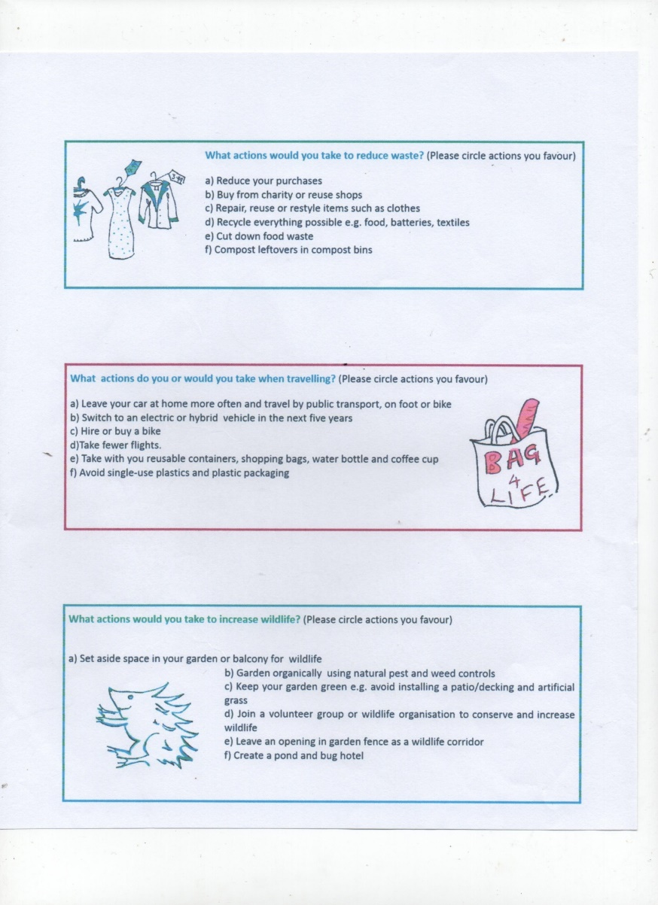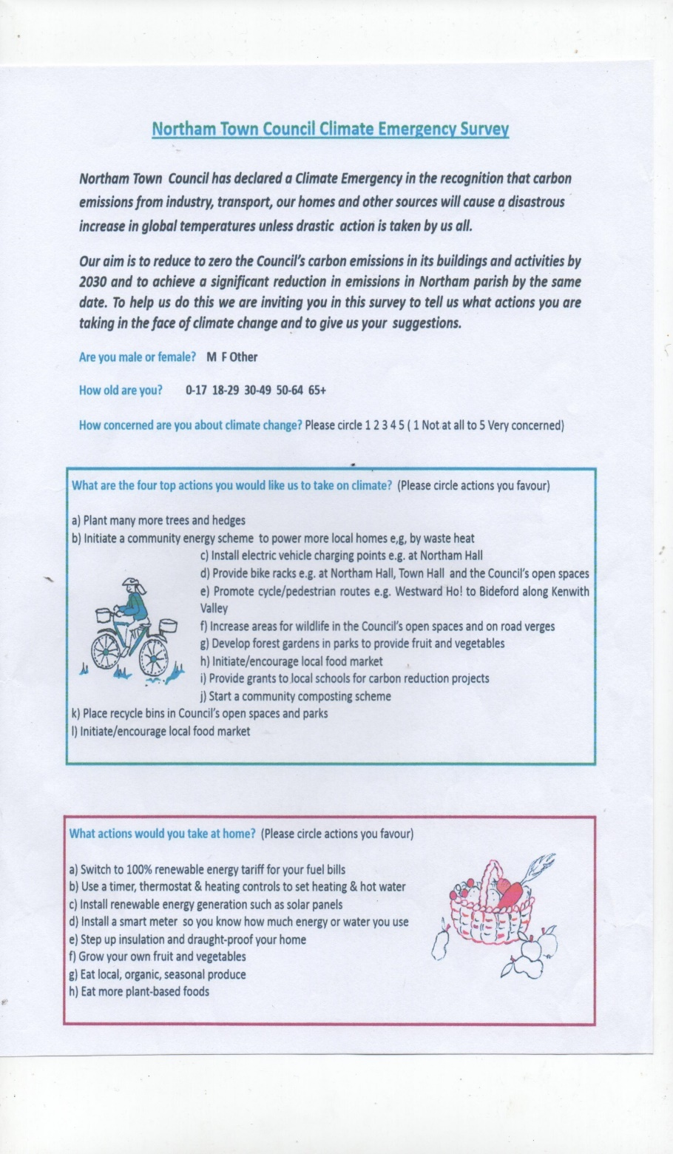**Appendix 2: Climate Survey and Results.**

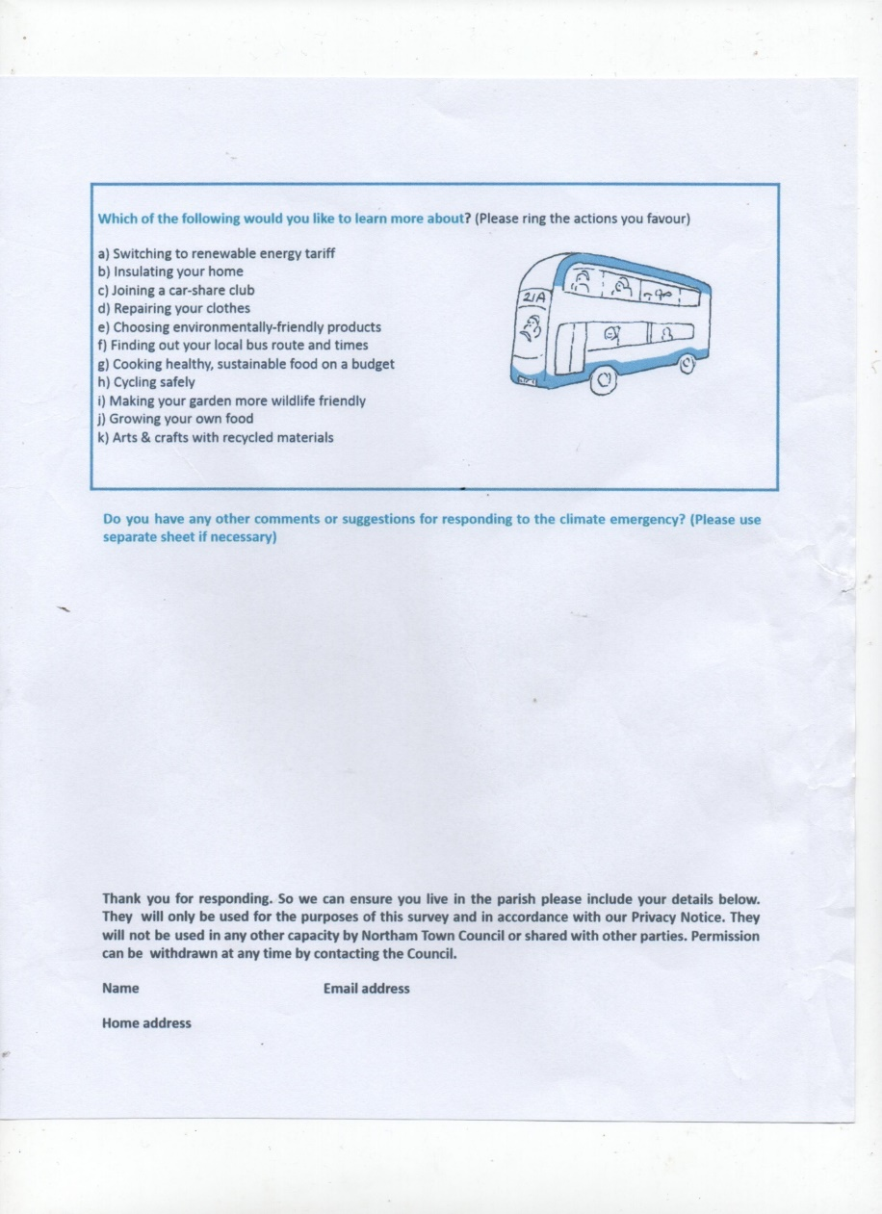

|  |  |
| --- | --- |
| Are you male or female? | |
| Male | 68 |
| Female | 137 |
| Unknown | 19 |
| Total | 224 |

|  |  |
| --- | --- |
| How old are you? | |
| 0-17 | 0 |
| 18-29 | 3 |
| 30-49 | 17 |
| 50-64 | 55 |
| 65+ | 136 |
| Unknown | 13 |
| Total | 224 |

|  |  |
| --- | --- |
| How Concerned are you about climate change?  (1 = not at all concerned | 5 = very concerned) | |
| 1 | 3 |
| 2 | 2 |
| 3 | 18 |
| 4 | 43 |
| 5 | 131 |
| No answer | 27 |
| Total | 224 |

|  |  |  |
| --- | --- | --- |
| What are the four top actions you would like us to take on climate? | | |
| A | 170 | Plant more trees and hedges |
| B | 102 | Initiate a community energy scheme to power more local homes by waste heat |
| C | 50 | Install electric vehicle points e.g. at Northam Hall |
| D | 27 | Provide bike racks e.g. Northam Hall, Town Hall and the Council's open spaces. |
| E | 103 | Promote cycle/pedestrian routes |
| F | 126 | Increase area's of wildlife in the Council's open spaces and on road verges. |
| G | 65 | Develop forest gardens in parks to provide fruit and vegetables |
| H | 128 | Initiate /encourage local food markets |
| I | 57 | Provide grants to local schools for carbon reduction projects |
| J | 40 | Start a community composting scheme |
| K | 75 | Place recycle bins in council open spaces and parks |
| Total | 943 |  |

|  |  |  |
| --- | --- | --- |
| What actions would you take at home | | |
| A | 116 | Switch to 100% renewable energy tariff for your fuel bills |
| B | 126 | Use a timer, thermostat & heating controls to set heating and hot water |
| C | 109 | Install renewable energy generation such as solar panels |
| D | 75 | Install a smart meter so you know how much energy or water you use |
| E | 129 | Step up insulation and draught-proof your home |
| F | 92 | Grow your own fruit and vegetables |
| G | 133 | Eat local, seasonal, organic produce |
| H | 101 | Eat more plant based foods |
| Total | 881 |  |

|  |  |  |
| --- | --- | --- |
| What actions would you take to reduce waste | | |
| A | 104 | Reduce your purchases |
| B | 112 | Buy from charity or reuse shops |
| C | 96 | Repair, reuse or restyle items such as clothes |
| D | 169 | Recycle everything possible e.g. food, batteries, textiles |
| E | 147 | Cut down food waste |
| F | 132 | Compost leftovers in compost bins |
| Total | 760 |  |

|  |  |  |
| --- | --- | --- |
| What actions do you or would you take when travelling? | | |
| A | 116 | Travel by public transport, on foot or bike |
| B | 90 | Switch to electric or hybrid vehicle in the next five years |
| C | 40 | Hire or buy a bike |
| D | 99 | Take fewer flights |
| E | 181 | Take with you reusable containers, shopping bags, water bottle and coffee cup |
| F | 181 | Avoid single use plastics and plastic packaging |
| Total | 707 |  |

|  |  |  |
| --- | --- | --- |
| What actions would you take to increase wildlife? | | |
| A | 153 | Set aside space in your garden or balcony for wildlife |
| B | 129 | Garden organically using natural pest and weed free controls |
| C | 141 | Keep your garden green e.g. avoid installing decking or artificial grass |
| D | 56 | Join a wildlife conservation group or organisation |
| E | 127 | Leave an opening in garden fence as a wildlife corridor |
| F | 113 | Create a pond and bug hotel |
| Total | 719 |  |

|  |  |  |
| --- | --- | --- |
| Which of the follow would you like to learn more about? | | |
| A | 69 | Switch to renewable energy |
| B | 49 | Insulating your home |
| C | 13 | Joining a car share club |
| D | 22 | Repairing your clothes |
| E | 96 | Choosing environmentally friendly products |
| F | 62 | Finding out your local bus route and times |
| G | 64 | Cooking healthy, sustainable food on a budget |
| H | 29 | Cycling safely |
| I | 77 | Making your garden more wildlife friendly |
| J | 52 | Growing your own food |
| K | 48 | Arts and crafts with recycled materials |
| Total | 581 |  |

**Appendix 3: Resources and Sources**

Northam Town Council and Torridge District Council are tying in with the climate action plan of **Devon County Council.** More information can be found on <https://www.devon.gov.uk/energyandclimatechange/strategy/climate-change-strategy>

[**https://www.climateemergency.uk/**](https://www.climateemergency.uk/) has many resources including a full list of councils which have declared a Climate Emergency and their targets and motions, some plans, and a [Basecamp](https://3.basecamp.com/4185879/projects/11222672) site for discussion, and sharing resources.

**Community Energy England** is a not for profit organisation that represents and supports those committed to the community energy sector. Contact  info@communityenergyengland.org.

**Extinction Rebellion** has produced an excellent [briefing](https://trello-attachments.s3.amazonaws.com/5d90a2e7072a843ba0e470fe/5dd6e6a78df7ee417cda881f/ed7a75afb659dc38ff80874680379aee/Rebel_Actions_for_Emergency_Declarations__with_Teeth_Vn1_26.11.19.pdf) to make sure that Declarations are meaningful and have teeth. It has sections on energy as well as housing.

**Friends of the Earth** has a [climate action plan for local authorities](https://takeclimateaction.uk/climate-action/get-your-council-adopt-climate-action-plan) as part of its [Climate Action Groups](https://takeclimateaction.uk/) campaign to mobilise local volunteers around the Climate Emergency planning.

**The Centre for Sustainable Energy** has launched a [Climate Emergency Support Programme](https://www.cse.org.uk/news/view/2392) for local authorities. It is focussing especially on the challenges in two-tier authorities. It is encouraging District Councils to connect with their Town and Parish Council and resourcing those to declare Climate Emergencies and engage their very local communities in solutions that will help the District Council meet their targets.

**Green Alliance** will be working with three different city councils, to enable the planning process and then to share good practice.

Councillors and council officers can apply to join the **Local Government Association (LGA)** Special Interest group, the Climate Emergency Network, to support Local Authorities in declaring a Climate Emergency and in preparing and implementing plans to achieve carbon neutral status as quickly as possible

[**Local Energy Hubs**](http://ec2-52-26-194-35.us-west-2.compute.amazonaws.com/x/d?c=4198789&l=bdc2a13e-cd02-4afc-b472-524055f69403&r=7e332b74-f39a-4b2f-8d7e-28abd34a5f7f)  have been set up by BEIS to support local energy initiatives. ‘Local energy’ refers to all energy projects that are led by local organisations (public, private, third sector) for local benefit. All aspects of collective action to reduce, purchase, manage and generate energy are included within ‘local energy.’ This includes but goes beyond community energy.

**Transition Town** initiatives have been working on this agenda for many years. Find your local one at [**https://transitionnetwork.org/transition-near-me/**](https://transitionnetwork.org/transition-near-me/)

There are many places in the UK where strong action is being taken to reduce carbon emissions. For example, **Leeds** has a bold plan which can be found on[**https://news.leeds.gov.uk/council-approves-plan-to-more-than-halve-carbon-emissions-by-2025/**](https://news.leeds.gov.uk/council-approves-plan-to-more-than-halve-carbon-emissions-by-2025/) and a website [**https://www.leedsbyexample.co.uk/**](https://www.leedsbyexample.co.uk/)

Campaigning locally against single-use plastic is Plastic Free Torridge on [**https://www.facebook.com/plasticfreetorridge/**](https://www.facebook.com/plasticfreetorridge/)**.**

**361 Energy** is based in North Devon and helps to reduce emissions, providing practical advice. Contact on info@361energy.org.

1. Centre for Sustainable Energy | St James Court, St James Parade, Bristol BS1 3LH. Registered Charity 298740

   [www.cse.org.uk](http://www.cse.org.uk)