**To all members of the Council:**

You are hereby summoned to attend the **ENVIRONMENT and MAINTENANCE COMMITTEE** meeting on

**Wednesday 30th July 2025 at 6:30pm**

at The Town Hall, Windmill Lane, Northam for the transaction of the business listed on the agenda below.

**Membership:**

Cllrs Bell, Cllr Edwards, Cllr Hames, Cllr Sawyer, Cllr Lo-Vel, Tait and the Mayor, Cllr Bach (ex-officio). One vacancy.

**Questions by the public**

There will be a period for questions by the public. In accordance with Standing Order 3, members of the public may make representations, ask questions and give evidence at a meeting which they are entitled to attend in respect of any Council business at Full Council, and at Committee meetings in respect of business on the agenda.

Anyone wishing to ask questions is requested to notify the Town Clerk prior to the meeting.

**Recording, photographs and filming**

In accordance with the Council’s policy on filming and recording of Local Council and Committee meetings (available to read in the Chamber) and arising from the *Local Government and Accountability Act 2014* the press or public may audio-record, photograph or film meetings, or report from the meeting using social media. As such, members of the public may be recorded or photographed during the meeting. Anyone wishing to record or photograph the meeting must notify the Town Clerk before the commencement of the meeting.

**Public attendance at Council and committee meetings**

As a public body, Northam Town Council understands the need for transparency and accountability. The Council will therefore seek to conduct meetings using practices and procedures set out within the Public Bodies (Admission to Meetings) Act 1960, which states:

*Subject to subsection (2) * below, any meeting of a body exercising public functions, being a body to which this Act applies, shall be open to the public.*

Subsection (2) states:

*Where a meeting is open to the public, a body may, by resolution exclude the public from the meeting (whether during the whole or part of the proceedings) whenever publicity would be prejudicial to the public interest by reason of the confidential nature of the business to be transacted or for other special reasons stated in the resolution and arising from the nature of that business or of the proceedings; and where such a resolution is passed, this Act shall not require the meeting to be open to the public*

*during proceedings to which the resolution applies.*

Therefore, the Council’s policy is to allow public access to meetings unless the business being.

transacted is confidential or there are ‘other special reasons’ to exclude the public.

*Guy Langton*

Guy Langton, Town Clerk & RFO

Date of issue: 24th July 2025

**AGENDA**

**1 To receive and approve apologies for absence, in accordance with Local Government Act 1972 s85(1)** *All apologies must be notified to the Town Council offices by 5pm on the day of the meeting.*

**2 Chair’s announcements**

**3 To receive any dispensations and disclosable pecuniary or other interests** *Members are reminded that all interests must be declared prior to the item being discussed.*

**4 To agree the agenda as published.**

**5 To confirm as a correct record and sign the minutes of the ENVIRONMENT and MAINTENANCE COMMITTEE** **held on 30th July 2025 (p3-p5)**

**6 Public Participation**

*Members of the public are permitted to make representations, answer questions and give evidence in respect of any item of business included in the agenda. Each member of the public is entitled to speak once only in respect of business itemised on the agenda and shall not speak for more than 4 minutes. The period of time which is designated for public participation in accordance with standing orders shall not exceed 20 minutes.*

**7** **To receive an update on actions** **(p6-7)**

**8 To consider the purchase and placement of notice boards (p7)**

**9 To consider the purchase of an outdoor water fountain for Westward Ho! Park *(p7,8,9.verbal)***

**10 To review the locations and quantities of Christmas trees within the Parish *(p9)***

**11 To consider the purchase and placement of a three-tier bin at Churchfields Play Park *(p9)***

**Page \*\*\***

**Northam Town Council – Minutes of the Environment and Maintenance committee meeting held Wednesday 18th June 2025 at 6:30pm**

**at 6.30pm in the Town Hall, Windmill Lane, Northam.**

Present: Cllrs Bell, Edwards, Hames, Lo-Vel, Cllr Tait and the Mayor, Cllr Bach (ex-officio). Two vacancies.

In attendance: Ian Rawle – Parks & Buildings Manager.

**2506/101 To elect a Chair for the committee**

Cllr Bach **nominated** Cllr Bell as Chair of the Environment and Maintenance Committee. The nomination was seconded by Cllr Lo-Vel. There being no other nominations, the matter was put to a vote. All members were in favour and **Cllr Bell was** **duly elected Chair of the Environment and Maintenance 2025-26**.

**2506/102 To elect a Deputy Chair for the committee**

Cllr Tait **nominated** Cllr Hames as Vice Chair of the Environment and Maintenance Committee. The nomination was seconded by Cllr Edwards. There being no other nominations, the matter was put to a vote. All members were in favour**. Cllr Hames was** **duly elected Vice Chair of the** **Environment and Maintenance** **Committee** **for 2025-26.**

**2506/103 To receive and approve apologies for absence, in accordance with Local Government Act 1972 s85(1)**

All members were present.

**2506/104 Chair’s Announcements**

The Chair had no announcements.

**2506/105 To receive any dispensations and disclosable pecuniary or other interests**

Members were reminded that all interests must be declared prior to the item being discussed.

**2506/106 To agree the agenda as published**

It was **resolved** to agree the agenda as published.

**Proposed:** Cllr Tait, Seconded: Cllr Lo-Vel (all in favour).

**2506/107 To confirm as a correct record and sign the minutes of the** Environment and Maintenance Committee held on 18th of June 2025.

It was **resolved** that to approve the minutes of that Environment and Maintenance committee meeting as a true and correct record, they were signed by the Chair.

**Proposed:** Cllr Bach, Seconded Cllr Tait (all in favour).

**2506/108 Public Participation**

*Members of the public are permitted to make representations, answer questions and give evidence in respect of any item of business included in the agenda. Each member of the public is entitled to speak once only in respect of business itemised on the agenda and shall not speak for more than 4 minutes. The period of time which is designated for public participation in accordance with standing orders shall not exceed 20 minutes.*

There were no members of the public present.

**2506/109 To receive an update on action points**

The Action points were considered and noted as presented overleaf.

**Page 037**

**2506/110 To receive an update on actions**

|  |  |  |  |
| --- | --- | --- | --- |
| **Action** | | **April 2025** | **June 2025** |
| **1** | Drop kerbs in Westward Ho!  (brought forward from TP&AM) | Contractor instructed.  ONGOING | Contractor instructed.  ONGOING |
| **2** | Schools to be contacted to design their own ‘don’t idle’ signs for the Council to have made and installed. | Seeking a discussion with the interested school. ONGOING | ONGOING |
| **3** | Prepare a report on the purchase and installation of MVSIDs for the Parish | NOT STARTED | Work on the report has started and is currently in progress. ONGOING |
| **4** | Traffic issues at the Square, Northam | Costs of traffic surveys not yet researched.  Cost of air quality surveys not yet researched.  NOT STARTED | NOT STARTED |
| **5** | Locations of Council provided Christmas trees in 2025 – liaise with the Westward Ho! Business association over the sites in Westward Ho! | To be considered later in the year. | Agreed at the previous meeting, to advertise closer to December 2025. COMPLETE |
| **6** | Schedule the works for Life on the Verge | Works scheduled in 2025. | The design is being redrafted in line with the requirements of the Neighbourhood Highways Officer. ONGOING |
| **7** | Golf Links Road street scene | Seek a derelict boat for use as a planter along that stretch of road and enhance the current planting.  Make good the land recently disturbed by utility works.  ONGOING | A Councillor approached local residents, who expressed that they do not want a boat planter in the area. Instead, the area will be planted with bulbs in September. COMPLETE |
| **8** | Liaise with Torridge District Council to determine the reasons for the insufficient number of bins, and offer support in providing additional bins and assisting with their emptying. |  | NTC Officers liaised with TDC and agreed that NTC Maintenance team will support TDC during high footfall seasons by assisting with bin emptying and helping to keep the general area clean and tidy. COMPLETE |
| **9** | NTC Officers to submit the P3 request for the upgrading of footpaths 35 and 36. |  | The P3 funding request has been submitted and is currently awaiting approval. ONGOING |
| **10** | Officers to liaise with Devon County Council to request the upgrading of the stiles on Footpaths 4 and 6 to kissing gates. |  | Liaison with Devon County Council has taken place, and the works have been scheduled for November. ONGOING |

**Page \*\*\***

**2506/111** **Proposal to Repaint the Seawall in Westward Ho! with Volunteer and Business Support to consider a proposal for Northam Town Council to coordinate the repainting of the seawall in Westward Ho! with the support of local volunteers and potential collaboration from local businesses.**

It was **resolved** to proceed with the repainting of the seawall in Westward Ho!, coordinated by Northam Town Council, with support from local volunteers and collaboration from local businesses where possible.

The Council noted that preparation works would be undertaken by the Maintenance Team and that the project would be overseen onsite. Torridge District Council will supply the paint, subject to risk assessment approval.

**Proposed:** Cllr Bach, Seconded Cllr Lo-Vel (all in favour).

**2506/112 Proposal to Install Bottle Filling Stations in Appledore and Westward Ho! Park.**

It was **resolved** to proceed with the repair of the existing bottle filling station at Churchfields, Appledore, and to install a new unit at Westward Ho! Park, to be plumbed into the pavilion building.

It was further **resolved** to explore the installation of an additional bottle filling unit in Westward Ho!, with Officers to investigate options and report back to the Council with costings.

The Council noted that discounts or grant support could be explored as potential funding opportunities for the unit at Westward Ho! Park.

**Proposed:** Cllr Tait, Seconded Cllr Bach (all in favour).

**2506/113 To note the location of the Three-Tier Planter in Westward Ho!**

It was **noted** the location of the three tier planters. Positive feedback from the community has been received, with many expressing that they are very pleased with the additions.

**2506/114 To purchase of a STIHL FSA 200 Cordless Brushcutter (Strimmer)**

It was **resolved** to purchase a STIHL FSA 200 Cordless Brushcutter (Strimmer) to support the ongoing work of the Maintenance Team.

**Proposed:** Cllr Edwards, Seconded Cllr Tait (all in favour).

**2506/115 To consider tree works at Dane Close / Burrough Farm**

It was **resolved** that the tree works at Dane Close / Burrough Farm be carried out after the bird nesting season, with the aim of scheduling the works for September.

At juncture Cllr Hames entered the meeting.

**Proposed:** Cllr Bach, Seconded Cllr lo-Vel (all in favour).

**2506/116** **To consider setting up a task and finish group to consider the purchase of MVSIDs and removal of fixed units.**

It was **resolved** to set up a task and finish group to explore the potential purchase of Mobile Vehicle Speed Indicator Devices (MVSIDs) and the removal of existing fixed units. The group will consider suitable options, costs, and locations, and report back to the Council with recommendations.

The task and finish group will consist of Cllrs Hames, Bell and Edwards.

**Proposed:** Cllr Hames, Seconded Cllr Bach (all in favour).

There being no further business the meeting closed at 7:22pm.

Signed………………………………………………..Dated……………………………………………….

**Item 7 – Action Points**

|  |  |  |  |  |
| --- | --- | --- | --- | --- |
| **Action** | | **April 2025** | **June 2025** | **July 2025** |
| **1** | Drop kerbs in Westward Ho!  (brought forward from TP&AM) | Contractor instructed.  ONGOING | Contractor instructed.  ONGOING | DCC advises this would not be advisable due to a dropped curb being 3 m away from proposed location. |
| **2** | Schools to be contacted to design their own ‘don’t idle’ signs for the Council to have made and installed. | Seeking a discussion with the interested school. ONGOING | ONGOING | ONGOING |
| **3** | Prepare a report on the purchase and installation of MVSIDs for the Parish | NOT STARTED | Work on the report has started and is currently in progress. ONGOING | ONGOING |
| **4** | Traffic issues at the Square, Northam | Costs of traffic surveys not yet researched.  Cost of air quality surveys not yet researched.  NOT STARTED | NOT STARTED | NOT STARTED |
| **5** | Locations of Council provided Christmas trees in 2025 – liaise with the Westward Ho! Business association over the sites in Westward Ho! | To be considered later in the year. | Agreed at the previous meeting, to advertise closer to December 2025. COMPLETE | No Change |
| **6** | Schedule the works for Life on the Verge | Works scheduled in 2025. | The design is being redrafted in line with the requirements of the Neighbourhood Highways Officer. ONGOING | Not supported by Highways officer. Revisit Plans. |
| **7** | Golf Links Road street scene | Seek a derelict boat for use as a planter along that stretch of road and enhance the current planting.  Make good the land recently disturbed by utility works.  ONGOING | A Councillor approached local residents, who expressed that they do not want a boat planter in the area. Instead, the area will be planted with bulbs in September. COMPLETE | Request removing |
| **8** | Liaise with Torridge District Council to determine the reasons for the insufficient number of bins, and offer support in providing additional bins and assisting with their emptying. |  | NTC Officers liaised with TDC and agreed that NTC Maintenance team will support TDC during high footfall seasons by assisting with bin emptying and helping to keep the general area clean and tidy. COMPLETE | Complete |
| **9** | NTC Officers to submit the P3 request for the upgrading of footpaths 35 and 36. |  | The P3 funding request has been submitted and is currently awaiting approval. ONGOING | No Change. |
| **10** | Officers to liaise with Devon County Council to request the upgrading of the stiles on Footpaths 4 and 6 to kissing gates. |  | Liaison with Devon County Council has taken place, and the works have been scheduled for November. ONGOING | Awaiting response from DCC |

**Item 8 To consider the purchase and placement of notice boards**

To **agree** the purchase and installation of three new notice boards within the allocated budget of £6,000 (three notice boards would be approx. £4,000, the remainder would cover installation materials). Proposed locations for the new boards are: Northam Hall, Northam Town Council Office, and Hanson Park. It is also proposed that the existing notice board at Hanson Park be relocated to Appledore.

**Item 9 To consider the purchase of an outdoor water fountain for Westward Ho! Park**

To **agree** in principle to the installation of an outdoor water fountain in Westward Ho! Park, and to resolve to purchase a unit from the selection of fountains listed on the agenda. This is to support hydration, environmental sustainability, and reduced single-use plastics in the park.

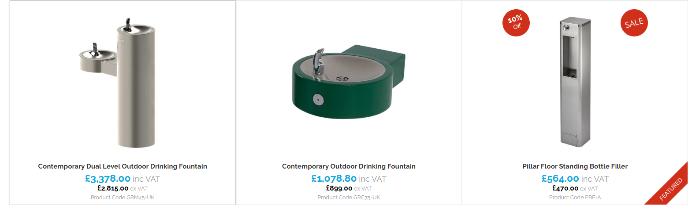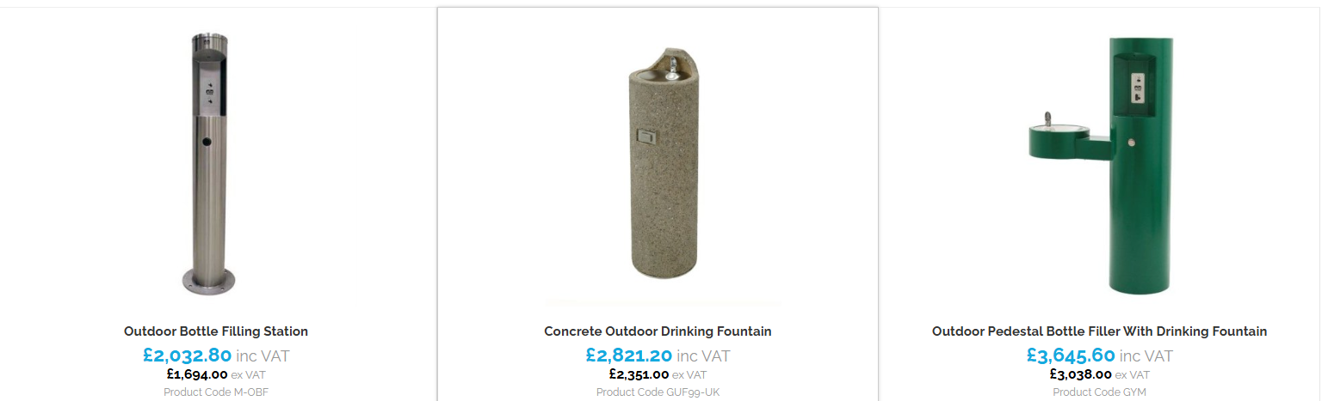

**Item 10 To review the locations and quantities of Christmas trees within the Parish**  
To **consider** the current provision of Christmas trees across the Parish and review potential adjustments to locations and quantities. The Committee is asked to agree on any changes required for the 2025 festive period to ensure fair coverage and suitability for local events and displays.

2024-25 locations:

Westward Ho! Park

Northam Hall

Northam Square

Bone Hill

Appledore (memorial/gig club)

Previous location:

Westward Ho! green

**Item 11 To consider the purchase and placement of a three-tier bin at Churchfields Play Park**  
To **consider** installing a new three-part litter bin at Churchfields Play Park to improve waste management and cleanliness in the area, the same as installed in various parks in 2024. Funding for the purchase and installation will be supported by contributions from Northam Town Council, Torridge District Council, and Devon County Council. Permission from Torridge District Council, as landowner, will be required prior to installation.

For example:

Triple Slim Recycling Bin (3 x 80ltr)

Dimensions: 1290mm Wide x 428mm Deep x 1015mm High

Material: 2mm Galv Steel

£700 (exVAT – estimated)