To all members of the Council:
You are hereby summoned to attend the PARKS and RECREATION COMMITTEE meeting on
Wednesday 17th September 2025 at 6:30pm
at The Town Hall, Windmill Lane, Northam for the transaction of the business listed on the agenda below.

Membership:
Cllrs Jeremy Bell, Barry Edwards, Peter Hames, Claire Hodson, Sam Newman-McKie, Niki Tait, Jane Whittaker Plus the Mayor, Cllr Louis Bach (ex-officio).

Questions by the public
There will be a period for questions by the public. In accordance with Standing Order 3, members of the public may make representations, ask questions and give evidence at a meeting which they are entitled to attend in respect of any Council business at Full Council, and at Committee meetings in respect of business on the agenda.
Anyone wishing to ask questions is requested to notify the Town Clerk prior to the meeting.

Recording, photographs and filming
In accordance with the Council’s policy on filming and recording of Local Council and Committee meetings (available to read in the Chamber) and arising from the Local Government and Accountability Act 2014 the press or public may audio-record, photograph or film meetings, or report from the meeting using social media. As such, members of the public may be recorded or photographed during the meeting. Anyone wishing to record or photograph the meeting must notify the Town Clerk before the commencement of the meeting.

Public attendance at Council and committee meetings
As a public body, Northam Town Council understands the need for transparency and accountability. The Council will therefore seek to conduct meetings using practices and procedures set out within the Public Bodies (Admission to Meetings) Act 1960, which states:
Subject to subsection (2)* below, any meeting of a body exercising public functions, being a body to which this Act applies, shall be open to the public.

Subsection (2) states:
Where a meeting is open to the public, a body may, by resolution exclude the public from the meeting (whether during the whole or part of the proceedings) whenever publicity would be prejudicial to the public interest by reason of the confidential nature of the business to be transacted or for other special reasons stated in the resolution and arising from the nature of that business or of the proceedings; and where such a resolution is passed, this Act shall not require the meeting to be open to the public
during proceedings to which the resolution applies.

Therefore, the Council’s policy is to allow public access to meetings unless the business being
transacted is confidential or there are ‘other special reasons’ to exclude the public.

Guy Langton
Guy Langton, Town Clerk & RFO
Date of issue: 11th September 2025

AGENDA

1 To receive and approve apologies for absence, in accordance with Local Government Act 1972 s85(1) All apologies must be notified to the Town Council offices by 5pm on the day of the meeting.

2 Chair’s announcements

3 To receive any dispensations and disclosable pecuniary or other interests Members are reminded that all interests must be declared prior to the item being discussed.

4 To agree the agenda as published.

5 To confirm as a correct record and sign the minutes of the Parks and Recreation Committee held on 16th July 2025 (p3-p8)

6 Public Participation
Members of the public are permitted to make representations, answer questions and give evidence in respect of any item of business included in the agenda. Each member of the public is entitled to speak once only in respect of business itemised on the agenda and shall not speak for more than 4 minutes. The period of time which is designated for public participation in accordance with standing orders shall not exceed 20 minutes.

7 To receive an update on actions (p9,10)

8 To receive a report from the chair of FOTWHOP (p11, verbal)

9 a) To note the popularity of, and positive feedback from the community regarding, the temporary pump track at Lords Meadow Park. (p11)

b) To resolve to instruct a pump track specialist to provide advice and costings for the potential installation of a permanent pump track, either at Lords Meadow Park or Burrough Farm.(p11)

10 To consider and approve the planting plan for Anchor Park, Lords Meadow and Westward Ho! (p11,12)

11 To note and acknowledge the completion of essential repair works at Appledore Skatepark. (p13)

12 Proposal for Resident-Inclusive Committee at Anchor Park (p13, verbal)

Page 073

Northam Town Council – Minutes of the Parks and Recreation committee meeting held 16th July 2025 at 6.30pm in the Town Hall, Windmill Lane, Northam.

Present: Cllrs Hames, Edwards, Tait, Newman-McKie, Whittaker, Hodson and Bell.

In attendance: Ian Rawle – Parks & Buildings Manager.
Christine Hutchins – Friends of Westward Ho! Park (FOTWHOP).

2507/185 To receive and approve apologies for absence, in accordance with Local Government Act 1972 s85(1)
Cllr Bach tendered his apologises, the reasons for which were accepted.

2507/186 Chair’s Announcements
The Chair made no announcements.
2507/187 To receive any dispensations and disclosable pecuniary or other interests
Members were reminded that all interests must be declared prior to the item being discussed.

2507/188 To agree the agenda as published
It was resolved to agree the agenda as published.
Proposed Cllr Hodson, Seconded Cllr Whittaker (all in favour)

2507/189 To confirm as a correct record and sign the minutes of the Parks and Recreation Committee held on 16th July 2025
It was resolved that to approve the minutes as a true and correct record, which were signed by the Chair.
Proposed Cllr Hodson, Seconded Cllr Bell (majority in favour, 2 abstentions – not present at the meeting).

2507/190 Public Participation
Members of the public are permitted to make representations, answer questions and give evidence in respect of any item of business included in the agenda. Each member of the public is entitled to speak once only in respect of business itemised on the agenda and shall not speak for more than 4 minutes. The period of time which is designated for public participation in accordance with standing orders shall not exceed 20 minutes.
There were no members of the public present other than Christine Hutchins (FOTWHOP) , who would be invited to contribute at the relevant time.

2507/191 To receive an update on actions
The Action table is presented overleaf.
Page 074

Action |  | January 2025 | March 2025 | May 2025
1 | Replacement of the ball fencing at Lords Meadow, a substantial sum has been included in the budget for work required at Lords Meadow for next year. | The damp weather has caused some issues. The contractor is being reminded the work needs completing.  ONGOING | The contractor will undertake the works in April 25. Date TBC  ONGOING | The contractor will undertake the works in April 25. Date TBC  ONGOING
2 | To consult the community on the use of outdoor gym. |  | INCOMPLETE | The committee has decided to remove the gym equipment due to safety concerns regarding its current condition  COMPLETE
3 | Churchfields Skate Park – paint and ‘graffiti’. | The Parks & Recreation Manager has been in discussion with a graffiti artist  ONGOING |  | This committee agreed it would remain as painted now until it is next refurbished.  COMPLETE
4 | Tennis Court gate – quality of work | The matter has been raised with the LTA directly and the Surveying Firm overseeing the work. The gate installer has advised the Surveyor that the replacement parts will be installed. No date for the work has yet been advised.  ONGOING |  | The work has been completed by the installer. The condition will continue to be monitored.  COMPLETE

Page 075

5 | Reinstall sign bee friendly planting at Anchor Park | The sign has not yet been reinstated. The Council is advised to wait until the new work is undertaken to establish wildflower swathes at the Park.  ONGOING |  | The work has been completed by the Maintenance Team.  COMPLETE
6 | Actions arising from Play Inspection Reports |  |  | On the agenda ONGOING
7 | Schedule Play Inspection Reports for 2025-26 |  |  | Scheduled for January/February 2026  COMPLETE
8 | The installation of CCTV at Westward Ho! Park within the Northam Town Councils grounds. | The Parks & Recreation Manager is currently looking into costings and suitable locations for the installation.  ONGOING | The Parks & Recreation Manager is currently looking into costings and suitable locations for the installation.  ONGOING | Awaiting quote from contractor. ONGOING
9 | The volunteer gardeners asked the Council to help recruit volunteers through its communication channels. Further discussion with the Town Clerk and Community Engagement Officer is needed. | Not started.  INCOMPLETE | Not started.  INCOMPLETE | Started. An email has been sent to Barbara asking whether the Council should design a poster or if there is an existing one we can use for social media promotion.

Page 076
2507/192 Lords Meadow signage
To Consider the installation of a sign at Lords Meadow prohibiting golf, following a recent incident where a resident's window was broken by someone playing golf in the area.

It was brought to the officers attention that a resident's window was recently smashed due to someone playing golf at Lords Meadow. This incident has raised concerns about the safety of nearby properties and the appropriate use of the area.
To consider allocating a budget of £100 to instal of "No Golf" signs at both ends of Lords Meadow to prevent further incidents and ensure the safety and comfort of local residents.

The committee was informed of a recent incident in which a resident’s window was broken due to someone playing golf at Lords Meadow. This raised concerns regarding the safety of nearby properties and the suitability of golfing activities in the park.
Members discussed the potential risks to residents and park users and agreed that action should be taken to discourage golfing in the area.
It was resolved to put out temporary "No Golfing" signs at all entrances to Lords Meadow Park.

Proposed: Cllr Tait, Seconded: Cllr Bell (all in favour) majority in favour, 1 abstention.

2507/193 Installation of Compliant Signage at Wrens Close and Westward Ho! Park
- Recent park inspections have identified the need for updated signage to meet safety and compliance standards. The January inspection at Westward Ho! Park reported the following:
Finding: BS EN 1176 Part 7 recommends that signage shall include emergency contact details and contact details of the owner/operator for reporting maintenance issues.
To consider allocating a budget of £400 to instal new signage at both Wrens Close and Westward Ho! Park that includes emergency contact details and the contact information of the owner/operator, in line with BS EN 1176 Part 7 recommendations. This will ensure compliance, improve safety, and provide clear channels for reporting maintenance issues.

Members considered the proposal to install compliant signage in line with these recommendations.
It was resolved to purchase and install new signage at both Wrens Close and Westward Ho! Park.
A budget of up to £400 will be allocated for this purpose.

Proposed: Cllr Tait, Seconded: Cllr Whittaker (majority in favour).
- To consider updating and replacing the existing park signage at Westward Ho! Park to improve visibility and clarity.
Cllr Edwards contacted the Council on Friday to raise concerns about the current signage in the centre of Westward Ho!, stating that it is not sufficiently clear. The existing sign was originally approved by Torridge District Council (TDC), the owner of the street furniture on which it is mounted.

To review the current signage and explore options for updating or replacing it with clearer, more visible signage, while ensuring compliance with TDC’s requirements for street furniture, with a budget of £400.

It was resolved to liaise with the volunteer gardeners and commission a new, clearer sign that can be installed in the park to include information about the sensory gardens and the Changing Places toilet. The signage will also be designed to allow Northam Town Council to include additional advertisements in the future.
Cllr Hodson confirmed that she is happy for additional signage to be placed on her external wall, where appropriate.
Page 077

It was also agreed to contact Devon County Council (DCC) to explore the possibility of installing signage along the perimeter wall near the Avon Road / Golf Links Road entrance to improve visibility and wayfinding.
Proposed: Cllr Newman-McKie, Seconded: Cllr Tait (majority in favour).

The Chair suspended Standing Orders to allow Christine Hutchins, representing the Friends of Westward Ho! Park (FOTWHOP), to give her report to the committee. (19:26)
Proposed: Cllr Hodson, Seconded: Cllr Whittaker (majority in favour).

Report from Christine Hutchins (Friends of Westward Ho! Park)
Christine informed the Committee that the park and gardens are looking very good, with increased support from new volunteers. She raised a concern that visitors to the area may not be aware of the park’s location, particularly those parking near the church who may not realise the park is nearby.
She advised that a grant application has been submitted to fund a replacement bench, as the existing bench has become unsafe and unusable. The new bench would be made from recycled materials, offering greater durability and reduced maintenance.
Christine also reported that efforts are ongoing to attract more members to the 200 Club.

Standing Orders were then resumed, and the meeting continued (19:29)
Proposed: Cllr Hodson, Seconded: Cllr Whittaker (majority in favour).

2507/194 Construction of Steps and improvement of ‘desire line’ surface at Blackies Footpath
Cllr Hames has initiated a proposal to construct steps at the bottom of the footpath at Blackies, improving access to the Community Land Trust housing and housing at The Mount and Western Avenue. He will approach Officers at NTC regarding the project. The steps would be constructed by NTC maintenance staff, with minimal costs limited to timber and potentially some chippings to make good the path where it crosses NTC land. The proposed steps aim to enhance safety and accessibility for residents using the footpath to reach Appledore and public transport. This supports the objectives of NTC’s Carbon Reduction Plan and Neighbourhood Plan by encouraging walking and public transport use, thereby contributing to a reduction in carbon emissions.

It was resolved to proceed with investigating the proposal, including:
- Costing the materials and labour required for the construction of the steps;
- Investigating the public liability and legal aspects of constructing steps and formalising the desire line;
- Confirming land ownership and any permissions that may be required.

Proposed: Cllr Hodson, Seconded: Cllr Whittaker (majority in favour).

2507/195 Update on MUGA Project and Section 106 Funding Application
The Parks and Buildings Manager provided an update on the MUGA project. Three contractors have been contacted and are in the process of submitting plans and costings, which are expected within the next couple of weeks. Once a contractor has been selected, an application for Section 106 funding will be submitted to support the project.

Page 078
2507/196 To consider requesting the Review Committee review the allotment tenancy agreement (Windmill Lane) in light of comments from allotment holders and local residents
It was resolved to request that the Review Committee undertake a review of the Windmill Lane Allotment Tenancy Agreement in light of recent comments and concerns raised by allotment holders and local residents regarding the level of cultivation on some plots.
Members of the allotment will be invited to attend the Review Committee meeting to contribute to the discussion.
Proposed: Cllr Edwards, Seconded: Cllr Hodson (majority in favour).

2507/197 To consider proposals for additional tree planting and the creation of a community orchard
It was resolved to investigate potential areas within the parish suitable for additional tree planting and the development of a community orchard. The Parks and Buildings Manager will investigate the site(s) within the parish. Findings will be reported back to Full Council for further consideration.
Proposed: Cllr Hodson, Seconded: Cllr Whittaker (majority in favour).

There being no further business the meeting closed at 19:54pm.

Signed………………………………………………..Dated……………………………………………….

Item 7

Action |  | January 2025 | March 2025 | May 2025 | September 2025
1 | Replacement of the ball fencing at Lords Meadow, a substantial sum has been included in the budget for work required at Lords Meadow for next year. | The damp weather has caused some issues. The contractor is being reminded the work needs completing.  ONGOING | The contractor will undertake the works in April 25. Date TBC  ONGOING | The contractor will undertake the works in April 25. Date TBC  ONGOING | Consider removing
2 | To consult the community on the use of outdoor gym. |  | INCOMPLETE | The committee has decided to remove the gym equipment due to safety concerns regarding its current condition  COMPLETE | Consider removing
3 | Churchfields Skate Park – paint and ‘graffiti’. | The Parks & Recreation Manager has been in discussion with a graffiti artist  ONGOING |  | This committee agreed it would remain as painted now until it is next refurbished.  COMPLETE | Consider removing
4 | Tennis Court gate – quality of work | The matter has been raised with the LTA directly and the Surveying Firm overseeing the work. The gate installer has advised the Surveyor that the replacement parts will be installed. No date for the work has yet been advised.  ONGOING |  | The work has been completed by the installer. The condition will continue to be monitored.  COMPLETE | Consider removing
5 | Reinstall sign bee friendly planting at Anchor Park | The sign has not yet been reinstated. The Council is advised to wait until the new work is undertaken to establish wildflower swathes at the Park.  ONGOING |  | The work has been completed by the Maintenance Team.  COMPLETE | Consider removing
6 | Actions arising from Play Inspection Reports |  |  | On the agenda ONGOING | Works to all Parks continue
7 | Schedule Play Inspection Reports for 2025-26 |  |  | Scheduled for January/February 2026  COMPLETE | Keep on agenda to roll through 26 - 27
8 | The installation of CCTV at Westward Ho! Park within the Northam Town Councils grounds. | The Parks & Recreation Manager is currently looking into costings and suitable locations for the installation.  ONGOING | The Parks & Recreation Manager is currently looking into costings and suitable locations for the installation.  ONGOING | Awaiting quote from contractor. ONGOING | Awaiting camera location conformation from M&E alarms
9 | The volunteer gardeners asked the Council to help recruit volunteers through its communication channels. Further discussion with the Town Clerk and Community Engagement Officer is needed. | Not started.  INCOMPLETE | Not started.  INCOMPLETE | Started. An email has been sent to Barbara asking whether the Council should design a poster or if there is an existing one we can use for social media promotion. | Facebook has been used to publish recruitment posters. It is suggested that these are reposted every six weeks to maintain visibility and engagement.

8 To receive a report from the chair of FOTWHOP (verbal)

9 a) To note the popularity of, and positive feedback from the community regarding, the temporary pump track at Lords Meadow Park.

b) To resolve to instruct a pump track specialist to provide advice and costings for the potential installation of a permanent pump track, either at Lords Meadow Park or Burrough Farm.

That Northam Town Council notes the popularity and positive community feedback regarding the temporary pump track at Lords Meadow Park, and instructs a pump track specialist to provide advice, designs, and costings for a potential permanent pump track at either Lords Meadow Park or Burrough Farm.

10 To consider and approve the planting plan for Anchor Park, Lords Meadow and Westward Ho! (p9)

As part of seasonal improvements to Anchor Park, Lords Meadow and Westward Ho! proposals have been made to introduce additional planting schemes. These include daffodils, wildflowers, and bluebells, which will enhance biodiversity, provide seasonal colour, and improve the visual appeal of both parks for the community and visitors.

To consider and approve the planting guide of daffodils, wildflowers, and bluebells at Anchor Park and Lords Meadow, to enhance biodiversity, support pollinators, and add seasonal colour and interest to the parks.

Anchor Park
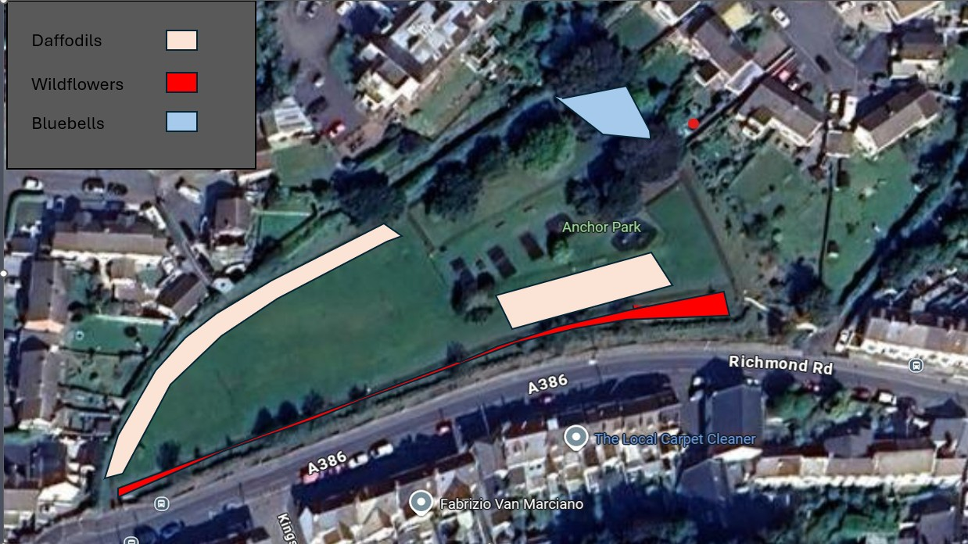

Lords Meadow

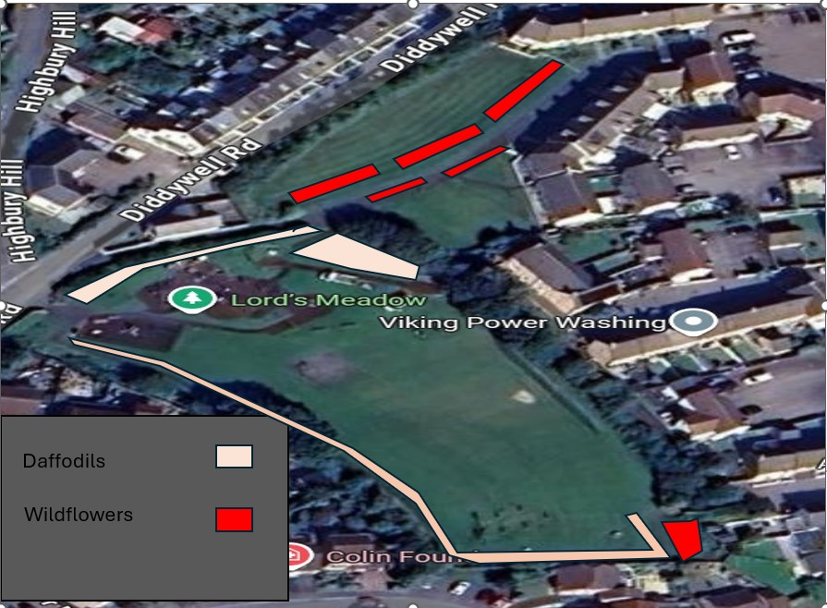

Westward Ho!

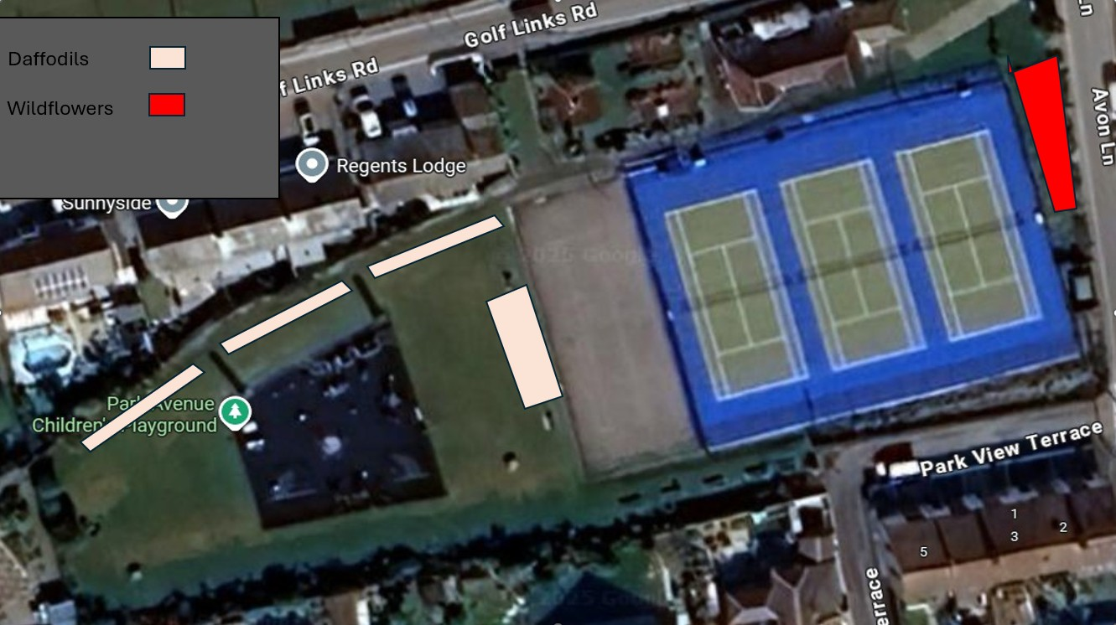

11 To note and acknowledge the completion of essential repair works at Appledore Skatepark.
The Maintenance Team recently carried out essential works at Appledore Skatepark. This included the repair and replacement of structural trusses/beams that support the facility. These works were necessary to ensure the continued safety and usability of the skatepark for the community.

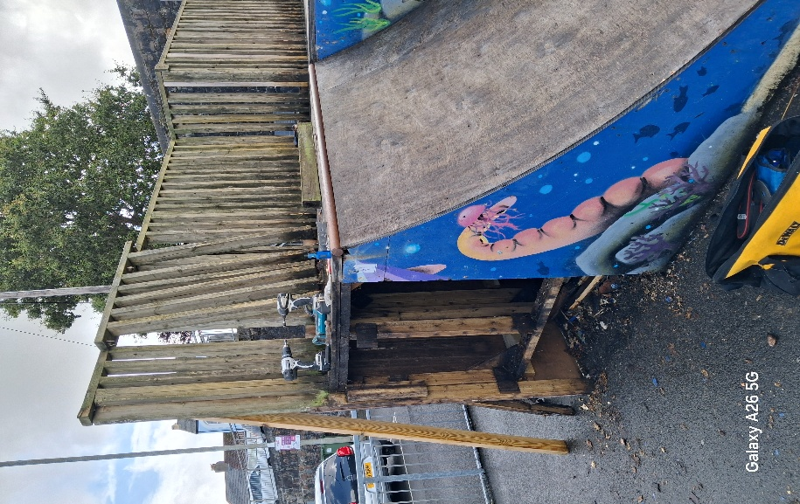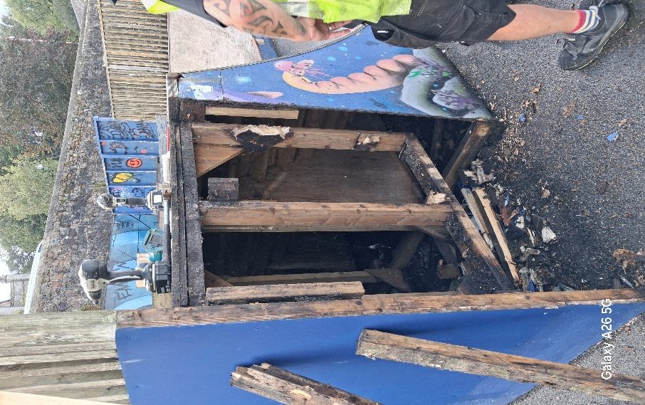

12 Proposal for Resident-Inclusive Committee at Anchor Park
To consider a letter proposing the creation of a resident-inclusive committee for Anchor Park. The committee would bring together councillors, the charity, and local residents, with the aim of strengthening collaboration, supporting biodiversity, and ensuring the park continues to serve the community across all generations.

To discuss and decide whether to establish or explore the formation of such a group, and to make recommendations to Full Council as appropriate.

