To all members of the Council:
You are hereby summoned to attend the PLANNING AND DEVELOPMENT MEETING on
THURSDAY 10th July 2025 2025 at 6.30pm
at The Town Hall, Windmill Lane, Northam for the transaction of the business listed on the agenda overleaf.

Membership:
Appledore Ward: Cllr Hames
Northam/Orchard Hill ward: Cllr Horrocks, Cllr Lo-Vel, Cllr Newman-McKie
Westward Ho! ward: Cllr Bach, Cllr Hodson. (two vacancies)

Questions by the public: There will be a period for questions by the public. In accordance with Standing Order 3, members of the public may make representations, ask questions and give evidence at a meeting which they are entitled to attend in respect of any Council business at Full Council, and at Committee meetings in respect of business on the agenda.
Anyone wishing to ask questions is requested to notify the Town Clerk by 12 noon on the day of the meeting.

Recording, photographs and filming: In accordance with the Council’s policy on filming and recording of Local Council and Committee meetings (available to read in the Chamber) and arising from the Local Government and Accountability Act 2014 the press or public may audio-record, photograph or film meetings, or report from the meeting using social media. As such, members of the public may be recorded or photographed during the meeting. Anyone wishing to record or photograph the meeting must notify the Town Clerk before the commencement of the meeting.

Public attendance at Council and committee meetings
As a public body, Northam Town Council understands the need for transparency and accountability. The Council will therefore seek to conduct meetings using practices and procedures set out within the Public Bodies (Admission to Meetings) Act 1960, which states:
Subject to subsection (2)* below, any meeting of a body exercising public functions, being a body to which this Act applies, shall be open to the public.

Subsection (2) states:
Where a meeting is open to the public, a body may, by resolution exclude the public from the meeting (whether during the whole or part of the proceedings) whenever publicity would be prejudicial to the public interest by reason of the confidential nature of the business to be transacted or for other special reasons stated in the resolution and arising from the nature of that business or of the proceedings; and where such a resolution is passed, this Act shall not require the meeting to be open to the public
during proceedings to which the resolution applies.

Therefore, the Council’s policy is to allow public access to meetings unless the business being
transacted is confidential or there are ‘other special reasons’ to exclude the public.

Guy Langton
Guy Langton, Town Clerk& RFO Date of issue: 4th July 2025

AGENDA
1 To receive and approve apologies for absence, in accordance with Local Government Act 1972 s85(1) All apologies must be notified to the Town Council offices prior to the meeting.

2 Chair’s announcements

3 To receive any dispensations and disclosable pecuniary or other interests
Members are reminded that all interests must be declared prior to the item being discussed.

4 To agree the agenda as published

5 To confirm as a correct record and sign the minutes of the Planning and Development Meeting held on 19th June 2025 (p4-9)

6 Public Participation
Members of the public are permitted to make representations, answer questions and give evidence in respect of any item of business included in the agenda. Each member of the public is entitled to speak once only in respect of business itemised on the agenda and shall not speak for more than 4 minutes. The period of time which is designated for public participation in accordance with standing orders shall not exceed 20 minutes.

7 To receive an update on the progress of the Northam Neighbourhood Plan (verbal)

8 To note the Tree Preservation Orders placed on specimen trees at Knapp House (TPO/004/2025) (attached)

9 Torridge District Council Planning Applications:
Torridge District Council, the determining Authority, has asked for comments from the Town Council on the following Parish planning applications:

i) 1/0511/2025/FUL
Proposal: Demolition of domestic garage and construction of
extensions to the side and rear of dwelling, plus internal
refurbishment works and landscaping (Variation of
condition 2 of planning approval 1/0961/2024/FUL)
Location: 3 Swanswood Gardens, Westward Ho!
Response date: 13th July 2025

ii) 1/0500/2025/FUL
Proposal: Erection of ground floor and first floor extensions, including
roof dormer and associated alterations
Location: 10 Highfield, Northam
Response date: 14th July 2025

iii) 1/0438/2025/FUL
Proposal: Single storey extension to front of dwelling with balcony
roof, replacement of existing garage with open carport &
associated landscaping
Location: 74 Atlantic Way, Westward Ho!
Response date: 14th July 2025

iv) 1/0543/2025/FUL
Proposal: Extension and alterations to include associated works
Location: Fordlands, Heywood Road, Northam,
Response date: 26th July 2025

10 Torridge District Council Planning Decisions
Torridge District Council, the determining Authority, has granted permission for the following applications with conditions as filed:

i) 1/0395/2025/FUL
Proposal: Erection of two storey side extension
Location: Oakridge, Limers Lane, Northam
(Northam Town Council recommended that the proposal be granted permission.)

11 Torridge District Council Planning Decisions
Torridge District Council, the determining Authority, has refused permission for the following applications with conditions as filed:

i) 1/0251/2025/OUTM
Proposal: Outline application with all matters reserved except for
access for up to 39no. dwellings
Location: Land At Grid Reference 245543 129173, Northam
(Northam Town Council recommends the proposal be refused permission)

ii) 1/0398/2025/REM
Proposal: Reserved matters application for Access, Appearance,
Landscaping, Layout and Scale for 1no. dwelling pursuant
to application 1/1293/2021/OUT
Location: Culloden House, Fosketh Hill, Westward Ho!
(Northam Town Council recommended that the proposal be granted permission)

iii) 1/0399/2025/FUL
Proposal: Erection of 1no. dwelling (Variation of Condition 1 of
planning approval (1/1249/2022/REM)
Location: Land At Grid Reference 243202 129005, Kingsley Road, Westward Ho!
(Northam Town Council recommended that the proposal be granted permission)


Page 039
Minutes of the Planning and Development Committee
19th June 2025 at 6.30pm in the Town Hall, Windmill Lane, Northam.

Present: Cllrs Bach (Mayor), Hames, Hodson, Horrocks and Lo-Vel and

In attendance: Guy Langton (Town Clerk & RFO)
N Arnold – member of the NNP working Group
1 member of the public

2506/116 To receive and approve apologies for absence, in accordance with Local Government Act 1972 s85 (1)
Cllr Newman-McKie tendered her apologies, the reasons for which were approved. There were two vacant seats.

2506/117 To agree the agenda as published
It was resolved to agree agenda as published were considered immediately after public participation.
Proposed Cllr Bach, Seconded Cllr Lo-Vel (all in favour)

2506/118 Chair’s announcements
The Chair had put down a resolution at Torridge District Council regarding the Government’s Infrastructure Bill and the effect on biodiversity and wildlife.

The Town Clerk announced that the District Council had placed tree protection orders on three trees at Knapp House, the details would be presented to the next meeting of this committee.

The Town Clerk read out a short news article from the SLCC regarding the withdrawal of MHCLG funding for neighbourhood plans as a result of the spending review, and that they could not be funding new neighbourhood planning support services from 2025 onwards, including Plan reviews, external examination fees and referenda.

2506/119 To receive any dispensations and disclosable pecuniary or other interests
Members were reminded that all interests must be declared prior to the item being discussed.

2506/120 To confirm as a correct record and sign the minutes of the Planning & Development Committee meeting held on 8th May 2025
It was resolved that to approve the minutes of that Planning & Development committee meeting as a true and correct record, they were signed by the Chair.
Proposed Cllr Bach, Seconded Cllr Horrocks (all in favour).

2506/121 Public Participation
It was agreed the member of the public present would address the committee when it considered the relevant planning proposal.

2506/122 To receive an update on the progress of the Northam Neighbourhood Plan and consider the establishment of a working group to review the feedback from the Planning Authority and Independent External Examiner
The final draft of the Northam Neighbourhood Plan had been submitted to the District Council, acknowledged on the 15th May 2025. The Town Clerk would seek an update from the District Council in advance of the next meeting of this committee.

The committee heard from Nick Arnold, who outlined the 4 stages the Neighbourhood Plan had before it:
Page 040
- Examination – to be arranged by Torridge District Council but may benefit from closer liaison by Northam Town Council.
- Prepare for the consultation exercise. Again, this is led by Torridge District Council but the Town Council could beneficially assist.
- Prepare for the responses from the external examination and feedback from the District Council (if any) and amend the Neighbourhood Plan as appropriate.
- Referendum – this would need a high turn-out to add weight to the Neighbourhood Plan if challenged by future development proposals.

It was resolved to continue with the NNP Working Group, made up of Cllr Hames, N Arnold and the Town Clerk, reporting work and progress to this committee, seeking approval as appropriate.
Proposed: Cllr Horrocks, Seconded: Cllr Lo-Vel (all in favour)

2506/123 To Note: Torridge District Council Planning Appeals
It was noted that Torridge District Council, the determining Authority, had notified the Council that the following appeals have been lodged with the Department of Communities and Local Government against the refusal of Planning Permission.
i)
Our Ref: | Our Ref: 1/0205/2022/OUTM
Appeal Reference: | Appeal Reference: APP/W1145/W/25/3359853
Appeal Start Date: | Appeal Start Date: 3rd March 2025
Date: | Date: 9th May 2025
Proposal: | Proposal: Outline application for No.36 dwellings, public open space
Location: | Land At Wooda Road Pitt Lane Appledore Devon

The Town Clerk reported that the District Council has published the public hearing date for this for this appeal as the 22nd July 2025. Any interested party could register to attend with the District Council by contacting Planning Support.
ii)
Our Ref: | 1/0174/2025/FUL
Appeal Reference: | APP/W1145/D/25/3365873
Appeal Start Date: | 19th May 2025
Date: | 19th May 2025
Proposal: | Removal of approved loft conversion application number 1/0373/2024/FUL and construction of a new first-floor extension over approved single storey side extension
Location: | The Mount, Lakenham Hill, Northam, Bideford

2506/124 Torridge District Council Planning Applications:
Torridge District Council, the determining Authority, has asked for comments from the Town Council on the following Parish planning applications:
- 1/0398/2025/REM
Proposal: Reserved matters application for Access, Appearance, Landscaping, Layout and Scale for 1 dwelling pursuant to application 1/1293/2021/OUT
Location: Culloden House, Fosketh Hill, Westward Ho!
It was resolved to recommend the proposal be granted permission.
Proposed: Cllr Bach; Seconded: Cllr Horrocks (all in favour)

Page 041
ii) 1/0399/2025/FUL
Proposal: Erection of 1no. dwelling (Variation of Condition 1 of planning approval (1/1249/2022/REM)
Location: Land At Grid Reference 243202 129005, Kingsley Road, Westward Ho!
It was resolved to recommend the proposal be granted permission.
Proposed: Cllr Bach; Seconded: Cllr Horrocks (all in favour)

iii) 1/0403/2025/FUL
Proposal: Erection of conservatory to side of property
Location: 32 Dudley Way, Westward Ho!
It was resolved to recommend the proposal be granted permission.
Proposed: Cllr Hodson; Seconded: Cllr Bach (all in favour)

iv) 1/0395/2025/FUL
Proposal: Erection of two storey side extension
Location: Oakridge, Limers Lane, Northam
It was resolved to suspend standing orders to hear from the member of the public.
Proposed: Cllr Hodson; Seconded: Cllr Bach (all in favour)

The committee was addressed by the applicant, who outlined the reasons for the proposal and explained the design principles used.

It was resolved to reinstate standing orders.
Proposed: Cllr Hodson; Seconded: Cllr Bach (all in favour)

It was resolved to recommend the proposal be granted permission.
Proposed: Cllr Bach; Seconded: Cllr Horrocks (all in favour)

v) 1/0422/2025/FUL
Proposal: Part retrospective change of use to a Microbrewery, Bar and Food Outlet (Hot Food) including Beer Garden
Location: 20 Fore Street, Northam
It was resolved to recommend the proposal be granted permission, subject to the concerns of the Environmental Protection Team being addressed to that team’s satisfaction.
Proposed: Cllr Horrocks; Seconded: Cllr Hodson (all in favour)

vi) 1/0373/2025/FUL
Proposal: Part retrospective application for the extension of an existing garage and conversion of the garage to ancillary accommodation
Location: 2 Richmond Park, Northam
It was resolved to recommend the proposal be granted permission.
Proposed: Cllr Bach; Seconded: Cllr Hodson (all in favour)

vii) 1/0439/2025/FUL
Proposal: Conversion of redundant agricultural building into a one-bedroom dwelling (Affecting a Public Right of Way)
Location: Barn At Grid Reference 245505 128192, Lower Cleave, Northam
Cllr Lo-Vel declared that she knew the applicant and would not take part in the discussion or vote.
It was resolved to recommend the proposal be granted permission.
Proposed: Cllr Horrocks; Seconded: Cllr Bach (majority in favour, 1 abstention)

Page 042
viii) 1/0467/2025/FUL
Proposal: Proposed front extension to accommodate single storey front porch and single storey extension to bedroom (Disabled Access)
Location: 6 Shoreland Way, Westward Ho!
It was resolved to recommend the proposal be granted permission.
Proposed: Cllr Bach; Seconded: Cllr Lo-Vel (all in favour)

2506/125 Torridge District Council Planning Decisions
It was noted that Torridge District Council, the determining Authority, had granted permission for the following applications with conditions as filed:

i) 1/1071/2024/FUL
Proposal: Alterations and extension to outbuilding to form ancillary accommodation
Location: Wellesbourne, Limers Lane, Northam
(Northam Town Council did not wish to make comment without the views of the conservation officer, which was submitted on the 25th April. The Town Council was not made aware of any re-consultation.)

ii) 1/0288/2025/FUH
Proposal: Alterations to roof dormers and associated works (amended description)
Location: 7 Hillcliff Terrace, Irsha Street, Appledore
(Northam Town Council recommended that this proposal be granted permission.)

iii) 1/0195/2025/FUL
Proposal: Conversion of loft into additional bedroom with en-suite and associated works.
Location: 6 Eastbourne Terrace, Westward Ho!
(Northam Town Council recommended that this proposal be granted permission.)

iv) 1/0057/2025/FUL
Proposal: Erection of double garage and widening of existing access in connection with an existing dwelling (Amended red edge and certificate)
Location: Lower Lodge, Golf Links Road, Westward Ho!
(Northam Town Council recommended that this proposal be refused permission.)

v) 1/0239/2025/FUL and 1/0240/2025/LBC
Proposal: Demolition of existing Interpretation Centre and erection of Heritage Boat House building and associated works (Resubmission of application 1/1230/2023/LBC)
Location: North Devon Maritime Museum, Odun House, Odun Road, Appledore
(Northam Town Council objected to the two related proposals, recommending that they be refused.)

vi) 1/0303/2025/FUL
Proposal: Extension to existing reception
Location: The Pier House, Merley Road, Westward Ho!
(Northam Town Council recommended that this proposal be granted permission.)

vii) 1/0190/2025/FUL
Proposal: Demolition of existing garage, erection of single storey rear extension and two storey side extension
Location: The Challenge, Limers Lane, Northam,
(Northam Town Council recommended that this proposal be refused permission.)

Page a

viii) 1/0279/2025/FUL
Proposal: Installation of air source heat pump
Location: 17 Graham Way, Westward Ho!
(Northam Town Council did not wish to comment).

ix) 1/0345/2025/FUL
Proposal: Erection of side extension, loft conversion with new dormers to the front and rear
Location: Oaklea, 1 Lea Terrace, Appledore
(Northam Town Council recommended that this proposal be granted permission).

There being no further business the meeting closed at 7:30pm.

Signed………………………………………………..Dated……………………………………………….

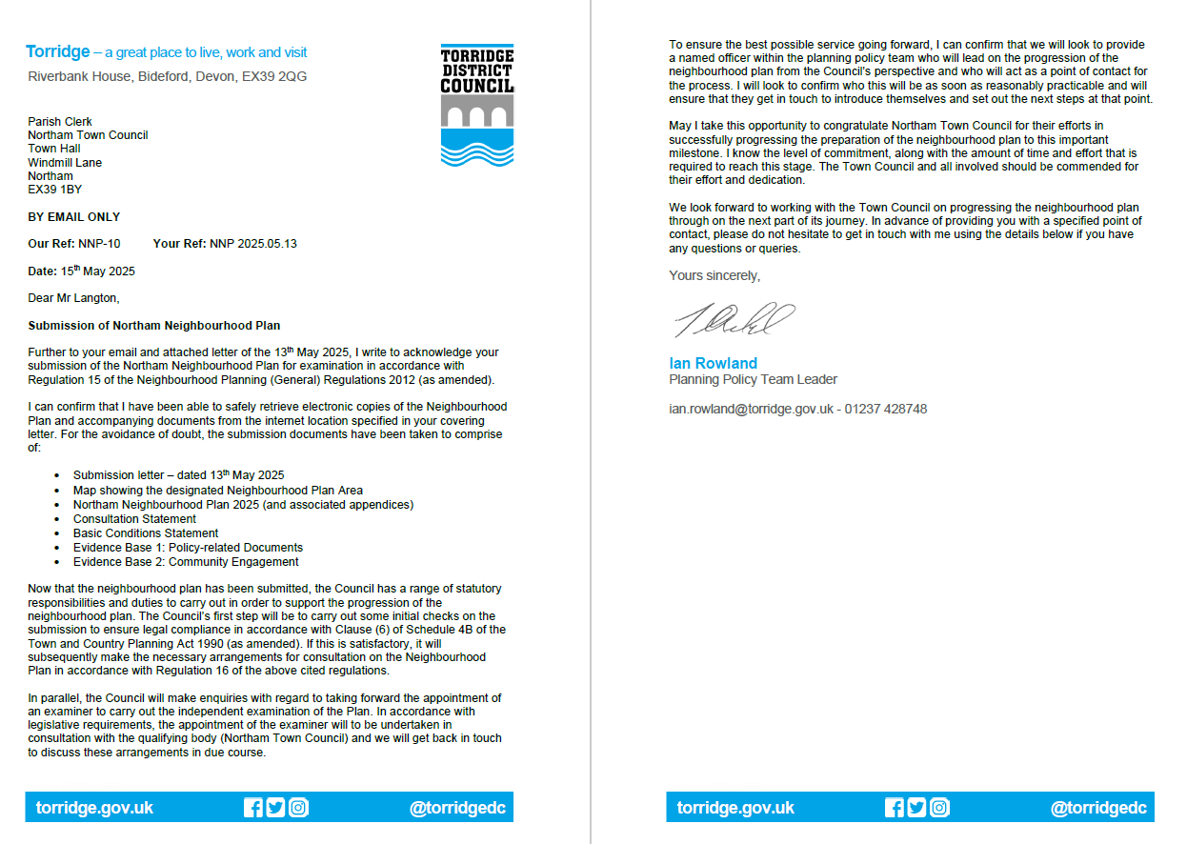
Item 7 To receive an update on the progress of the Northam Neighbourhood Plan and consider the establishment of a working group to review the feedback from the Planning Authority and Independent External Examiner

