To all members of the Committee:
You are hereby summoned to attend the ENVIRONMENT and MAINTENANCE COMMITTEE meeting on
Wednesday 18th February 2026 at 6:30pm
at The Town Hall, Windmill Lane, Northam for the transaction of the business listed on the agenda below.

Membership:
Cllrs Bell, Cllr Edwards, Cllr Hames, Cllr Sawyer, Cllr Lo-Vel, Tait and the Mayor, Cllr Bach (ex-officio). One vacancy.

Questions by the public: There will be a period for questions by the public. In accordance with Standing Order 3, members of the public may make representations, ask questions and give evidence at a meeting which they are entitled to attend in respect of any Council business at Full Council, and at Committee meetings in respect of business on the agenda.

Members of the public are asked to respect the fact that this is a meeting to conduct council business and interruptions during council business are not permitted. If, in the opinion of the Chairman, the business of the meeting is disrupted in any way, the Chairman may ask the person/s causing the disruption to be quiet and if they refuse then ask them to leave. Mobile phones must be switched off or silenced during the meeting.

Anyone wishing to ask questions is requested to notify the Town Clerk by 12 noon on the day of the meeting.

Recording, photographs and filming: In accordance with the Council’s policy on filming and recording of Local Council and Committee meetings (available to read in the Chamber) and arising from the Local Government and Accountability Act 2014 the press or public may audio-record, photograph or film meetings, or report from the meeting using social media. As such, members of the public may be recorded or photographed during the meeting. Anyone wishing to record or photograph the meeting must notify the Town Clerk before the commencement of the meeting.

Public attendance at Council and committee meetings
As a public body, Northam Town Council understands the need for transparency and accountability. The Council will therefore seek to conduct meetings using practices and procedures set out within the Public Bodies (Admission to Meetings) Act 1960, which states:
Subject to subsection (2)* below, any meeting of a body exercising public functions, being a body to which this Act applies, shall be open to the public.

Subsection (2) states:
Where a meeting is open to the public, a body may, by resolution exclude the public from the meeting (whether during the whole or part of the proceedings) whenever publicity would be prejudicial to the public interest by reason of the confidential nature of the business to be transacted or for other special reasons stated in the resolution and arising from the nature of that business or of the proceedings; and where such a resolution is passed, this Act shall not require the meeting to be open to the public during proceedings to which the resolution applies.

Therefore, the Council’s policy is to allow public access to meetings unless the business being
transacted is confidential or there are ‘other special reasons’ to exclude the public.

Guy Langton
Guy Langton, Town Clerk& RFO Date of issue: 10th February 2026

Members are requested to turn off or silence their mobile phones for the duration of the meeting.

AGENDA

1 To receive and approve apologies for absence, in accordance with Local Government Act 1972 s85(1) All apologies must be notified to the Town Council offices by 5pm on the day of the meeting.

2 Chair’s announcements

3 To receive any dispensations and disclosable pecuniary or other interests Members are reminded that all interests must be declared prior to the item being discussed.

4 To agree the agenda as published.

5 To confirm as a correct record and sign the minutes of the ENVIRONMENT and MAINTENANCE COMMITTEE held on 15th October 2025 (p3-p10)

6 Public Participation
Members of the public are permitted to make representations, answer questions and give evidence in respect of any item of business included in the agenda. Each member of the public is entitled to speak once only in respect of business itemised on the agenda and shall not speak for more than 4 minutes. The period of time which is designated for public participation in accordance with standing orders shall not exceed 20 minutes.

7 To receive an update on actions (p11)

8 To consider and approve the funding request for P3 footpaths around the Parish. (p12)

9 To consider the recommendation of the Working Group for Mobile Vehicle Speed Indicator Devices (MVSIDs) (p12)

10 Life on the Verge – Revised Works Programme (p12,13)

11 Environmental Licence – Upper Tier Waste Carrier Licence (p13)

Page 148

Northam Town Council – Minutes of the Environment and Maintenance committee meeting held Wednesday 15th October 2025 at 6:30pm in the Town Hall, Windmill Lane, Northam.

Present: Cllrs Bell, Edwards, Hames, Lo-Vel, Cllr Sawyer, Cllr Tait and the Mayor, Cllr Bach (ex-officio). One vacancy.

In attendance: Ian Rawle – Parks & Buildings Manager.

2510/373 To receive and approve apologies for absence, in accordance with Local Government Act 1972 s85(1)
All members were present.

2510/374 Chair’s Announcements
The Chair had no announcements.

2510/375 To receive any dispensations and disclosable pecuniary or other interests
Members were reminded that all interests must be declared prior to the item being discussed.

2510/376 To agree the agenda as published
It was resolved to agree the agenda as published.
Proposed: Cllr Hames, Seconded: Cllr Bach (all in favour).

2510/377 To confirm as a correct record and sign the minutes of the Environment and Maintenance Committee held on 30th of July 2025.
It was resolved to approve the minutes of that Environment and Maintenance committee meeting as a true and correct record, they were signed by the Chair.
Proposed: Cllr Hames, Seconded Cllr Bach (all in favour).

2510/378 Public Participation
Members of the public are permitted to make representations, answer questions and give evidence in respect of any item of business included in the agenda. Each member of the public is entitled to speak once only in respect of business itemised on the agenda and shall not speak for more than 4 minutes. The period of time which is designated for public participation in accordance with standing orders shall not exceed 20 minutes.
There were no members of the public present.

2510/379 To receive an update on action points
The action points were considered and noted as presented. In addition, the following updates were provided:
Page 149
Action |  | June 2025 | July 2025 | Oct 2025
1 | Schools to be contacted to design their own ‘don’t idle’ signs for the Council to have made and installed. | Seeking a discussion with the interested school. ONGOING | ONGOING | Schools re-contacted, ONGOING
2 | Prepare a report on the purchase and installation of MVSIDs for the Parish | Work on the report has started and is currently in progress. ONGOING | ONGOING | Awaiting location sign off from DCC
3 | Traffic issues at the Square, Northam | Costs of traffic surveys not yet researched.Cost of air quality surveys not yet researched.NOT STARTED | NOT STARTED | Traffic survey cost received,  Discussion required in refence to air quality survey
4 | Locations of Council provided Christmas trees in 2025 – liaise with the Westward Ho! Business association over the sites in Westward Ho! | Agreed at the previous meeting, to advertise closer to December 2025. COMPLETE | No Change | Started, ongoing
5 | Schedule the works for Life on the Verge | The design is being redrafted in line with the requirements of the Neighbourhood Highways Officer. ONGOING | Not supported by Highways officer. Revisit Plans. | Fresh plans will be put to council in December
6 | Liaise with Torridge District Council to determine the reasons for the insufficient number of bins, and offer support in providing additional bins and assisting with their emptying. | NTC Officers liaised with TDC and agreed that NTC Maintenance team will support TDC during high footfall seasons by assisting with bin emptying and helping to keep the general area clean and tidy. COMPLETE | Complete | Remove from actions
7 | NTC Officers to submit the P3 request for the upgrading of footpaths 35 and 36. | The P3 funding request has been submitted and is currently awaiting approval. ONGOING | No Change. | Email sent to chase funding
8 | Officers to liaise with Devon County Council to request the upgrading of the stiles on Footpaths 4 and 6 to kissing gates. | Liaison with Devon County Council has taken place, and the works have been scheduled for November. ONGOING | Awaiting response from DCC | Email sent to chase funding
9 | Investigate power issues to 3 lighting columns at WWH! |  | Added 30th July 25 | Investigation complete, works ongoing
10 | Install Dog fouling signs at both entrances in WWH! Park. |  | Added 30th July 25 | Complete
11 | Parks & Building Manager to investigate Festoon lighting and Xmas tree lights |  | Added 30th July 25 | On agenda

Page 150
2510/380 Christmas Motif Allocation
To agree on the allocation of the 12 available Christmas motifs between Westward Ho! and Appledore, based on the number of suitable posts at each location.
A total of 12 Christmas motifs are available for installation this year, at a cost of £138 each (3 for 2 offer applied, total £1,104). There is a budget of £2,000 allocated, with no spending yet.
To ensure a fair and proportional distribution, the number of posts at each site has been considered:
- Westward Ho! – 5 posts
- Appledore – 15 posts
- Total: 20 posts

Proposal:
Allocate motifs proportionally as follows:
Westward Ho!: 3 motifs
Appledore: 9 motifs

This approach provides an even balance relative to the number of posts at each site while ensuring both areas are suitably decorated for the festive period.
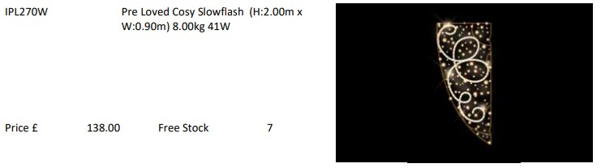
To agree the proposed allocation of Christmas motifs and approve expenditure of £1,104 for the purchase (based on the 3-for-2 offer).

It was Resolved To purchase 12 Christmas motifs at £138 each under the supplier’s 3-for-2 offer (total £1,104), funded from the current Christmas budget (£2,000 allocation; no prior spend).
Allocation (proportional to suitable posts — Westward Ho! 5; Appledore 15):
- Westward Ho! — 3 motifs
- Appledore — 9 motifs
The newly purchased motifs will not replace existing motifs; they will be retained as spares.
Proposed: Cllr Tait, Seconded Cllr Bach (All in favour)

Page 151

2510/381 Purchase of Christmas Trees for 2025 Festive Period
Members are asked to consider and agree the purchase of five Christmas trees for the 2025 festive period, to be placed at the following locations:
- Northam Square
- Bone Hill
- Westward Ho! Green
- Appledore (Memorial/Gig Club)
- Appledore Seafront (12ft Nordmann)
- Previously, there has also been a tree at Northam Hall
The trees will consist of:
- 18ft–20ft Nordmann Firs @ £220 each
- 12ft Nordmann Fir @ £130
Proposed delivery date: 27th November 2025
Total cost: £1,010 to £1,230 (additional tree for Northam Hall. delivered). There is a budget of £1,000 allocated, with no spending yet. The cost over the budget could be vired from the Christmas Decorations cost code, they are in the same cost centre.
It was Resolved: To purchase seven Christmas trees for the 2025 festive period, to be placed at the following locations:

- Northam Square
- Bone Hill
- Westward Ho! Green
- Appledore (Memorial/Gig Club)
- Appledore Seafront (12ft Nordmann)
- Northam Hall
- Westward Ho! Park
The trees will consist of 18ft–20ft Nordmann Firs at £220 each and one 12ft Nordmann Fir at £130, with delivery on 27th November 2025.
Total spend: £1,450.
Funding to be taken from the 2025 Christmas budget (£1,000) with the remaining £450 to be vired from the Christmas Decorations cost code within the same cost centre.

Proposed: Cllr Edwards, Seconded Cllr Bach (Majority in favour) 1 agains
Page 152

2510/382 Construction of Wood chipping and Green Waste Bay

To consider and agree the installation of a wood chipping and green waste bay measuring approximately 10ft x 10ft at the location marked on the attached plan.

The bay will provide a tidy, designated space for green waste, making it easier to store and manage materials safely. It will also support recycling by keeping woodchip and other biodegradable waste organised and ready for use. The structure will be built from timber post and re-used scaffold board, ensuring it remains stable and low maintenance for years to come.
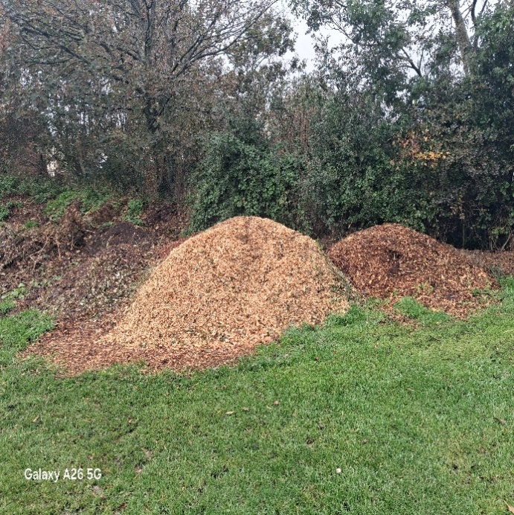
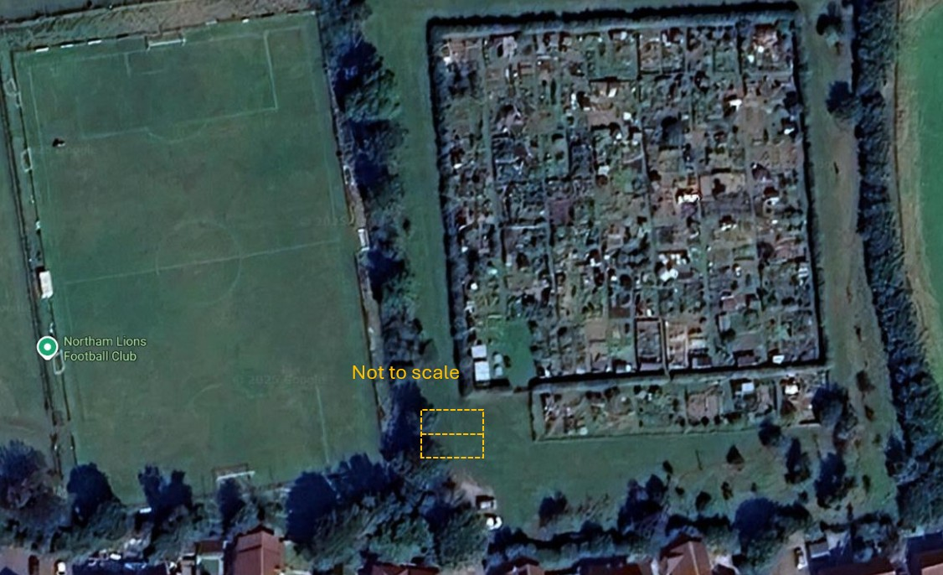

It was Resolved to approve the installation of a wood chipping and green waste bay measuring approximately 10ft x 10ft at the agreed location shown on the attached plan.
The bay will provide a designated and tidy area for the safe storage and management of green waste and woodchip, supporting recycling and site organisation. The structure will be built using timber posts and re-used scaffold boards, ensuring long-term durability and low maintenance.
It was further agreed to approach the Burrough Farm Allotment holders to ask if they would be willing to manage the composting area and to design the compost bay using the New Zealand three-bay composting system, which features a large, timber-built structure with removable front slats for easy access and turning of material.
Proposed: Cllr Hames, Seconded Cllr Bach (all in favour)

Page 153
2510/383 Replacement fingerpost at Westbourne Terrace, Westward Ho! (p9)
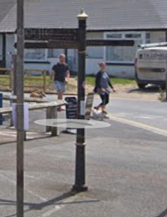
The current finger post is installed on highway land (though out of courtesy, the landowner of the adjunct parcel should be advised of any planned replacement). It is in a poor state of repair, having been eroded by the local climate over many years.
The fingers on the post are not rusted through and but are not suitable for refurbishment, pointing to local attractions that no longer exist. The fingers read:
- Tennis Court and Toilet – the public toilet is no longer there
- Car Park and Beach – signs to a private car park
- Putting – no longer there
- Country Park – needs renaming
- Golf Club – advertising a location that most will drive to anyway
The officers suggest that the fingers would more appropriately read:
- Playpark & Tennis
- Changing Places Toilet (with logo)
- Beach & Promenade
- Village Centre & Shops
- Burrows Centre & Café
The officer has sought costs from the supplier of the other post (at the corner of the promenade, close to the Hockings van) and of other designs of post from the same supplier. Quotations have been sought from two other suppers of the ‘traditional’ style post.
Traditional-style fingerpost  Arm 1: Play Park & Tennis Courts  Arm 2: Changing Places & Toilets with logo  Arm 3: Village Centre & Shops  Arm 4: Burrows Centre & Cafe  Arm 5: Beach & Promenade  Colour – Sapphire Blue (RAL5003)  Finial with logo (NTC crest and “Westward Ho!”)  £5,069 (exVAT) | 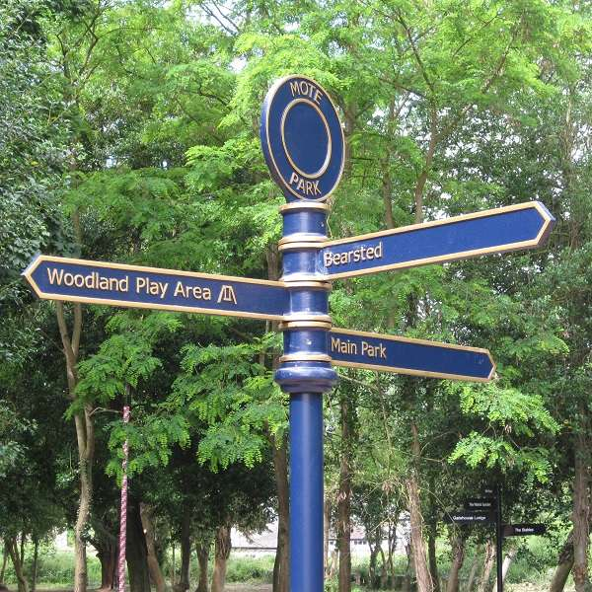
‘Grenadier’ fingerpost
Stainless steel arms:
Arm 1: Play Park & Tennis Courts
Arm 2: Changing Places & Toilets and Logo
Arm 3: Village Centre & Shops
Arm 4: Burrows Centre & Cafe
Arm 5: Beach & Promenade
£2,774 (exVAT)
Contemporary fingerpost

Arm 1: Play Park & Tennis Courts
Arm 2: Changing Places & Toilets and Logo
Arm 3: Village Centre & Shops
Arm 4: Burrows Centre & Cafe
Arm 5: Beach & Promenade

Colour – Sapphire Blue (RAL5003)
Finial with logo (NTC crest and “Westward Ho!”)

£2,569 (exVAT)
Rustic fingerpost
Arm 1: Play Park & Tennis Courts
Arm 2: Changing Places & Toilets and Logo
Arm 3: Village Centre & Shops
Arm 4: Burrows Centre & Cafe
Arm 5: Beach & Promenade

£2,324 (exVAT)
Page 154
The County Councillor has indicated that he would fund some or all of the replacement Installing the other post cost £645 in early 2024, plus a licence fee, which could be waived because the post is a replacement of a current piece of street furniture.
The new post would need to be included in the Council’s asset register so it is insured.
The Officer recommends that the fingerpost is replaced with a ‘Contemporary fingerpost’, as described below, seeking funding for the cost of the post from the County Councillor but meeting the cost of installation from the general project budget.

Page 155
Contemporary fingerpost

Arm 1: Play Park & Tennis Courts

Arm 2: Changing Places & Toilets and Logo
Arm 3: Village Centre & Shops
Arm 4: Burrows Centre & Cafe
Arm 5: Beach & Promenade

Colour – Sapphire Blue (RAL5003)
Finial with logo (NTC crest and “Westward Ho!”)

£2,569 (exVAT)

It was resolved and agreed to purchase the Contemporary Fingerpost for installation at Westward Ho!, as detailed in the officer’s report.
The existing signpost is in poor condition and no longer relevant, with several fingers directing to locations that no longer exist. The new fingerpost will be a Sapphire Blue (RAL5003) Contemporary design, featuring a finial with the NTC crest and “Westward Ho!” lettering, and will include the following directions:
• Play Park & Tennis Courts
• Changing Places & Toilets (with logo)
• Village Centre & Shops
• Burrows Centre & Café
• Beach & Promenade
Cost: £2,569 (excl. VAT) – with funding to be sought from the County Councillor for the post itself, and installation costs met from the general project budget.
It was further agreed to involve at least one Westward Ho! Councillor to assist in finalising the exact wording and layout of the fingerpost arms.
Proposed: Cllr Bach, Seconded Hames (all in favour)

There being no further business the meeting closed at 7:15pm.

Signed………………………………………………..Dated…………………………………………….

Item 7 – Action Point

Action |  | June 2025 | July 2025 | October 2025 | February 2026
1 | Schools to be contacted to design their own ‘don’t idle’ signs for the Council to have made and installed. | Seeking a discussion with the interested school. ONGOING | ONGOING | Schools re-contacted, ONGOING | No response. Decision required to remove or pursue.  ONGOING
2 | Prepare a report on the purchase and installation of MVSIDs for the Parish | Work on the report has started and is currently in progress. ONGOING | ONGOING | Awaiting location sign off from DCC | On Agenda. ONGOING.
3 | Traffic issues at the Square, Northam | Costs of traffic surveys not yet researched.  Cost of air quality surveys not yet researched.  NOT STARTED | NOT STARTED | Traffic survey cost received,  Discussion required in refence to air quality survey | Seeking updated quotes. ONGOING.
4 | Schedule the works for Life on the Verge | The design is being redrafted in line with the requirements of the Neighbourhood Highways Officer. ONGOING | Not supported by Highways officer. Revisit Plans. | Fresh plans will be put to council in December | On Agenda. ONGOING.
6 | NTC Officers to submit the P3 request for the upgrading of footpaths 35 and 36. | The P3 funding request has been submitted and is currently awaiting approval. ONGOING | No Change. | Email sent to chase funding | On Agenda. ONGOING.
6 | Officers to liaise with Devon County Council to request the upgrading of the stiles on Footpaths 4 and 6 to kissing gates. | Liaison with Devon County Council has taken place, and the works have been scheduled for November. ONGOING | Awaiting response from DCC | Email sent to chase funding | On Agenda. 6 Complete.
7 | Investigate power issues to 3 lighting columns at WWH! |  | Added 30th July 25 | Investigation complete, works ongoing. On Agenda. | See report.
8 | Finger post – Westbourne Terrace |  |  |  | Post ordered (to be delivered 11.2.26), S171 licence obtained, contractor instructed to install by 31.3.26.  Costs of the fingerpost and installation obtained from councillor grants (DCC and TDC). COMPLETE

Item 8
To consider a request for funding to carry out maintenance works to P3 footpaths across the Parish, including associated labour costs and surface repairs where required, and to approve the necessary expenditure.

Item 9
To confirm the recommendation of the working Group regarding the purchase of two Mobile Vehicle Speed Indicator Devices (MVSIDs) for use within the Parish. The Task and Finish Group considered proposals from three suppliers: Pandora Technologies Ltd, Elan City, and Swarco, and recommend that the committee source two MVSIDs from Elan City at a total cost of £6,215.98 (cost code 76 MVSIDs, £10,000 budget).

Item 10
To consider and approve the amended Life on the Verge project plans, noting the removal of works at Churchill Way due to practical constraints relating to tree and wildflower planting, and to agree that the programme of works will commence in March when ground conditions are more suitable.
1. Churchill way. The verge opposite Bloody Corner.  NTC Plan for ongoing management and maintenance:  Large central Wildflower bed. Grass maintained in accordance with DCC grass cutting contract.  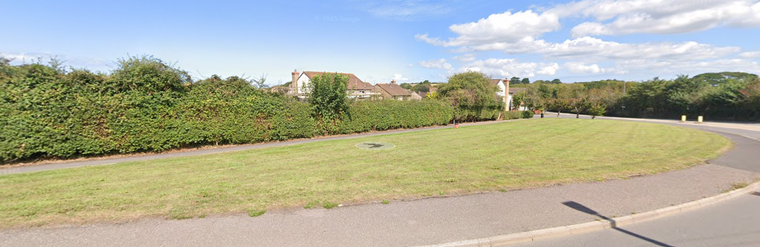 | 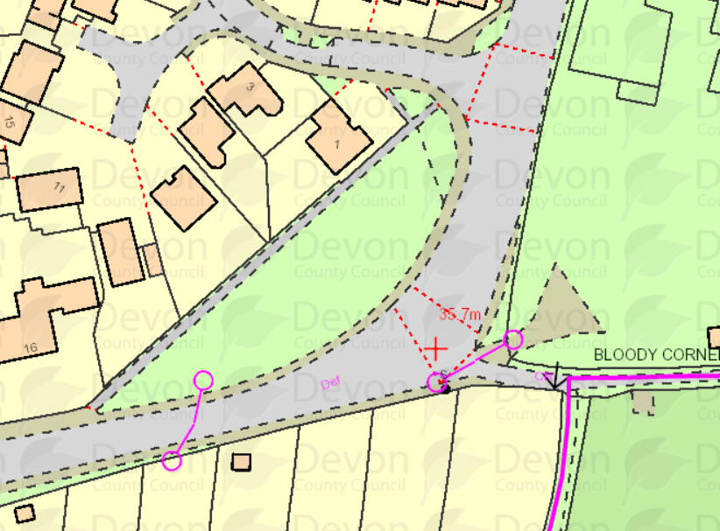
2. Highfield. The area of land next to the sub-station.  NTC Plan for ongoing management and maintenance:  The area bordered by the wall, sub-station and blue diagram would be prepared and planted with wild flowers and yellow rattle. The tree that can be seen to the left is no longer on the site. Note: Residents would need to be consulted  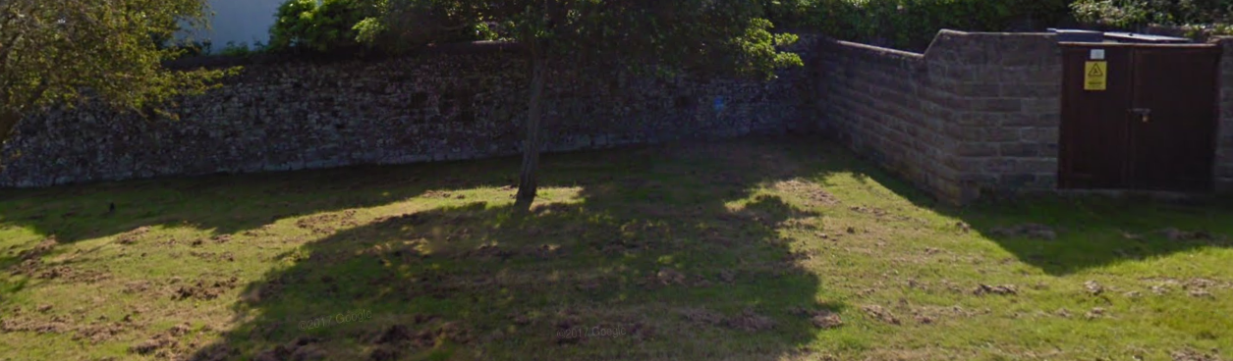 |  | 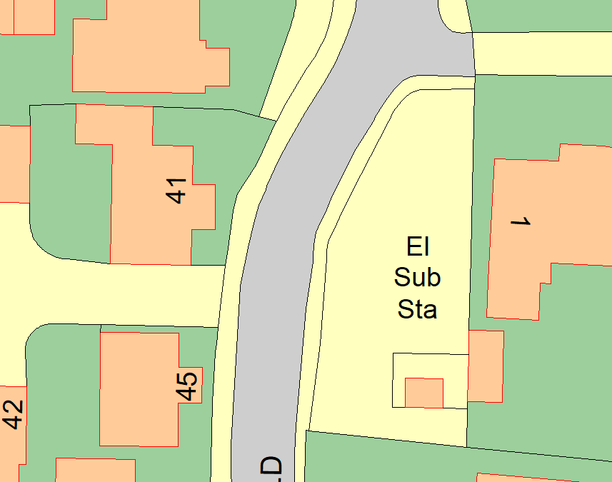
3. Churchfield.  NTC Plan for ongoing management and maintenance:  The bank facing the estuary would be planted with wildflowers, in approximately the area shown opposite.  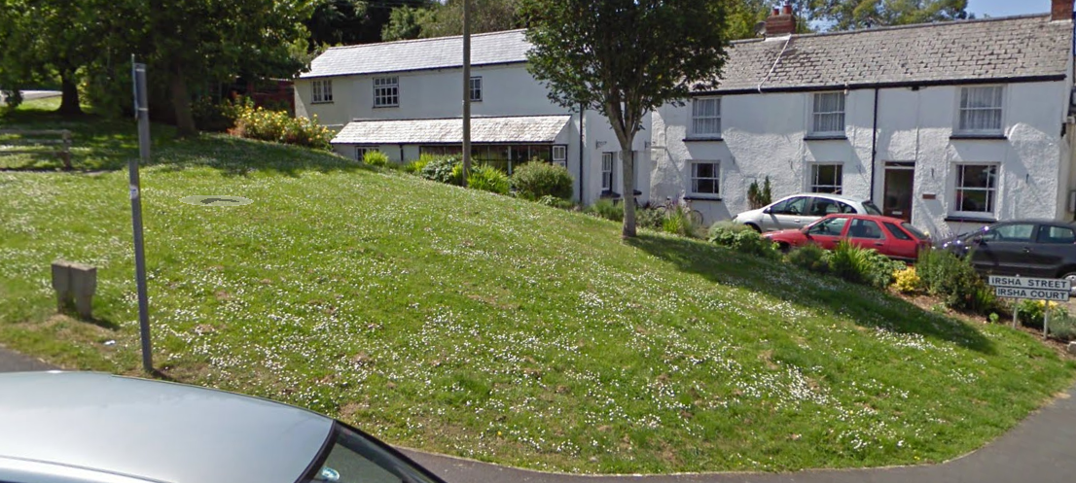 |  | 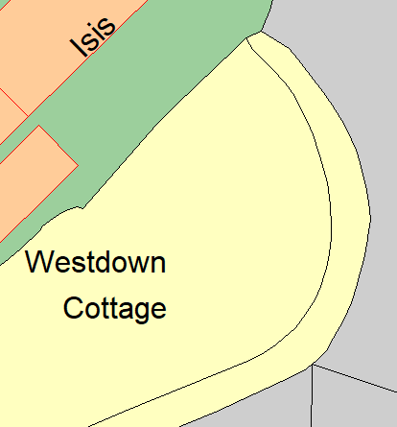
4. Lundy View. The triangle of land with a medium hawthorn, laid to grass (outside number 26).  NTC Plan for ongoing management and maintenance:  This area would be managed for wildflowers, starting with a 2m circle around the tree. Yellow Rattle plugs could be sown to erode the grass cover in advance of planting/sowing a wider range of species.  A 1m+ cut grass edge would be maintained.  Note: Residents would need to be consulted.  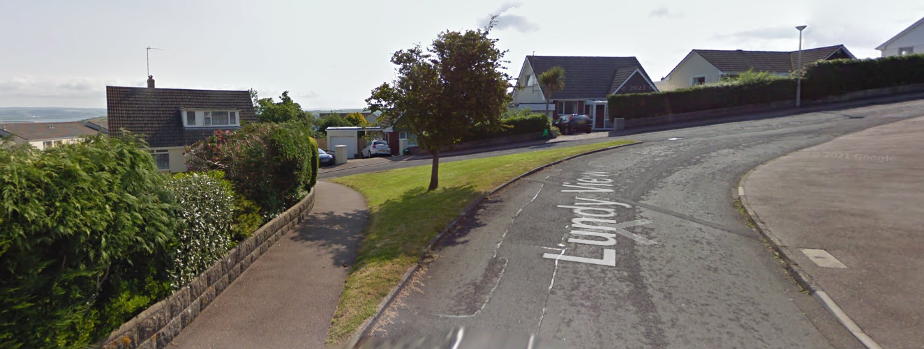 |  | 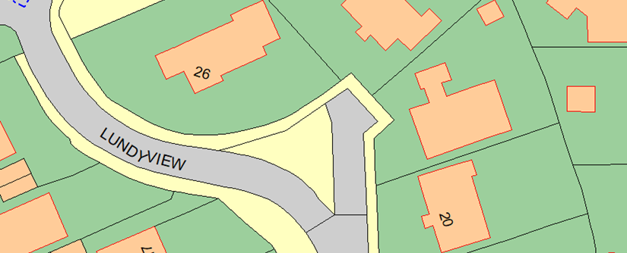

Item 11
To consider the requirement for an Upper Tier Waste Carrier Licence, which is a legal and compliance obligation when transporting other people’s waste or the Council’s own building, construction, and demolition waste. The licence permits the transport of all types of waste and is valid for a three-year period at a cost of £304 plus VAT, to be taken from an appropriate cost code in the Environment & Maintenance Budget (75 Litter/Recycling & Dog Waste Bins).
It is recommended that the Council obtain this licence to ensure continued legal compliance.

