To all members of the Council:
You are hereby summoned to attend the PLANNING AND DEVELOPMENT MEETING on
THURSDAY 19th June 2025 2025 at 6.30pm
at The Town Hall, Windmill Lane, Northam for the transaction of the business listed on the agenda overleaf.

Membership:
Appledore Ward: Cllr Hames
Northam/Orchard Hill ward: Cllr Horrocks, Cllr Lo-Vel, Cllr Newman-McKie
Westward Ho! ward: Cllr Bach, Cllr Hodson. (two vacancies)

Questions by the public: There will be a period for questions by the public. In accordance with Standing Order 3, members of the public may make representations, ask questions and give evidence at a meeting which they are entitled to attend in respect of any Council business at Full Council, and at Committee meetings in respect of business on the agenda.
Anyone wishing to ask questions is requested to notify the Town Clerk by 12 noon on the day of the meeting.

Recording, photographs and filming: In accordance with the Council’s policy on filming and recording of Local Council and Committee meetings (available to read in the Chamber) and arising from the Local Government and Accountability Act 2014 the press or public may audio-record, photograph or film meetings, or report from the meeting using social media. As such, members of the public may be recorded or photographed during the meeting. Anyone wishing to record or photograph the meeting must notify the Town Clerk before the commencement of the meeting.

Public attendance at Council and committee meetings
As a public body, Northam Town Council understands the need for transparency and accountability. The Council will therefore seek to conduct meetings using practices and procedures set out within the Public Bodies (Admission to Meetings) Act 1960, which states:
Subject to subsection (2)* below, any meeting of a body exercising public functions, being a body to which this Act applies, shall be open to the public.

Subsection (2) states:
Where a meeting is open to the public, a body may, by resolution exclude the public from the meeting (whether during the whole or part of the proceedings) whenever publicity would be prejudicial to the public interest by reason of the confidential nature of the business to be transacted or for other special reasons stated in the resolution and arising from the nature of that business or of the proceedings; and where such a resolution is passed, this Act shall not require the meeting to be open to the public
during proceedings to which the resolution applies.

Therefore, the Council’s policy is to allow public access to meetings unless the business being
transacted is confidential or there are ‘other special reasons’ to exclude the public.

Guy Langton
Guy Langton, Town Clerk& RFO Date of issue: 13th June 2025

AGENDA
1 To receive and approve apologies for absence, in accordance with Local Government Act 1972 s85(1) All apologies must be notified to the Town Council offices prior to the meeting.

2 Chair’s announcements

3 To receive any dispensations and disclosable pecuniary or other interests
Members are reminded that all interests must be declared prior to the item being discussed.

4 To agree the agenda as published

5 To confirm as a correct record and sign the minutes of the Planning and Development Meeting held on 8th May 2025 (p4-8)

6 Public Participation
Members of the public are permitted to make representations, answer questions and give evidence in respect of any item of business included in the agenda. Each member of the public is entitled to speak once only in respect of business itemised on the agenda and shall not speak for more than 4 minutes. The period of time which is designated for public participation in accordance with standing orders shall not exceed 20 minutes.

7 To receive an update on the progress of the Northam Neighbourhood Plan and consider the establishment of a working group to review the feedback from the Planning Authority and Independent External Examiner (p9)

8 To Note: Torridge District Council Planning Appeals
Torridge District Council, the determining Authority, has notified the Council that the following appeals have been lodged with the Department of Communities and Local Government against the refusal of Planning Permission.
i)
Our Ref: | Our Ref: 1/0205/2022/OUTM
Appeal Reference: | Appeal Reference: APP/W1145/W/25/3359853
Appeal Start Date: | Appeal Start Date: 3rd March 2025
Date: | Date: 9th May 2025
Proposal: | Proposal: Outline application for No.36 dwellings, public open space
Location: | Land At Wooda Road Pitt Lane Appledore Devon

ii)
Our Ref: | 1/0174/2025/FUL
Appeal Reference: | APP/W1145/D/25/3365873
Appeal Start Date: | 19th May 2025
Date: | 19th May 2025
Proposal: | Removal of approved loft conversion application number 1/0373/2024/FUL and construction of a new first-floor extension over approved single storey side extension
Location: | The Mount, Lakenham Hill, Northam, Bideford

9 Torridge District Council Planning Applications:
Torridge District Council, the determining Authority, has asked for comments from the Town Council on the following Parish planning applications:

i) 1/0398/2025/REM
Proposal: Reserved matters application for Access, Appearance, Landscaping, Layout and Scale for 1no. dwelling pursuant to application 1/1293/2021/OUT
Location: Culloden House, Fosketh Hill, Westward Ho!
Response date: 2nd June 2025 (extension 20th June)

ii) 1/0399/2025/FUL
Proposal: Erection of 1no. dwelling (Variation of Condition 1 of planning approval (1/1249/2022/REM)
Location: Land At Grid Reference 243202 129005, Kingsley Road, Westward Ho!
Response date: 2nd June 2025 (extension 20th June)

iii) 1/0403/2025/FUL
Proposal: Erection of conservatory to side of property
Location: 32 Dudley Way, Westward Ho!
Response date: 6th June 2025 (extension 20th June)

iv) 1/0395/2025/FUL
Proposal: Erection of two storey side extension
Location: Oakridge, Limers Lane, Northam
Response date: 6th June 2025 (extension 20th June)

v) 1/0422/2025/FUL
Proposal: Part retrospective change of use to a Microbrewery, Bar and Food Outlet (Hot Food) including Beer Garden
Location: 20 Fore Street, Northam
Response date: 14th June 2025 (extension 20th June)

vi) 1/0373/2025/FUL
Proposal: Part retrospective application for the extension of an existing garage and conversion of the garage to ancillary accommodation
Location: 2 Richmond Park, Northam
Response date: 20th June 2025

vii) 1/0439/2025/FUL
Proposal: Conversion of redundant agricultural building into a one-bedroom dwelling (Affecting a Public Right of Way)
Location: Barn At Grid Reference 245505 128192, Lower Cleave, Northam
Response date: 26th June 2025

viii) 1/0467/2025/FUL
Proposal: Proposed front extension to accommodate single storey front porch and single storey extension to bedroom (Disabled Access)
Location: 6 Shoreland Way, Westward Ho!
Response date: 28th June 2025

10 Torridge District Council Planning Decisions
Torridge District Council, the determining Authority, has granted permission for the following applications with conditions as filed:

i) 1/1071/2024/FUL
Proposal: Alterations and extension to outbuilding to form ancillary accommodation
Location: Wellesbourne, Limers Lane, Northam
(Northam Town Council did not wish to make comment without the views of the conservation officer, which was submitted on the 25th April. The Town Council was not made aware of any re-consultation.)

ii) 1/0288/2025/FUH
Proposal: Alterations to roof dormers and associated works (amended description)
Location: 7 Hillcliff Terrace, Irsha Street, Appledore
(Northam Town Council recommended that this proposal be granted permission.)

iii) 1/0195/2025/FUL
Proposal: Conversion of loft into additional bedroom with en-suite and associated works.
Location: 6 Eastbourne Terrace, Westward Ho!
(Northam Town Council recommended that this proposal be granted permission.)

iv) 1/0057/2025/FUL
Proposal: Erection of double garage and widening of existing access in connection with an existing dwelling (Amended red edge and certificate)
Location: Lower Lodge, Golf Links Road, Westward Ho!
(Northam Town Council recommended that this proposal be refused permission.)

v) 1/0239/2025/FUL and 1/0240/2025/LBC
Proposal: Demolition of existing Interpretation Centre and erection of Heritage Boat House building and associated works (Resubmission of application 1/1230/2023/LBC)
Location: North Devon Maritime Museum, Odun House, Odun Road, Appledore
(Northam Town Council objected to the two related proposals, recommending that they be refused.)

vi) 1/0303/2025/FUL
Proposal: Extension to existing reception
Location: The Pier House, Merley Road, Westward Ho!
(Northam Town Council recommended that this proposal be granted permission.)

vii) 1/0190/2025/FUL
Proposal: Demolition of existing garage, erection of single storey rear extension and two storey side extension
Location: The Challenge, Limers Lane, Northam,
(Northam Town Council recommended that this proposal be refused permission.)

viii) 1/0279/2025/FUL
Proposal: Installation of air source heat pump
Location: 17 Graham Way, Westward Ho!
(Northam Town Council did not wish to comment).

ix) 1/0345/2025/FUL
Proposal: Erection of side extension, loft conversion with new dormers to the front and rear
Location: Oaklea, 1 Lea Terrace, Appledore
(Northam Town Council recommended that this proposal be granted permission).

Page 005


Minutes of the Planning and Development Committee
8th May 2025 at 6.30pm in the Town Hall, Windmill Lane, Northam.

Present: Cllrs Bach (Mayor), Hames, Hodson, Horrocks, Lo-Vel and Newman-McKie

In attendance: Guy Langton (Town Clerk & RFO)
7 members of the public

2505/027 Election of the Chair
Cllr Bach nominated Cllr Hames as Chair of the Planning & Development Committee. The nomination was seconded by Cllr Newman-McKie. There being no other nominations, the matter was put to a vote. All members were in favour and Cllr Hames was duly elected Chair of the Planning and Development Committee for 2025-26.

2505/028 Election of the Vice Chair and signing of acceptance of Office
Cllr Newman-McKie nominated Cllr Bach as Vice Chair of the Planning & Development Committee. The nomination was seconded by Cllr Horrocks. There being no other nominations, the matter was put to a vote. All members were in favour. Cllr Bach was duly Vice Chair of the Planning and Development Committee for 2025-26.

2505/029 To agree the agenda as published
It was resolved to amend the agenda so that planning proposals 1/0239/2025/FUL & 1/0240/2025/LBC were considered immediately after public participation.
Proposed Cllr Bach, Seconded Cllr Lo-Vel (all in favour)

2505/030 To receive and approve apologies for absence, in accordance with Local Government Act 1972 s85 (1)
All members of the committee were present. There were two vacant seats.

2505/031 Chair’s announcements
The Chair made no announcements.

2505/032 To receive any dispensations and disclosable pecuniary or other interests
Members were reminded that all interests must be declared prior to the item being discussed.

2505/033 To confirm as a correct record and sign the minutes of the Planning & Development Committee meeting held on 24th April 2025
It was resolved that to approve the minutes of that Planning & Development committee meeting as a true and correct record, they were signed by the Chair.
Proposed Cllr Newman-McKie, Seconded Cllr Bach (Majority in favour with one abstention - not present at that meeting).

2505/034 Public Participation
Five members of the public addressed the committee, all registering their concerns and objections to proposals 1/0239/2025/FUL & 1/0240/2025/LBC. The objections cited related to:
the loss of parking at Odun Rd car park,
the demolition of historic buildings,
the detrimental effect the scale, height and design of the proposed building would have on the street scene in Odun Rd, within the conservation area, and
the increased likelihood of flooding, the car park having only a single soakaway point.
A sixth member of the public submitted written comments, noting objections to the proposal, which were read out by the Town Clerk.

Page 006

2505/035 Torridge District Council Planning Applications:
Torridge District Council, the determining Authority, has asked for comments from the Town Council on the following Parish planning applications:
- 1/0239/2025/FUL & 1/0240/2025/LBC
Proposal: Demolition of existing Interpretation Centre and erection of Heritage Boat House building and associated works (Resubmission of application 1/1230/2023/LBC)
Location: North Devon Maritime Museum, Odun House, Odun Road, Appledore
It was resolved to submit the same response to two related proposals, recommended that they be refused on the following grounds:

The proposal would cause harm to the Appledore Conservation area and neighbouring listed and undesignated heritage assets. Views of and from the conservation areas would be obscured (south along Odun Road and south-east from New Quay Street) and close views from the green car park. The proposed building is excessive in height and massing, has an inappropriate modern frontage, picture window and roof lantern. The proposal therefore conflicts with policies ST15 and DM07 of the NDAT Local Plan 2031 and policy HE1 in the emerging Northam Neighbourhood Plan. Further, it does not comply with NPPF paragraph 215, which expects less than substantial be harm done to designated conservation area and listed buildings, and undesignated heritage asset of NPPF 215.

In its refusal of permission for the previous application for development at this site (1/0229/2023/FUL), the Planning Authority noted that:
“The development is contrary to Policies ST04 and DM04 of the North Devon and Torridge Local Plan 2018. In particular, the development does not contribute positively to the area nor is it appropriate to its setting and location due to the overbearing height and scale of the design. The scheme is not considered to be of sufficient architectural quality and the materials are inappropriate for this location, in particular the metal roof covering.”

The proposal would harm neighbouring property’s amenity by overlooking the private garden of Lyndale. The fans and extractor units would cause noise and likely produce fumes, which would affect the neighbouring properties (Lyndale and Sundale). proximity of fans, likely fumes and noise to Sundale. The proposal therefore conflicts with policies DM01, DM02 (2)(a) & (c) and does not align with the expectations of NPPF 198(a) with regard to noise pollution.

The scale of the proposal would result in a net loss of parking at the Odun Road car park. This car park is used by local residents and visitors alike, parking cars and camper vans. The car park is used a s ‘park-and-stroll’ location for visitors to Appledore. Five spaces would be lost as a result of this proposal. The proposal therefore conflicts with policy: DM06 (Parking provision) and with policy TR3 of the emerging Northam Neighbourhood Plan. Any public benefit from the proposed development would be outweighed by the adverse impacts listed above and NPPF paragraph 214 applies here.
Proposed: Cllr Bach, Seconded: Cllr Newman-McKie (all in favour).

2505/036 To receive an update on the progress of the Northam Neighbourhood Plan
The Northam Neighbourhood Plan had been submitted to the District Council for external examination.

Page 007

2505/037 To note an appeal lodged with the Inspectorate:

TDC Ref: | 1/0972/2023/OUT
Appeal Reference: | APP/W1145/W/25/3362449
Appeal Start Date: | 26th March 2025
Proposal: | Outline application for 1no. dwelling with all matters reserved (Affecting a Public Right of Way)
Location: | Land At Grid Reference 244709 127666, Raleigh Hill, Bideford, Devon
The appeal was noted.

2505/038 Torridge District Council Planning Applications:
Torridge District Council, the determining Authority, has asked for comments from the Town Council on the following Parish planning applications:

i) 1/0345/2025/FUL
Proposal: Erection of side extension, loft conversion with new dormers to the front and rear
Location: Oaklea, 1 Lea Terrace, Appledore
It was resolved to recommend the proposal be granted permission.
Proposed: Cllr Bach; Seconded: Cllr Hodson (all in favour)

ii) 1/0350/2025/FUL
Proposal: Demolition of existing outbuilding and erection of 1 no. dwelling and garage with ancillary accommodation above (self-build)
Location: Land At Pitt Bungalow, Pitt Lane, Appledore
It was resolved to submit the following comments on the proposal:
The Council fully expects that, should the proposal be granted permission, the recommendations contained within the submitted arboriculture report be included as conditions on the granting of permission. Further, the proposed re-planting scheme referred to in the Planning, Design and Access statement be included as a condition of the granting of permission.
Proposed: Cllr Newman-McKie; Seconded: Cllr Bach (majority in favour)

2505/039 Torridge District Council Planning Decisions
It was noted that Torridge District Council, the determining Authority, had granted permission for the following applications with conditions as filed:

i) 1/0169/2025/LBC
Proposal: Replacement window
Location: On Track Education, Saunders House, Fore Street, Northam
(Northam Town Council recommended that this proposal be granted permission.)

ii) 1/0156/2025/FUL
Proposal: Partial removal of existing hedge bank and enlarged conservatory
Location: 8 Mondeville Way, Northam, Bideford, Devon
(Northam Town Council recommended that this proposal be granted permission).

It was noted that Torridge District Council, the determining Authority, had refused permission for the following applications with conditions as filed:

Page 008

iii) 1/0174/2025/FUL
Proposal: Removal of approved loft conversion application number 1/0373/2024/FUL and construction of a new first-floor extension over approved single storey side extension
Location: The Mount, Lakenham Hill, Northam
(Northam Town Council recommended that this proposal be granted permission).

There being no further business the meeting closed at 7:40pm.

Signed………………………………………………..Dated……………………………………………….

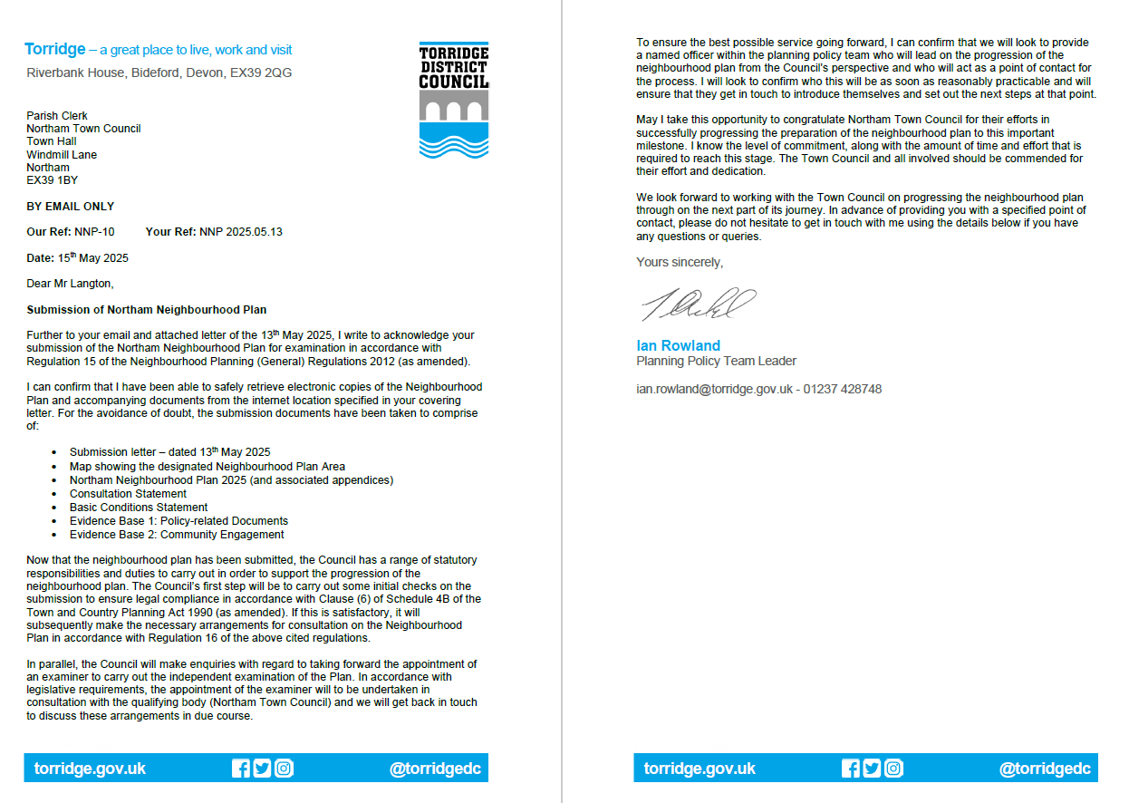
Item 7 To receive an update on the progress of the Northam Neighbourhood Plan and consider the establishment of a working group to review the feedback from the Planning Authority and Independent External Examiner

