To all members of the Council:
You are hereby summoned to attend the ENVIRONMENT and MAINTENANCE COMMITTEE meeting on
Wednesday 2nd April 2025 at 6:30pm
at The Town Hall, Windmill Lane, Northam for the transaction of the business listed on the agenda below.

Membership:
Louis Bach (Chair), Barry Edwards, Peter Hames (Deputy Chair) and Wendy Lo-Vel, plus the Mayor, Cllr Niki Tait (ex-officio). Three vacancies.

Questions by the public
There will be a period for questions by the public. In accordance with Standing Order 3, members of the public may make representations, ask questions and give evidence at a meeting which they are entitled to attend in respect of any Council business at Full Council, and at Committee meetings in respect of business on the agenda.
Anyone wishing to ask questions is requested to notify the Town Clerk prior to the meeting.

Recording, photographs and filming
In accordance with the Council’s policy on filming and recording of Local Council and Committee meetings (available to read in the Chamber) and arising from the Local Government and Accountability Act 2014 the press or public may audio-record, photograph or film meetings, or report from the meeting using social media. As such, members of the public may be recorded or photographed during the meeting. Anyone wishing to record or photograph the meeting must notify the Town Clerk before the commencement of the meeting.

Public attendance at Council and committee meetings
As a public body, Northam Town Council understands the need for transparency and accountability. The Council will therefore seek to conduct meetings using practices and procedures set out within the Public Bodies (Admission to Meetings) Act 1960, which states:
Subject to subsection (2) * below, any meeting of a body exercising public functions, being a body to which this Act applies, shall be open to the public.

Subsection (2) states:
Where a meeting is open to the public, a body may, by resolution exclude the public from the meeting (whether during the whole or part of the proceedings) whenever publicity would be prejudicial to the public interest by reason of the confidential nature of the business to be transacted or for other special reasons stated in the resolution and arising from the nature of that business or of the proceedings; and where such a resolution is passed, this Act shall not require the meeting to be open to the public
during proceedings to which the resolution applies.

Therefore, the Council’s policy is to allow public access to meetings unless the business being.
transacted is confidential or there are ‘other special reasons’ to exclude the public.

Guy Langton
Guy Langton, Town Clerk & RFO
Date of issue: 27th March 2025

AGENDA

1 To receive and approve apologies for absence, in accordance with Local Government Act 1972 s85(1) All apologies must be notified to the Town Council offices by one hour prior to the start of the meeting.

2 Chair’s announcements

3 To receive any dispensations and disclosable pecuniary or other interests Members are reminded that all interests must be declared prior to the item being discussed.

4 To agree the agenda as published.

5 To confirm as a correct record and sign the minutes of the Environment and Maintenance Committee held on 6th February 2025 (p3-7)

6 Public Participation
Members of the public are permitted to make representations, answer questions and give evidence in respect of any item of business included in the agenda. Each member of the public is entitled to speak once only in respect of business itemised on the agenda and shall not speak for more than 4 minutes. The period of time which is designated for public participation in accordance with standing orders shall not exceed 20 minutes.

7 To receive an update on actions (p8)

8 To note the resolution by Full Council regarding Bus Shelters along the 21/21A routes through Northam, Appledore and Westward Ho! (p9)

9 To consider seeking a grant for a BinForGreenSeas and a suitable location (p9-10)

10 To consider offering to support local waste collection (p11)

11 To consider upgrading the surface of footpaths 35 and 36 and their inclusion in the P3 request (p11)

12 To consider the wider P3 request for footpath improvements (verbal/to follow)

13 To consider repainting the wall along Footpath 36 (p12)

14 To consider purchasing two 500L IBCs and suitable pumps to assist with watering the Council’s planters, baskets and newly planted areas (verbal and to follow)


Page 208

Northam Town Council – Minutes of the Environment and Maintenance committee meeting held 6th February 2025 at 6.30pm in the Town Hall, Windmill Lane, Northam.

Present: Cllrs Bach (Chair), Edwards, Hames, Lo-Vel and the Mayor, Cllr Tait.

In attendance: Guy Langton – Town Clerk & RFO.
Ian Rawle – Parks & Buildings Manager.

2502/574 To receive and approve apologies for absence, in accordance with Local Government Act 1972 s85(1)
All members were present.

2502/575 Chair’s Announcements
The Chair had no announcements.

The Town Clerk reported that following the winter storms, the hedge layer instructed to work on the hedge and bank at Burrough Farm had contacted the Council to ask if the work could be delayed until the autumn. The Committee agreed to delay the work.
Action point: contact the hedge layer.

The Parks & Buildings Manager reported that a tree would be removed from adjacent to Wren Close play area following the play area inspection, which had identified it as a hazard. It was agreed to remove the tree and plant two others locally to replace it.
Action point: Communicate the decision to local residents and arrange the removal and planting.

2502/576 To receive any dispensations and disclosable pecuniary or other interests
Members were reminded that all interests must be declared prior to the item being discussed.

2502/577 To agree the agenda as published
It was resolved to agree the agenda as published.
Proposed: Cllr Tait, Seconded: Cllr Edwards (all in favour).

2502/578 To confirm as a correct record and sign the minutes of the Environment & Maintenance Committee held on 11th December 2024
It was resolved to confirm the minutes of the meeting as a correct record, though the action point at minute 2412/469 would be clarified to read: Include consideration of the draft Biodiversity Policy on the agenda of the next meeting of the Review committee.
The amended minutes would be signed at a later date.
Proposed Cllr Tait, Seconded Cllr Hames (all in favour)

2502/579 Public Participation
Members of the public are permitted to make representations, answer questions and give evidence in respect of any item of business included in the agenda. Each member of the public is entitled to speak once only in respect of business itemised on the agenda and shall not speak for more than 4 minutes. The period of time which is designated for public participation in accordance with standing orders shall not exceed 20 minutes.
There were no members of the public present.

2502/580 To receive an update on action points
The Action points were considered and noted as presented overleaf
Page 209
Action |  | December 2024 | February 2025
1 | Write to the Company Secretary regarding the handrail at Fosketh Hill, footpath 24. | Rail not yet received.  Action point: Town Clerk to follow up with the Company Secretary at Kipling Terrace and the fabricators.  ONGOING | The installation was scheduled for 31st January 2025.  COMPLETE
2 | Drop kerbs in Westward Ho!  (brought forward from TP&AM) | DCC has confirmed that no licence fee would be required. The locations will be re-identified and a contractor instructed.  ONGOING | No further action has been taken.  Action point: The Parks and Buildings Manager was to approach contractors before the next meeting of this committee.  ONGOING
3 | Footpath work | The agreed and reported footpath work is being reviewed and are scheduled for week commencing 16th Dec 24. ONGOING  The signs have been purchased and installed on Footpath 10a. COMPLETE | Footpath work is continuing, working through the works agreed in 2024.  COMPLETE
4 | Schools to be contacted to design their own ‘don’t idle’ signs for the Council to have made and installed. | The schools have been contacted. Only one was interested but not all had replied.  ONGOING | Seeking a discussion with the interested school.  ONGOING
5 | Prepare a report on the purchase and installation of MVSIDs for the Parish | NOT STARTED | NOT STARTED
6 | Planting hedge whips at Burrough Farm | The hedge whips have been received and temporarily planted. The work is scheduled. ONGOING | Work COMPLETE.
7 | Design a suitable graphic for the Council’s EV to wrap on bodywork | ONGOING | On the agenda  COMPLETE
8 | Request from member of the public for litter picking equipment |  | Member of the public invited to the February 2025 meeting.  ONGOING

Page 210
Action |  | December 2024 | February 2025
9 | Traffic issues at the Square, Northam |  | Mr Gilbert’s response is on the agenda.  Costs of traffic surveys not yet researched.  ONGOING
10 | Offer Council help for the bus shelter opposite the Seagate Hotel, Appledore |  | Council assistance offered, the volunteers advised the Town Clerk that they had agreed works with TDC, to start May 2025.  COMPLETE
11 | Locations of Council provided Christmas trees in 2025 – liaise with the Westward Ho! Business association over the sites in Westward Ho! |  | To be considered later in the year.  ONGOING
12 | Include suitable machinery in the budget for 2025-26 and arrange for its purchase. |  | Following advice from the Council’s vehicle maintenance provider that one of the Council’s trucks required considerable repair, the matter has been passed to the Finance committee for further review.  COMPLETE
13 | Schedule the works for Life on the Verge |  | Works scheduled in 2025.  ONGOING
14 | Refer the draft Biodiversity Policy to the Review committee |  | The matter would be included on the next committee agenda.  COMPLETE

Page 211
2502/581 To consider the Devon County Council grass cutting agreement
The committee recommended that the contract be signed and referred the matter to a meeting of the Full Council.
Proposed: Cllr Bach, Seconded: Cllr Tait (all in favour)
Action point: Include on a Full Council meeting agenda.

2502/582 To note the plans for Churchill Way bank
The Parks & Buildings Manager had submitted the below plans to DCC Highways the Ecologist.
The Ecologist was supportive of the plans, noting the bramble had become out of control, though its ecological benefits are considerable. The bramble patch to the southern end of the bank, towards the retaining wall, would be left (but trimmed back to aid pedestrian passage).
DCC Highways had asked NTC’s officers to prepare a more detailed plan with exact locations and distances to maintain the visibility splay opposite the entrance to North Street, which the officers planned to complete in February 2025.
It was resolved to continue with the project.
Proposed: Cllr Bach, Seconded: Cllr Edwards (all in favour).
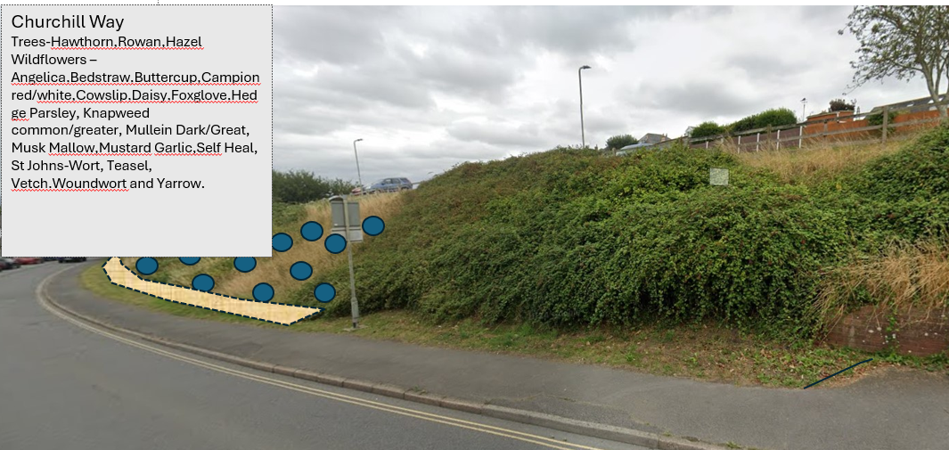
Action points: Draft a more detailed plan as required by Devon County Council.
2502/583 To consider plans for improving the street scene at Golf Links Rod, between Avon Lane and Beach Road
It was agreed that Town Council officers would seek a derelict boat for use as a planter along that stretch of road and enhance the current planting.
Action points:
Seek a suitable derelict boat.
Make the land good after recent utility works and enhance the current planting scheme.

2502/584 To consider offering a Christmas tree recycling scheme to residents of the Northam Town Council area in 2025
It was resolved to offer a Christmas Tree recycling scheme across the Parish after the 2025-26 festive season, identifying a number of suitable collection locations, which could include:
- Northam Hall
- Burrough Farm, allotment entrance and football club entrance
- Lords Meadow, both entrances
Page 212

- Anchor Park, main entrance
- Westward Ho! Park, both entrances
- Bone Hill
- Other local play areas
- Town Hall
Proposed: Cllr Hames, Seconded: Cllr Bach (all in favour)
Action point: Advertise service in December 2025.

2502/585 To receive the response from TDC regarding the siting of air quality survey equipment
The Town Clerk reported that he had received a response from the Torridge District Council Public Health and Community Safety Manager, which is copied below:

Yes, we are responsible for air quality monitoring in the district. We have a number of fixed sites around the district, as described in the appendices of the air quality status reports, produced annually and available on this page: https://torridge.gov.uk/article/20227/Air-Quality

Every monitor we place has a resource implication in terms of officer time collecting and replacing the monitors and lab costs for analysis. This is not huge, but our resource is planned around the current monitoring sites. For this reason, and because we don’t have any concerns about other areas exceeding the thresholds, we will not be substantially increasing the number of monitoring sites.

That said, we do have plans to install a further three monitors around schools in the district in 2025. We will not be considering further monitoring sites until 2026.

The Council’s officers noted that they were in the process of seeking costs for private air quality and traffic monitoring.
Action point: Include on a future meeting of this committee when costs are available.

There being no further business the meeting closed at 7:30pm.

Signed………………………………………………..Dated……………………………………………….

7 To receive an update on actions
Action |  | February 2025 | April 2025
1 | Drop kerbs in Westward Ho!  (brought forward from TP&AM) | No further action has been taken. | Contractor instructed.  ONGOING
2 | Schools to be contacted to design their own ‘don’t idle’ signs for the Council to have made and installed. | Seeking a discussion with the interested school. | Seeking a discussion with the interested school. ONGOING
3 | Prepare a report on the purchase and installation of MVSIDs for the Parish | NOT STARTED | NOT STARTED
4 | Request from member of the public for litter picking equipment | Member of the public invited to the February 2025 meeting. | No response from the member of the public.  COMPLETE
5 | Traffic issues at the Square, Northam | Mr Gilbert’s response is on the agenda.  Costs of traffic surveys not yet researched. | Costs of traffic surveys not yet researched.  Cost of air quality surveys not yet researched.  NOT STARTED
6 | Locations of Council provided Christmas trees in 2025 – liaise with the Westward Ho! Business association over the sites in Westward Ho! | To be considered later in the year. | Agreed at the previous meeting, to advertise closer to December 2025. COMPLETE
7 | Schedule the works for Life on the Verge | Works scheduled in 2025. | The design is being redrafted in line with the requirements of the Neighbourhood Highways Officer. ONGOING
8 | Postpone Hedge-laying at Burrough Farm |  | It was agreed to postpone the hedge-laying to the autumn. The contractor has been informed. COMPLETE
9 | Remove the tree from Wren Close play area as per ROSPA inspection report |  | The local residents were informed of the work and it has been COMPLETED.
10 | DCC Grass Cutting 2025-26 |  | Full Council considered the contract and resolved to continue it. It has been signed and returned to DCC. COMPLETE
11 | Golf Links Road street scene |  | Seek a derelict boat for use as a planter along that stretch of road and enhance the current planting.  Make good the land recently disturbed by utility works.  ONGOING

Item 8 To note the resolution by Full Council regarding Bus Shelters along the 21/21A routes through Northam, Appledore and Westward Ho!
Fernbank, the provider of the advertising shelters along the 21/21A bus route. The proposal for the extension is outlined below. The shelters that would not be included are:
Seagate Hotel (Stop ID: dvnagpat)
Marine Parade (Stop ID: dvnagmwt)
Swimming Pool (Stop ID: dvnagdtg)
Memorial (Stop ID: dvnagatg)

Full Council resolved to approve the extension at its meeting on the 19th March 2025, subject to the usable shelters being sympathetically removed and retained for use elsewhere.

Further to our recent discussions & emails, I would like to propose an extension to our current agreement in return for new living roof bus shelters in the Northam Town Council area.
The original agreement commenced on 1st November 2013 to run until 31st October 2033.
The agreement states it can be extended for successive periods of four years (Devon County Contract Agreement) Subject as per the original agreement to paragraphs 2 Term.
The agreement would incorporate 3 successive periods which amounts to an extension of 12 years. The extended & supplemented will therefore extend beyond 31st October 2033 until 31st October 2045.

Below are my suggestions on the shelters to be changed to new living roof shelters.
3 x Shelters on Golf Links Road:
outside new development
adjacent to Aysha Gardens, and
adjacent to the Co-op (If Northam TC have it as an asset).
A386 opposite Durrant Hotel (really old one)
Opposite Hanson Park against the wall, which doesn’t seem to have an owner.

Fernbank would clean & maintain all the shelters under the agreement, with the exception of Appledore shelters & the wooden shelter. We would leave in the agreement the option to add shelters into the agreement at a future date.

Any more possible shelters identified would be non advertising, some will be on the route 21 and could have some potential funding from Devon County, they may ask for a contribution to upgrade the non ads.
Bus shelter sites replaced with Fernbank’s new Living Roof shelters will be planted with Sedum plants.
Recommendation: That the committee monitor the installation process.

Item 9 To consider seeking a grant for a BinForGreenSeas and a suitable location
The 2025 applications for one FREE BinForGreenSeas per council, are now open. The award, worth £4000, covers all the associated costs with the manufacture and delivery of a BinForGreenSeas to the chosen site.
The officers consider the best locations to be either at the promenade/village green in Westward Ho! or the Quay in Appledore (Churchfields end), though it is noted that this Council does not own either of the locations, them being owned by Torridge DC and Devon CC respectively. The conditions for the application are overleaf.

The conditions for receiving a free BinForGreenSeas are:
1. The BinForGreenSeas must be sited in an area of high footfall by the sea/river side (as appropriate).
2. Your organisation must agree to provide 4 months of quantitative data on the plastic bottles collected. This can be in actual numbers, or by the plastic load weight, or by using a 140-240 litre wheelie bin as a guide, having quantified the number of plastic bottles the wheelie contains. The data does not have to be provided for each consecutive month (if off-season) but should provide a meaningful picture of peak beach/waterfront use in the first 8 months of installation. The data is used as an important metric for measuring our success and to provide feedback to our grant givers, helping to support further installations.
3. Please complete the attached application. The deadline for applications is 25th April 2025.

Recommendation: The committee resolve to seek a grant for a BinForGreenSeas, to be located at either of the locations suggested, with the Council seeking permission from the
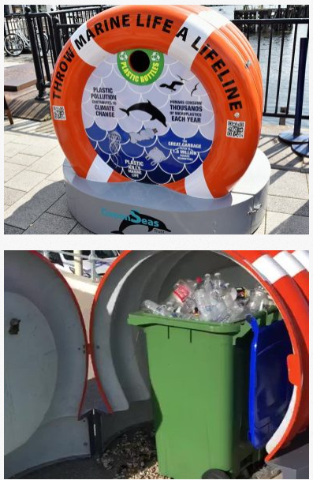

Item 10 To consider offering to support local waste collection
The officers note that Torridge District Council’s wheelie bins, sited for the holiday season at strategic locations around the Parish, are often full. The officers consider that the situation could be resolved by the Town Council offering to purchase ten extra bins to support the work carried out by Torridge.

These bins would remain the property of Northam Town Council, being used for other events in the ‘off’ season.

Ten 240L wheelie bins can be purchased for £405 (exVAT), including delivery. (A 240L bin is the same size as a TDC garden waste bin)

Recommendation: The Council liaise with TDC to ascertain the reason why there are insufficient bins and offer to help supply the bins as described above.

Item 11 To consider upgrading the surface of footpaths 35 and 36 and their inclusion in the P3 request

Footpath 35
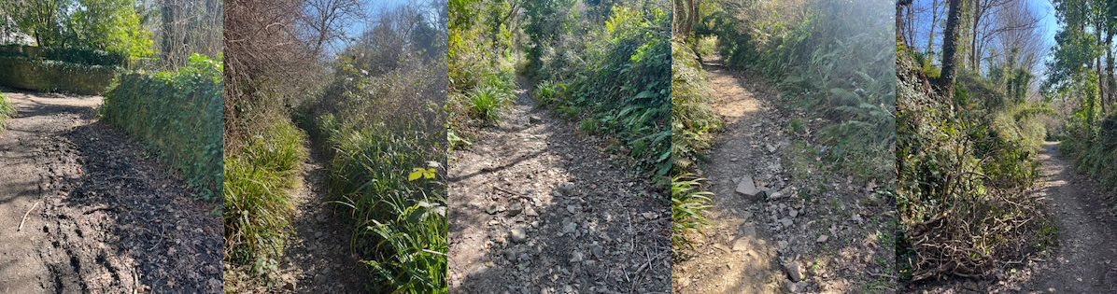
Footpath 36
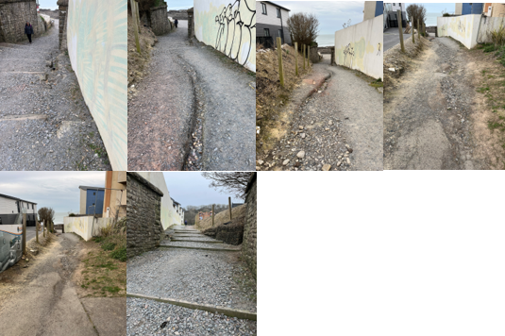

The officers note that the deadline is the 28th March annually but requests are considered on a case by case basis outside that timeframe.

Recommendation: The Council estimate costs for the work to resurface the two footpaths and submit them as the annual P3 funding request.

Item 12 To consider the wider P3 request for footpath improvements (verbal/to follow)
The committee will hear from Cllr Hames.

Item 13 To consider repainting the wall along Footpath 36
The officer notes that the wall has previously been painted by the Council, to cover graffiti. This work continues.
The Council could commission a graffiti artist to paint the wall at the expense of the Council, though given the location, there is a possibility local ‘amateur’ graffiti artists may overpaint any artwork.
Anti-graffiti coatings are available to apply to newly-painted surfaces, at a cost of £30/5L or 800L for £2,975 (both exVAT) (e.g. https://www.chemiphase.co.uk/euroshield-anti-graffiti-coatings-treatment/?sku=SKU-AB9AFE65&gad_source=1&gclid=Cj0KCQjwy46_BhDOARIsAIvmcwNKqrw0xMLStraoqu5eX7h-nOdhfzsAggg1wFV7xHAfQ_T_t2POUgkaAv9VEALw_wcB) with a similar coverage to paint.
It may be used on all porous and non-porous surfaces, e.g. brickwork, stone, rendering, painted surfaces, tiles and road signs.
- Will not damage reflective surfaces.
- Can be cleaned up with Jet Washer
- Eliminates need for chemical cleaners.
- Simply requires high pressure water for graffiti removal.
- Where pressure washer use is not suitable, allows for localised removal using environmentally friendly proprietary cleaner.
- Virtually invisible will not significantly alter or visually emphasise treated areas.

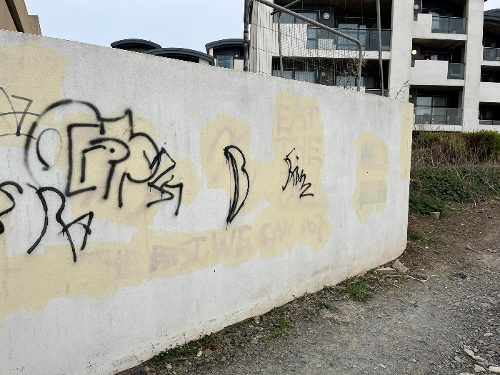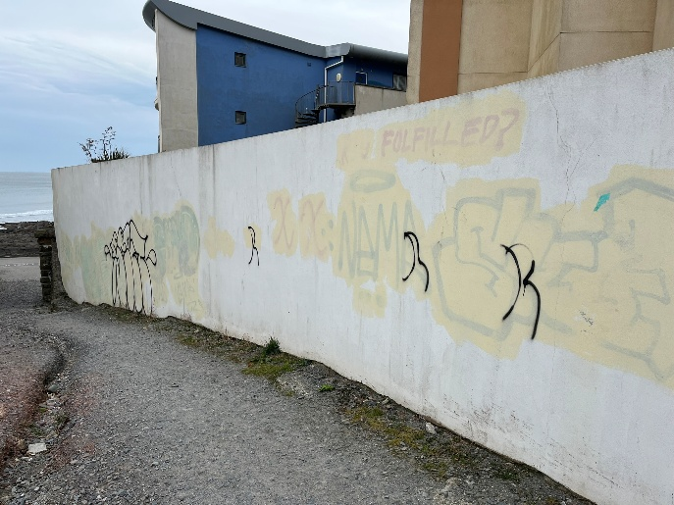

Recommendation: There being no identifiable owner of the wall, this Council repaint the wall in a suitable colour, using anti-graffiti coating.

Item 14 To consider purchasing two 500L IBCs and suitable pumps to assist with watering the Council’s planters, baskets and newly planted areas (verbal and to follow).

