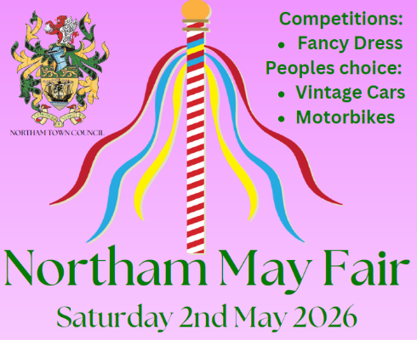

COMPETITION RULES

Think of a good idea for a fancy-dress costume.

Judging and prize giving will take place on the morning of the May Fair at 12am on Saturday 2nd May 2025 in the main arena. Entrants can be part of the opening parade if they want, starting outside the library and finishing in the Rectory Gardens if they wish at 10am.

Entrants for the fancy dress competition must be aged between 3 and 16.

Remember, all entry forms must be returned to Northam Town Council Offices, Windmill Lane, Northam or email tina.s@northamtowncouncil.gov.uk by Monday 27th April 2026 at the latest.

----------------------------------------------------------------------------------------------------------------------------
COMPETITION ENTRY FORM

NAME of entrant: _______________________________

TELEPHONE NUMBER: __________________________

PARENTAL CONSENT
I give my permission for my child to take part in this fancy-dress competition, and for any photographs of the event to appear in future advertising and/or newspaper coverage.

NAME:_______________________ SIGNATURE:_____________________

