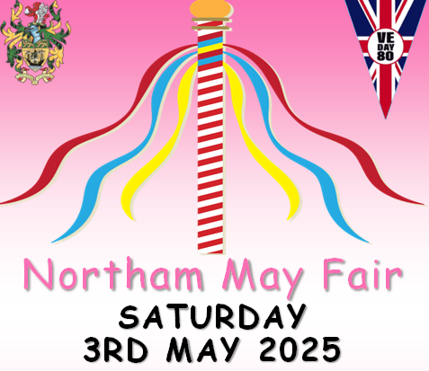

**COMPETITION RULES**

## Think of a good idea for a fancy dress costume – the theme is *VE Day*.

## Judging and prize giving will take place on the morning of the May Fair at 11am on Saturday 3rd May 2025 in the main arena. Entrants can be part of the opening parade if they want, starting outside the library and finishing in the Rectory Gardens if they wish at 10am.

## Entrants for the fancy dress competition must be aged between 3 and 16.

## Remember, all entry forms *must* be returned to Northam Town Council Offices, Windmill Lane, Northam or email [tina.t@northamtowncouncil.gov.uk](mailto:tina.t@northamtowncouncil.gov.uk) by Monday 28th April 2025 at the latest.

 ✂------------------------------------------------------------------------------------------------------------------------------

**COMPETITION ENTRY FORM**

 Please tick which age group you are entering:

NAME of entrant: _______________________________

AGE: Please tick box 8 and under 9 and over

TELEPHONE NUMBER: __________________________ 

PARENTAL CONSENT

I give my permission for my child to take part in this fancy dress competition and/or the hat competition, and for any photographs of the event to appear in future advertising and/or newspaper coverage.

NAME:_______________________ SIGNATURE:_____________________