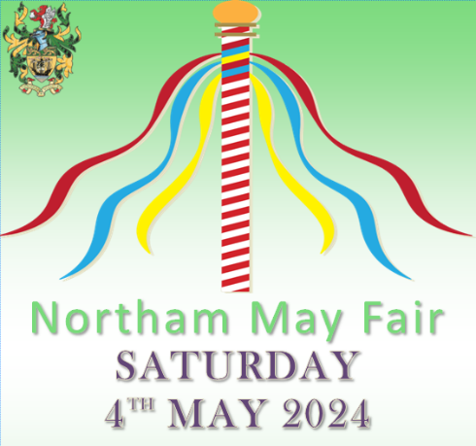

COMPETITION RULES

Think of a good idea for a costume or a hat – the themes are Medieval and Vikings fancy dress or a Medieval and Vikings hat.

Judging and prize giving will take place on the morning of the May Fair, at 9.30am on Saturday 4th May 2024. Entrants can be part of the opening parade, starting outside the library and finishing in the Rectory Gardens.

Entrants for the Medieval and Vikings fancy dress competition must be aged 12 and under. Entrants for the Medieval and Vikings hat competition will be entered as either children aged 12 and under, or everyone else.

Remember, all entry forms must be returned to Northam Town Council Offices, Windmill Lane, Northam by noon, Friday 26th April 2023 at the latest.
------------------------------------------------------------------------------------------------------------------------------

COMPETITION ENTRY FORM

Please tick which competition you are entering:

Fancy Dress competition Hat competition

NAME of entrant: _______________________________

AGE: Please tick box 12 and under Over 12

TELEPHONE NUMBER: __________________________
PARENTAL CONSENT
I give my permission for my child to take part in this fancy dress competition and/or the hat competition, and for any photographs of the event to appear in future advertising and/or newspaper coverage.

NAME:_______________________ SIGNATURE:_____________________

