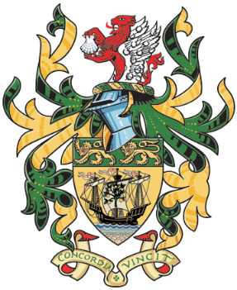
NORTHAM TOWN COUNCIL
TOWN HALL
WINDMILL LANE
NORTHAM
DEVON
EX39 1BY

Town Clerk: Mrs Jane Mills MILCM
Telephone and Fax: 01237 474976
e-mail admin@northamtowncouncil.gov.uk

COMMUNITY CHAMPIONS NOMINATION FORM
Making an outstanding contribution to the community of Northam Parish.
Details of the person/s being nominated for the award:
First Name: Surname:
Address:
Postcode:
Telephone Number: E-mail:
Reasons for Nomination:
You should provide full details of why you are making the nomination giving comprehensive reasons why you consider that the person being nominated has enriched the lives of the residents of Northam, Westward Ho! or Appledore. Each nomination will be considered on its own merits by the Council. (see overleaf.)

I certify that to the best of my knowledge all details given are correct and that I have not been influenced or canvassed in any way.

PROPOSER: Print Name: Signature:

Address: Postcode:

Telephone Number: E-mail:

SECONDER: Print Name: Signature:

Address:. Postcode:

Telephone Number: E-mail:

Award details and nomination procedures:

What is the purpose of the award?
The purpose of the award is to recognise those individuals that have made a significant contribution to enriching the lives of Northam, Westward Ho! or Appledore residents.

What form will the award take?
The award is a framed scroll bearing the name of the individual/s. This will be presented at the next Mayor Introduction Ceremony.

Who can make a nomination?

Any individual who resides or is based within the parish of Northam, Westward Ho! or Appledore.

Who can be nominated?

Any person either living in or outside Northam, Westward Ho! or Appledore providing that residents within Northam, Westward Ho! or Appledore have significantly benefited from their activities. If the person/s nominated performs the tasks as part of their paid employment, then in order to qualify their contribution must be well above and beyond that normally expected as part of their employment. Town Councillors and Council staff are not eligible for nomination. By signing this form you agree for us to hold and use your data for contact purposes. When your personal data is no longer required, we will destroy it securely. Please see our Privacy Notice

When should nominations be made?

All nominations must be returned to the Northam Town Council Offices, Town Hall, Windmill Lane by Friday 17th May 2024

