To all members of the Council:
You are hereby summoned to attend the PARKS and RECREATION COMMITTEE meeting on
Wednesday 20th May 2026 at 6:30pm
at The Town Hall, Windmill Lane, Northam for the transaction of the business listed on the agenda below.

Membership:
Cllrs Jeremy Bell, Louis Bach, Barry Edwards, Peter Hames, Claire Hodson, Niki Tait, Jane Whittaker Plus the Mayor, Cllr Sam Newman-McKie (ex-officio).

Questions by the public
There will be a period for questions by the public. In accordance with Standing Order 3, members of the public may make representations, ask questions and give evidence at a meeting which they are entitled to attend in respect of any Council business at Full Council, and at Committee meetings in respect of business on the agenda.
Anyone wishing to ask questions is requested to notify the Town Clerk prior to the meeting.

Recording, photographs and filming
In accordance with the Council’s policy on filming and recording of Local Council and Committee meetings (available to read in the Chamber) and arising from the Local Government and Accountability Act 2014 the press or public may audio-record, photograph or film meetings, or report from the meeting using social media. As such, members of the public may be recorded or photographed during the meeting. Anyone wishing to record or photograph the meeting must notify the Town Clerk before the commencement of the meeting.

Public attendance at Council and Committee meetings
As a public body, Northam Town Council understands the need for transparency and accountability. The Council will therefore seek to conduct meetings using practices and procedures set out within the Public Bodies (Admission to Meetings) Act 1960, which states:
Subject to subsection (2)* below, any meeting of a body exercising public functions, being a body to which this Act applies, shall be open to the public.

Subsection (2) states:
Where a meeting is open to the public, a body may, by resolution exclude the public from the meeting (whether during the whole or part of the proceedings) whenever publicity would be prejudicial to the public interest by reason of the confidential nature of the business to be transacted or for other special reasons stated in the resolution and arising from the nature of that business or of the proceedings; and where such a resolution is passed, this Act shall not require the meeting to be open to the public
during proceedings to which the resolution applies.

Therefore, the Council’s policy is to allow public access to meetings unless the business being
transacted is confidential or there are ‘other special reasons’ to exclude the public.

Guy Langton
Guy Langton, Town Clerk & RFO
Date of issue: 13th May 2026

AGENDA

1 To elect a Chair for the Committee
Standing Order 4 (d) (v) states, inter alia: any member who sits on a committee or sub-committee ex-officio should not be appointed Chair of that committee or sub-committee.

2 To elect a Deputy Chair for the Committee
Standing Order 4 (d) (v) states, inter alia: any member who sits on a committee or sub-committee ex-officio should not be appointed Chair of that committee or sub-committee.

3 To receive and approve apologies for absence, in accordance with the Local Government Act 1972 s85(1)
All apologies must be notified to the Town Council offices by 5 pm on the day of the meeting.

4 Chair’s announcements

5 To receive any dispensations and disclosable pecuniary or other interests Members are reminded that all interests must be declared prior to the item being discussed.

6 To agree the agenda as published.

7 To confirm as a correct record and sign the minutes of the Parks and Recreation Committee held on 18th March 2026 (p3-p6)

8 Public Participation
Members of the public are permitted to make representations, answer questions and give evidence in respect of any item of business included in the agenda. Each member of the public is entitled to speak once only in respect of business itemised on the agenda and shall not speak for more than 4 minutes. The period of time which is designated for public participation in accordance with standing orders shall not exceed 20 minutes.

9 To receive an update on actions (p7,8)

10 To receive a report from the Chair of FOTWHOP (p9, verbal)

11 To update members on the MUGA Project at Westward Ho! (p9)

12 To discuss and note the planned works for all Parish play parks and review the annual inspection report from The Play Inspection Company Ltd (p9)

13 Windmill Lane Allotments (p9 - 10)

14 Replacement of Benches at Westward Ho! Tennis Courts (p11 - 13)

Page 311

Northam Town Council – Minutes of the Parks and Recreation committee meeting held Wednesday 18th March 2026 at 6.30pm in the Town Hall, Windmill Lane, Northam.

Present: Cllrs Peter Hames (Chair), Barry Edwards, Sam Newman-McKie, Niki Tait and the Mayor, Cllr Louis Bach (ex-officio).

In attendance: Ian Rawle – Parks & Buildings Manager.
Christine Hutchins – Friends of Westward Ho! Park (FOTWHOP).
Barbara Potts – Volunteer Gardeners (Westward Ho! Park).

2603/688 To receive and approve apologies for absence, in accordance with Local Government Act 1972 s85(1)
Cllr Whittaker and Cllr Hodson apologised, the reasons for which were accepted.

2603/689 Chair’s Announcements
The Chair reported that the gates to the football field at Burrough Farm had been padlocked shut, and Members raised concerns regarding access.
A query was also raised by Cllr Tait regarding whether the parks budgets had been allocated separately or combined into a single overall budget.
The Parks and Buildings Manager confirmed he would investigate both matters and report back to the Committee.

2603/690 To receive any dispensations and disclosable pecuniary or other interests
Members were reminded that all interests must be declared prior to the item being discussed.

2603/691 To agree the agenda as published
It was resolved to agree the agenda as published.
Proposed Cllr Bach, Seconded Cllr Bell (all in favour)

2603/692 To confirm as a correct record and sign the minutes of the Parks and Recreation Committee held on 21st January 2026
It was resolved that to approve the minutes as a true and correct record, which were signed by the Chair.
Proposed Cllr Newman-McKie, Seconded Cllr Bach (all in favour)

2603/693 Public Participation
Members of the public are permitted to make representations, answer questions and give evidence in respect of any item of business included in the agenda. Each member of the public is entitled to speak once only in respect of business itemised on the agenda and shall not speak for more than 4 minutes. The period of time which is designated for public participation in accordance with standing orders shall not exceed 20 minutes.
There were no members of the public present other than Christine Hutchins and Barbara Potts, who would be invited to contribute at the relevant time.

2603/694 To receive an update on actions
The Action table is presented below.

Item 7 update on actions Page 312
The Chair asked if an item regarding laying the hedge along the Kimberley Drive side of Lords Meadow could be added to the Actions for the next meeting - Members were advised of the proposal to engage Steve McCulloch to do the work, with support from the trained maintenance team. It was agreed to obtain a formal quotation for consideration at a future meeting.
Action |  | November 2025 | January 2026 | March 2026
1 | To purchase Beech and Hazel trees (whips) to re-establish the hedge line/row at Burrough Farm | Added to actions | Whips purchased awaiting delivery. | COMPLETE.
2 | To seek legal advice regarding installation of a step at Blackies (Ref: 2507/194 Construction of Steps and improvement of ‘desire line’ surface at Blackies Footpath) | Added to actions | If access and steps are created for public use, they must meet safety standards and be regularly inspected to avoid liability. Public liability insurance should be considered. Permission is needed from the landowner, and if the access meets a road or pavement, Highways approval is required. Planning permission may also be needed. Further checks with insurers, legal advisors, and the landowner are recommended. | In progress.
3 | Permanent PumpTrack | Added to actions | Burrough Farm preferred site, Lord’s Meadow less suitable. Obtain expert advice and cost estimate.  If feasible, seek Full Council approval and go to tender.  Explore funding opportunities (Sports Lottery, Section 106, others). | In progress.
4 | To connect the Tarmac/wetpour path to the play area at Lords Meadow |  | Added to agenda. | Works planned for the end of March, ready for Easter Holidays.
5 | To replace damaged and diseased Silver Birch trees at Lords Meadow |  | Added to agenda. | On Agenda.
6 | Explore and develop alternative summer activities for Lords Meadow |  | Added to agenda. | Not Started.

Page 313
2603/695 To receive a report from the chair of FOTWHOP

The Committee received an update from Christine Hutchins. The 200 Club continues to operate steadily, with 138 members currently in the draw. A number of participants have generously donated their winnings. Two draws remain before April, when reminder emails will be issued to encourage renewals and new memberships, with further promotion planned ahead of the Mayfair.
Volunteer input remains significant, with approximately 947.5 hours contributed to date in 2025, despite challenging weather conditions. Positive feedback has been received from the public, including comments on social media regarding the appearance of the park and appreciation for the volunteers’ efforts.
Thanks, were also noted for members of the public who have supported the gardens, including donations of plants.
This was noted by the Committee.

2603/696 To update members on the MUGA Project at Westward Ho!
The Parks and Buildings Manager gave the following update a contractor has been engaged to produce revised plans for the MUGA project following feedback from Torridge District Council. The updated design includes a reduction in the overall size due to planning constraints.

Members were advised that additional sound mitigation measures, including anti-vibration posts and revised fencing arrangements, have been incorporated. The design now includes a separate enclosed fence to prevent noise transfer to the existing tennis court fencing.

Despite these amendments, all changes will remain within the agreed budget as approved at the CNR meeting at Torridge District Council.

This was noted by the Committee.

2603/697 Planned works for all Parish Play Parks and Annual Inspection Report
The Parks and Buildings Manager outlined the planned works for all Parish play parks and provided an overview of the annual inspection report from The Play Inspection Company Ltd.
However, Members deferred this item to the next meeting. Councillors requested that paper copies of the report be distributed in advance, as they did not wish to view the findings solely via the projector. The item will therefore be brought back to the next meeting for full consideration.

Action Point: Parks and Buildings Manager to distribute paper copies of the annual play park inspection report to all Councillors ahead of the next meeting.

Page 314
2603/698 Improvements at Anchor Park through wildlife-based activities
An initial suggestion was presented to host small community events aimed at highlighting the wildlife present within the park and encouraging residents to visit and learn more about the site. Two simple engagement activities were proposed:

- Bat Walk: An evening guided walk using bat detectors to identify species within the park, potentially supported by a Biosphere ecologist.

- Moth Trap Demonstration: A moth trap placed within the woodland area overnight, followed by a morning session where attendees can view and learn about the species captured, supported by a Biosphere ecologist and potentially a work experience student.

These activities are also intended to gauge community interest in forming a small volunteer or community group to support the park in the future. It was noted that timing may need to align with any planned works or activities scheduled for April.

Councillors agreed to the proposed community wildlife engagement activities.
Proposed Cllr Edwards, Seconded Cllr Tait (all in favour)

Action Point: Parks and Buildings Manager to progress the arrangements for the Bat Walk and Moth Trap Demonstration, including coordination with Biosphere staff and confirming suitable dates.

2603/699 To replace damaged and diseased Silver Birch trees at Lords Meadow
Members received an update following the investigation into the condition and suitability of the Silver Birch trees at Lords Meadow. The inspection confirmed that only one Silver Birch requires replacement, along with one Rowan in the same area.
The total cost for both trees is £86.40 (inc. VAT), within the previously approved budget of £600.
Councillors agreed to proceed with the purchase of one Silver Birch and one Rowan tree.
Proposed Cllr Bell, Seconded Cllr Tait (all in favour)

Action Point: Parks and Building Manager to arrange the purchase and planting of the replacement trees.

There being no further business, the meeting closed at 7:33 pm.

Signed………………………………………………..Dated………………………………………

Item 9 update on actions

Action |  | November 2025 | January 2026 | March 2026 | May 2026
1 | To seek legal advice regarding installation of a step at Blackies (Ref: 2507/194 Construction of Steps and improvement of ‘desire line’ surface at Blackies Footpath) | Added to actions | If access and steps are created for public use, they must meet safety standards and be regularly inspected to avoid liability. Public liability insurance should be considered. Permission is needed from the landowner, and if the access meets a road or pavement, Highways approval is required. Planning permission may also be needed. Further checks with insurers, legal advisors, and the landowner are recommended. | In progress. | In discussion with DCC Public Rights of Way Officer
2 | Permanent PumpTrack | Added to actions | Burrough Farm preferred site, Lord’s Meadow less suitable. Obtain expert advice and cost estimate.  If feasible, seek Full Council approval and go to tender.  Explore funding opportunities (Sports Lottery, Section 106, others). | In progress. | Researching funding and contractor cost (by in and place using contractors and NTC staff)
3 | To connect the Tarmac/wetpour path to the play area at Lords Meadow |  | Added to agenda. | Works planned for the end of March, ready for Easter Holidays. | Complete
4 | To replace damaged and diseased Silver Birch trees at Lords Meadow |  | Added to agenda. | On Agenda. | Complete
5 | Explore and develop alternative summer activities for Lords Meadow |  | Added to agenda. | Not Started. | Seeking quotation and availability
6 | MUGA WWH! |  | -Meet with Contractor to discuss plans  -investigate Planning, contact Environmental Health | Contractor appointed to revise MUGA plans following feedback  -Design reduced in size due to planning constraints  -Additional noise mitigation included (anti-vibration posts and revised fencing)  -Changes remain within approved budget | On Agenda
7 | Pavilion WWH! |  | -Survey completed  -Plans being developed for options (new build or renovation)  -Demolition costs currently being obtained | No Change | -Survey completed  -Plans being developed for options (new build or renovation) – Philip Hinton currently preparing draft plans  -Demolition costs currently being obtained
8 | Planned works for all Parish Play Parks and Annual Inspection Report |  | Inspections carried out | On Agenda | On Agenda
9 | Hedge laying Lords Meadow |  | Contact Steve McCulloch for quotation and advice. | In talks with Steve McCulloch. | Awaiting quotation.

Item 10 To receive a report from the chair of FOTWHOP (Verbal)

Item 11 To update members from the MUGA Working Group.

Members are advised that, following discussions at the recent meeting, it was agreed to proceed with a number of actions relating to the proposed MUGA project at Westward Ho!.

This includes progressing an application for a Lawful Development Certificate for the proposed development.

In addition, it was agreed that the draft tender documentation should be reviewed by the Council’s solicitor prior to being issued, in order to ensure the documentation is appropriate and robust.

Members also agreed to proceed with public consultation and engagement with local residents once the necessary amendments have been made. This will include the preparation and distribution of a consultation letter or leaflet outlining the proposed project, the intended benefits of the scheme, and opportunities for residents to provide feedback.

Recommendation:
That Members note the update from the MUGA Working Group.

Item 12 To discuss and note the planned works for all Parish play parks and review the annual inspection report from The Play Inspection Company Ltd

The Parks and Building Manager will outline the planned works and provide an overview of the annual inspection report from The Play Inspection Company Ltd.

Recommendation:
Members are asked to note the contents of the annual inspection report(s), and the planned maintenance works across the Parish play parks.

Item 13 Windmill Lane Allotments - Condition of Boundary Wall Adjacent to Allotments

To inform members of concerns regarding the condition of a boundary wall adjacent to the allotment plots.

The wall is showing signs of deterioration and may be unstable.

There is a potential risk that the wall could subside or collapse into an allotment holder’s plot, posing a safety concern.

Further assessment is required to determine the structural integrity of the wall and any necessary remedial action.

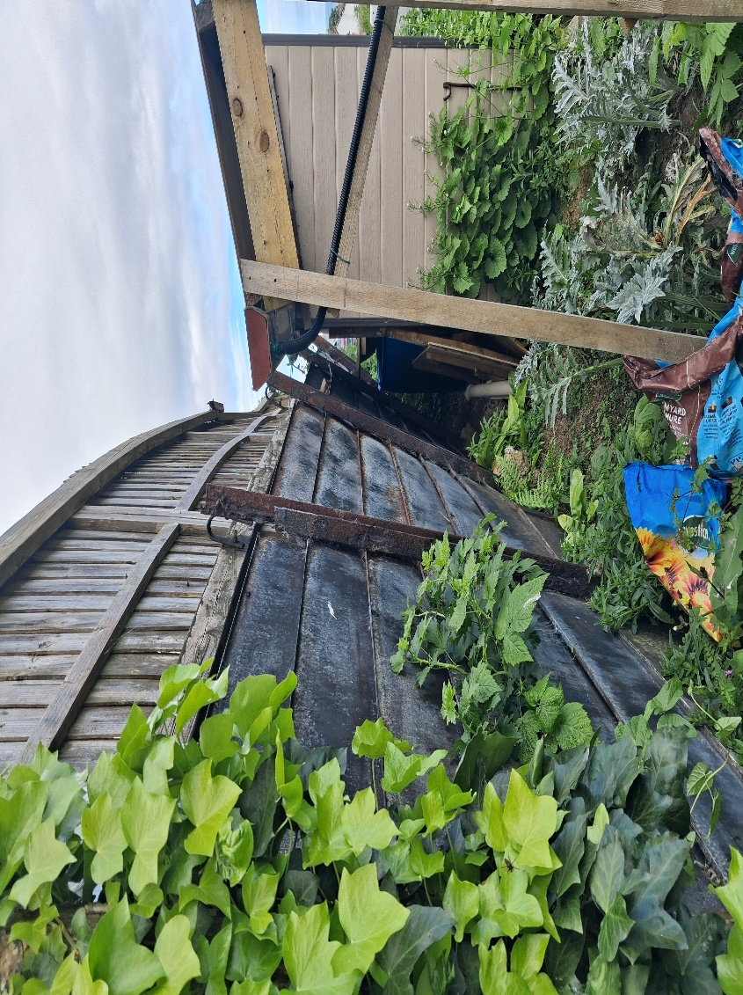

Recommendation
Members are recommended to: To approve instructing a suitably qualified professional.

Item 14 Replacement of Benches at Westward Ho! Tennis Courts

Members are requested to consider options for the replacement of the existing benches at Westward Ho! Tennis Courts.

Due to the site’s close proximity to the coast, the existing benches have been subject to significant weathering from the marine environment. Timber components are prone to rot and deterioration, while metal elements are susceptible to corrosion and rusting from salt exposure. As a result, replacement benches manufactured from recycled plastic are recommended as a more durable and lower-maintenance alternative suitable for coastal conditions.

Three replacement bench options have been identified for Members’ consideration, each offering varying styles, specifications, and associated costs.

The cost of the preferred option would be met from Cost Code 139 (Parks and Recreation).

Recommendation:
That Members consider the three recycled plastic bench options presented and determine the preferred specification for installation at Westward Ho! Tennis Courts.

Option 1
Designed for heavy-duty outdoor use, suitable for high-traffic areas such as tennis courts.
Durable and long-lasting recycled material with low maintenance requirements.

Total cost: £903.60 including VAT and delivery (3 x Benches).

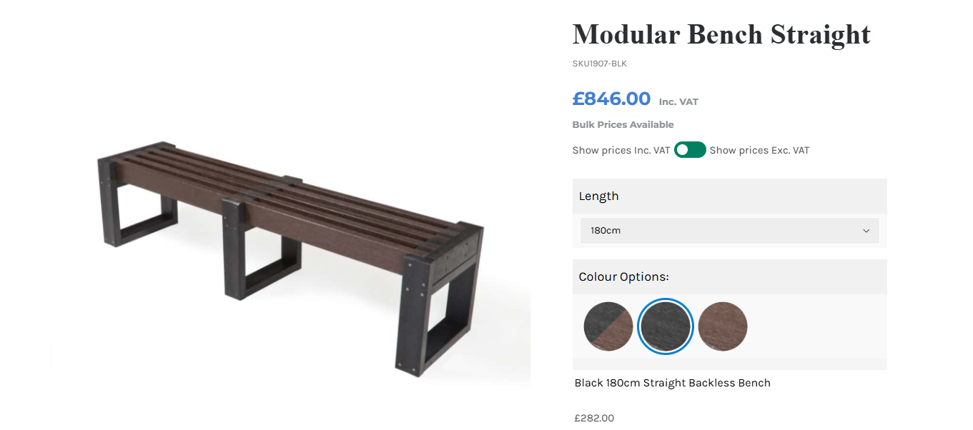

Option 2

Manufactured from 100% recycled plastic.
Key benefits include durability (up to 5x longer lifespan than timber), resistance to rot, insects, bacteria, and general wear.
Cost-effective option due to being completely maintenance-free and supported by a 25-year guarantee, with replacement parts available.
Safety advantages: no splintering, suitable for regular public use.
Sustainability value highlighted through a free plaque showing how many plastic bottles were recycled.
Designed with an attractive wood-grain finish.
Total cost: £738 inc VAT & delivery (3 x Benches).

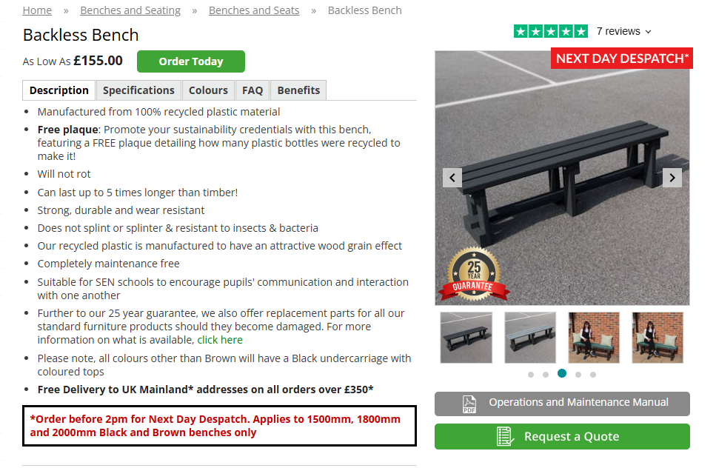

Option 3

Designed as durable, maintenance-free seating suitable for recreational areas, including tennis courts. Tough, long-lasting construction that will not rot and does not splinter.
UV-protected colours available, including bright primary options.
Highly durable “fit-and-forget” solution, intended to last for many years without replacement.
Total cost: £1,014.37 including VAT and delivery (3 x Benches).

