Al it?

To all members of the Council:
You are invited to attend the
NORTHAM BURROWS CHARITY MANAGEMENT COMMITTEE
Thursday 26th March 2026 at 10am
at The Town Hall, Windmill Lane, Northam for the transaction of the business listed on the agenda below.
Membership: Cllrs Edwards, Hames (deputy Chair), Leather, Tait (Chair) and Whittaker, and Cllrs Bach (Mayor) and Newman-McKie (Deputy Mayor) ex-officio.

Questions by the public
There will be a period for questions by the public. In accordance with Standing Order 3, members of the public may make representations, ask questions and give evidence at a meeting which they are entitled to attend in respect of any Council business at Full Council and at Committee meetings in respect of business on the agenda.
Anyone wishing to ask questions is requested to notify the Town Clerk by 12 noon on the day of the meeting.

Recording, photographs and filming
In accordance with the Council’s policy on filming and recording of Local Council and Committee meetings (available to read in the Chamber) and arising from the Local Government and Accountability Act 2014 the press or public may audio-record, photograph or film meetings, or report from the meeting using social media. As such, members of the public may be recorded or photographed during the meeting. Anyone wishing to record or photograph the meeting must notify the Town Clerk before the commencement of the meeting.

Guy Langton
Guy Langton, Town Clerk
Date of issue: 20/03/2026

AGENDA

- To receive apologies for absence

- Chair’s announcements

- To agree the agenda as published.

- To receive any dispensations and disclosable pecuniary or other interests Committee members are reminded that all interests must be declared prior to the item being discussed.

- To confirm as a correct record and sign the minutes of Northam Burrows Charity Management Meeting held on 22nd January 2026 (p3-4)

- To receive an update on action points (p5)

- To consider grazing allocations (p6)

- To consider works on the Burrows (p7)

- To note additional homes within the ancient Manor (p7 and enclosed)

- To note any business for future agendas (p7 and verbal)

Minutes Page 026

Minutes of the Northam Burrows Management Committee Meeting held on 22nd January 2026.

Present: Cllr Edwards, Hames (Deputy Chair), Cllr Leather and Cllr Tait (Chair)

In attendance: G Langton, Town Clerk; Miss T Tucker, Community Engagement Officer; M Day, Burrows Ranger. Melinda Stacey, grazier and landowner of FollyFoot Stables

- To receive and approve apologies for absence
Cllrs Bach and Whittaker all apologised.

- Chair’s announcements
There were none
- To agree the agenda as published.
The published agenda was agreed with the amendment to consider works on the Burrows immediately after the confirmation of the minutes.
Proposed: Cllr Hames, seconded: Cllr Leather (all in favour)

- To receive any dispensations and disclosable pecuniary or other interests
Members were reminded that all interests must be declared prior to the item being discussed.

- To confirm as a correct record and sign the minutes of Northam Burrows Charity Management Meeting held on 23rd October 2025
Proposed: Cllr Leather, seconded: Cllr Edwards (all in favour)

- To consider works on the Burrows.
- Improving access to FollyFoot stables from the Burrows to move the horses away from the road access point at Sandymere.
The ranger gave a brief description of what the project entails.
The works will provide a track through Follyfoot’s land, through the boundary and onto the Burrows, to reduce problems caused by horses gathering at the main gate of Sandymere entrance. We constantly receive complaints from the public that they cannot access Northam Burrow by car or by foot with large numbers of horses gathering at the main gate on the hard standing surface. This has now become a health and safety issue with a report of a car becoming damaged.
It was agreed that a map needs to be provided for the committee members to view, arrange a site visit and add it to a future agenda.
Action Point: Circulate the map, arrange a site visit and put on a future agenda.
- Installation of a new footbridge to improve crossings of the stream.
The ranger gave a brief description of the project and explained that Torridge District Council will cover 50% of the cost.
It was noted that the committee would like to be provided with a map and have a site visit.
Action Point: Circulate the map, arrange a site visit and put on a future agenda.
- Dog control signage (options below)
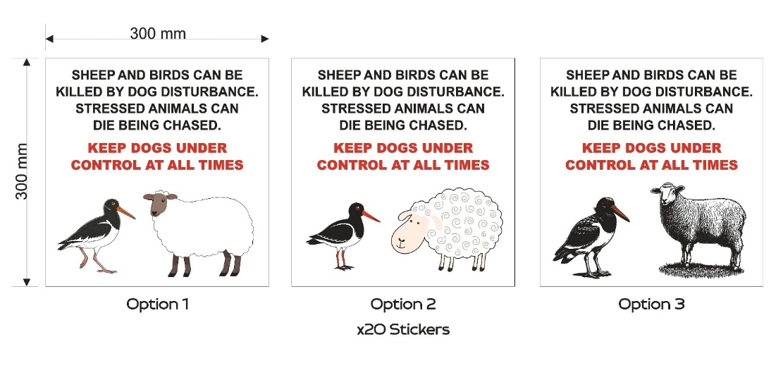

Page 027

The ranger has received many complaints with sheep and bird worrying. To help prevent the problem 20 stickers will be printed and stuck on every bin on Northam Burrows. The total cost of the stickers is £250 which Torridge District Council will pay 50% of the cost.
It was agreed to go ahead with a contribution of 50% of the above cost for Option 1 of the stickers but to amend the layout by putting the red text above the black, and that stickers could also be placed on the huts and gates.
Proposed: Cllr Hames, seconded: Cllr Leather (all in favour)

- To receive an update on action points
These were noted.
Action |  | October 2025
1 | To consider the progress being made by the consultant | The report’s recommendations were presented to a meeting of the Burrows Forum on 17th November 2025. COMPLETE
2 | Dung beetle workshop | Burrows ranger to arrange the workshop, dates awaited.  ONGOING
3 | Take out insurance policy | Policy taken out on 11th November 2025. COMPLETE

- To review the Grazing terms and conditions
It was agreed to accept the terms and conditions.
Proposed: Cllr Edwards, seconded: Cllr Edwards (all in favour)

- To receive the 2024-25 annual accounts
It was agreed to accept the accounts.
Proposed: Cllr Leather, seconded: Cllr Hames (all in favour)

- To note additional homes within the ancient Manor
It was noted that most of the development to the south of Bay View Road, all developments in Appledore and the lower part of Westward Ho! were within the Ancient Manor and, as such would be eligible for a Manor Pass.

- To note any business for future agendas
No matters were raised.

The meeting closed at 11:20am

Signed………………………………………………………… Date………………………………….

- To receive an update on action points
Action |  | October 2025
1 | To consider the progress being made by the consultant | The report’s recommendations were presented to a meeting of the Burrows Forum on 17th November 2025. COMPLETE
2 | Dung beetle workshop | Burrows ranger to arrange the workshop, dates awaited.  ONGOING
3 | Take out insurance policy | Policy taken out on 11th November 2025. COMPLETE
4. | To consider works on the Burrows.  • Improving access to FollyFoot stables from the Burrows to move the horses away from the road access point at Sandymere. | Circulate the map, arrange a site visit and put on a future agenda.  ONGOING
5. | To consider works on the Burrows.  • Installation of a new footbridge to improve crossings of the stream. | Circulate the map, arrange a site visit and put on a future agenda.  ONGOING

To consider grazing allocations

 | Apr-Jul |  | Aug-March
 | Min | Max | Min | Max
Sheep | 152 | 360 | 508 | 712
Horses | 9 | 32 | 32 | 45
Below is a summary of the applications received.

Sheep
APPLICANT | MAX ALLOCATION  2026/27  (to be completed) | MAX  REQUEST FOR  2026/2027 | Grazing numbers requested 2026/27
APPLICANT | MAX ALLOCATION  2026/27  (to be completed) | MAX  REQUEST FOR  2026/2027 | 1st April –  31st July | 1st August –  31st March
Mrs D Griffey |  | 300 | 150 | 300
Robert Griffey |  | 200 | 100 | 200
James Griffey |  | 200 | 100 | 200
TOTAL |  | 700 | 350 | 700

Horses
APPLICANT | Allocation 2025-26 |  | Max Allocation 2026-27  (To be completed) |  | Grazing numbers requested 2026/2027
APPLICANT | 1st April –  31st July | 1st August –  31st March | 1st April –  31st July | 1st August –  31st March | 1st April –  31st July | 1st August –  31st March
Mr M Lamey | 9 | 10 |  |  | 12 | 12
Derek Fitzgerald | 2 | 2 |  |  | 2 | 2
Melinda Stacey | 18 | 22 |  |  | 19 | 22
Ms Jobson-Scott | 3 | 3 |  |  | 3 | 4
Amy Alford | New application | New application |  |  | 1 | 1
Karen Haste | New application | 2 |  |  | 2 | 2
Total | 32 | 39 |  |  | 39 | 43

Highlighted in blue means requests exceed allocation.

- To consider works on the Burrows
The Burrows Ranger and Coastal Engineer have met with employees of NTC to identify projects which will require the Charity to assist with funding.

These are:
- Improving access to FollyFoot stables from the Burrows to move the horses away from the road access point at Sandymere.
  - The Ranger met with the stable owner in late 2025 and will be drawing together some costings to install a track and bridge from the stable yard directly on to Northam Burrows. This will alleviate the concerns raised by users regarding horses around the Sandymere entrance.
- Installation of a new footbridge to improve crossings of the stream.

Details of costs and options will follow as costs vary over time.

- To consider amending the list of roads within the Ancient Manor
The Ancient Manor has been mapped on the Parish by the Council’s mapping provider using a photocopy kept on file at the NTC offices, an original copy of the map not being held in the archives of Northam Town Council, Devon County Council or Torridge District Council.

This mapping has identified several anomalies when reviewing it against the list of roads that have been issued with Manor Passes. This is a live document and it is updated annually as new roads and properties are built, in liaison with Torridge District Council (copy enclosed). It is not clear when the roads added prior to 2025 were audited.

This year, the Officers noticed that addresses within Bideford TC boundary and not within the Ancient Manor have been supplied with passes, in some cases for many years. Those that applied did so in good faith, having been issued with passes in earlier years.

Enclosed are a copy of the Northam Ancient Manor overlayed onto a map, and two maps showing the detail of the area south of the New Bridge, where the Ancient Manor and the NTC boundaries are not consistent

Recommendation:
The committee review the list of addresses to establish that they are within the Northam TC boundary, the Northam Ancient Manor, or both.

- To note any business for future agendas:
  - A detailed Manor Pass issuing process has been requested by Finance & HR committee, with an estimate of the time taken to complete the whole process, which will inform any change to the recharge.
  - Grant fund available for the 2026 Burrows Grant year.
  - Any other matters raised by committee members.

